ACCESSIBILITY AND CLIMATE CHANGE
BC News - Climate change: Why are disabled people so affected by the climate crisis?
https://www.bbc.co.uk/news/disability-59042087
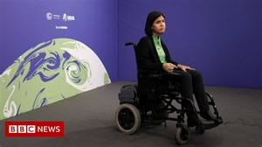 | Climate change: Why are disabled people so affected by the climate crisis?  Disabled people are among those worst affected by emergencies, including climate crises - but why?  www.bbc.co.uk

