ACCESSIBILITY: UBER AND PWD CHARGING SYSTEM

BBC News - Uber sued by Justice Department for overcharging disabled people
https://www.bbc.co.uk/news/business-59242866
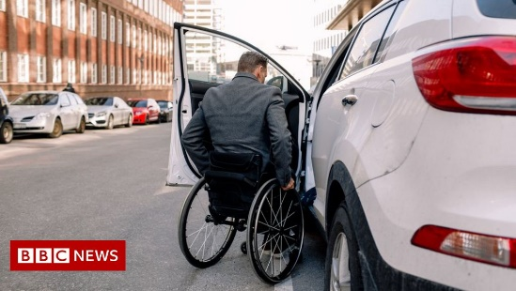 | Uber sued by Justice Department for overcharging disabled people - BBC News  The DoJ claims Uber's "wait time" fees are discriminating against disabled passengers who need more than two minutes to get into a car. It says Uber needs to comply with the Americans with ...  www.bbc.co.uk

