ACCESSIBILITY IN LONDON

BBC News - London elections: 'I don't feel welcome in this city'
https://www.bbc.co.uk/news/uk-england-london-56815242
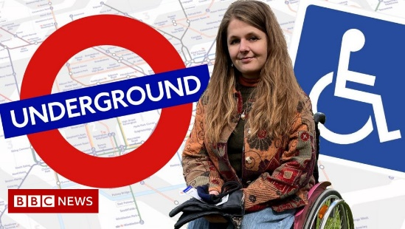 | 'I don't feel welcome in this city'  Accessible transport campaigner Katie Pennick says a lack of progress by consecutive London mayors has left her feeling "unwelcome".  www.bbc.co.uk

