DEAFNESS AND COVID INFORMATION

BBC News - Deaf community concerned over Covid-19 information
https://www.bbc.co.uk/news/uk-northern-ireland-52122929
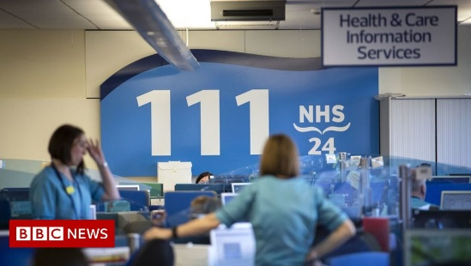 | Deaf community concerned over Covid-19 information - BBC News  The deaf community in Northern Ireland say some information sources are not available to them.  www.bbc.co.uk

