NEW APPROACHES BY JOB SEEKERS

BBC News - Job-seekers turn to TikTok to post 'CareerTok' CVs
https://www.bbc.co.uk/news/world-us-canada-59044854
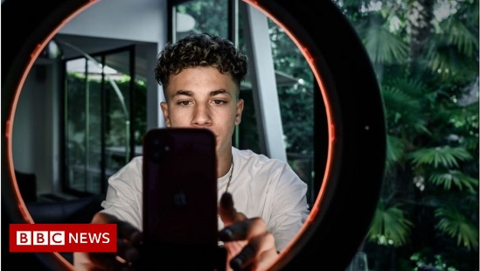 | Job-seekers turn to TikTok to post 'CareerTok' CVs - BBC News  "TikTok changed my life," Ms Prigozhina, 22, tells the BBC - the latest young person to benefit from a growing trend on the video sharing platform: "CareerTok".  www.bbc.co.uk

