**People with disabilities still face barriers finding work during the pandemic—here’s how companies can help**

[**https://www.cnbc.com/2021/10/29/people-with-disabilities-still-face-barriers-finding-work-during-the-pandemicheres-how-companies-can-help.html**](https://www.cnbc.com/2021/10/29/people-with-disabilities-still-face-barriers-finding-work-during-the-pandemicheres-how-companies-can-help.html)

**Published Fri, Oct 29 20212:23 PM EDTUpdated Mon, Nov 1 20212:11 PM EDT**

[**Morgan Smith**](https://www.cnbc.com/morgan-smith/)[**@THEWORDSMITHM**](https://twitter.com/thewordsmithm)

**SHARE**Share Article via FacebookShare Article via TwitterShare Article via LinkedInShare Article via Email

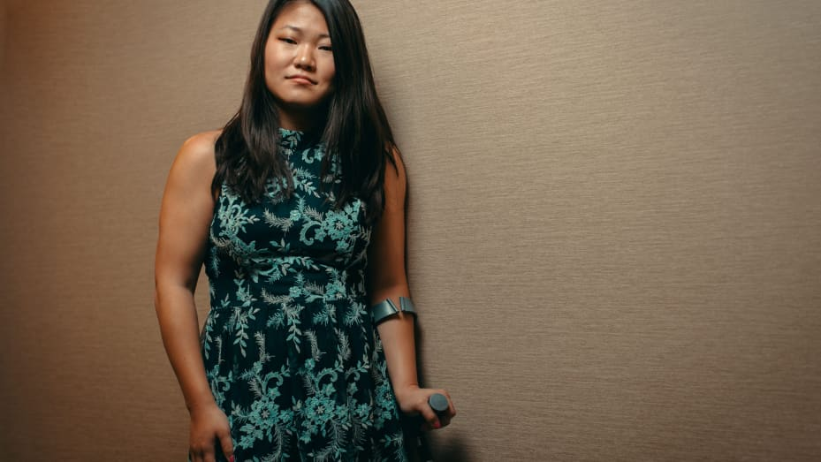

**Alyse Brewer**

Photo: Disability:IN

For nearly 20 months, debates about the future of work have dominated meetings and Twitter feeds as the coronavirus pandemic upended every aspect of our jobs from commutes to office dress codes. These conversations [continue to influence](https://www.cnbc.com/2021/09/02/return-to-office-is-now-the-great-wait-and-costing-employers-millions.html) companies’ return-to-office plans and their remote work policies. But despite the pandemic taking a disproportionate toll on their job prospects and well-being, people with disabilities continue to be left out of many of these critical conversations.

According to the [Bureau of Labor Statistics](https://www.bls.gov/news.release/empsit.t06.htm), the unemployment rate for people with disabilities is more than double that of those without: 9% compared to 4.4% as of September. People with disabilities are also far less likely to be employed than workers with no disabilities. There are several factors driving this disparity, including discriminatory hiring practices and fewer people with disabilities completing bachelor’s degrees.

The pandemic has only exacerbated this gap. Before the pandemic, workers with disabilities were more likely than those without disabilities to work from home, a [new report](https://smlr.rutgers.edu/sites/default/files/Documents/Centers/Program_Disability_Research/FactSheet_DisabilityTelework_Pandemic_Sept2021.pdf)from Rutgers University found. But because people with disabilities are more likely to hold blue-collar and service jobs, they have had far fewer options for remote or flexible work arrangements during the Covid-19 crisis, the report notes.

As employers announce plans to bring people back to offices and experiment with hybrid work schedules in the coming months, workers with disabilities and disability advocates are urging companies to rethink the structure of their organizations to better accommodate people with disabilities. “Folks with disabilities have been asking for flexible and remote work options for decades and have been consistently denied,” Maria Town, the president and CEO of The American Association of People with Disabilities, tells [CNBC Make It](https://www.cnbc.com/make-it/). “Now we know these jobs can be done remotely — and people don’t want to see these options go away the moment we decide the pandemic is over.”

**The pandemic created new challenges for workers who were already struggling**

People with disabilities already experienced “significant” barriers while navigating the pre-pandemic job market — the pandemic has both amplified existing barriers and removed certain hurdles, Town points out. Job applications and interviews are increasingly online, but Town observes that many people with disabilities don’t have access to the assistive technology they need to navigate online job boards. “The expectation is that you will find and apply for jobs online, and for many people with disabilities, that’s not possible,” she says. “But they can’t approach a community center or store in person and ask if they’re hiring anymore, because it’s riskier during the pandemic.” Some people with disabilities are more likely to get infected or have severe illness from coronavirus, according to the [CDC](https://www.cdc.gov/ncbddd/humandevelopment/covid-19/people-with-disabilities.html#:~:text=Most%20people%20with%20disabilities%20are,severe%20illness%20from%20COVID%2D19.).

The ongoing pandemic has also heightened the isolation people with disabilities faced prior to the pandemic. A [recent study](https://www.ncbi.nlm.nih.gov/pmc/articles/PMC7403030/#:~:text=People%20with%20disability%20experienced%20loneliness,were%20significantly%20greater%20for%20loneliness.) published by the Disability and Health Journal shows that people with disabilities experience loneliness and social isolation at much higher rates than those without disabilities. “With social distancing and the rise in new variants, it’s even harder to find out about job opportunities and connect with others,” Town says.

People with disabilities have also struggled to get certain accommodations approved for their work throughout the pandemic. Town notes, for example, that some immunocompromised teachers have been asked to be in the classroom or host in-person office hours[despite their concerns](https://www.cnbc.com/2021/03/01/more-teachers-plan-to-quit-as-covid-stress-overwhelms-educators.html) of falling severely ill from the virus. People infected with long Covid [may also qualify as disabled](https://www.cnbc.com/2021/07/26/long-covid-biden-says-some-qualify-for-federal-disability-resources.html), but struggle to get the accommodations and benefits that come with a more well-known condition.

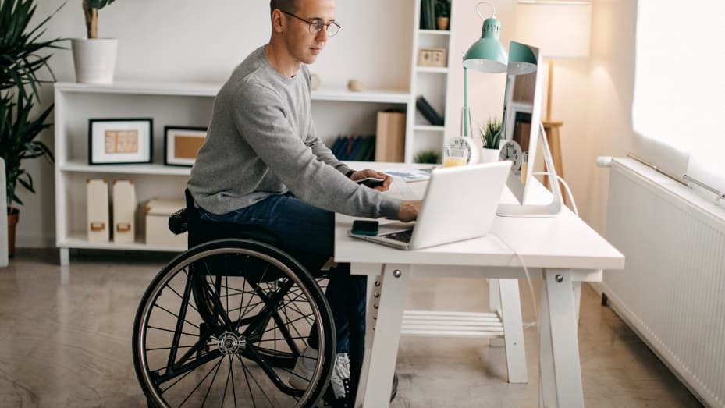

**Young man with disabilities working on his stock market portfolio**

eclipse_images | E+ | Getty Images

**Remote work can open new doors for people with disabilities**

Remote work has also made life easier for many people with disabilities, Town adds. “A lot of employees with disabilities tell us they’ve experienced less stigma in remote environments,” she says. “They can apply for jobs without people doubting their competency the moment they realize that they’re disabled — this remote environment has really leveled the playing field.”

When Alyse Brewer’s then-boss announced that their team would be returning to the office at the start of the summer, her heart sank. Brewer has cerebral palsy, a neurological disorder that has left her unable to drive. “It’s pretty readily obvious when people see me that I am disabled, because I walk with a crutch,” Brewer, 27, says. “Sometimes my disability feels like the elephant in the room, but I have embraced that and am comfortable talking about it.”

Brewer started her previous job remote with the expectation that employees would return back to the office once in-person work felt safe again. But she felt uneasy about the surge in virus cases due to the delta variant and being indoors with all of her colleagues. “I’m not immunocompromised, but many of my friends and a large portion of the disability community is,” she says. “By going into the office, I would be putting them at risk of getting really sick.” Public transit is also not widely available in her hometown of Doylestown, Pennsylvania, so Brewer would have to use a rideshare service, like Uber, which she says have been less available and more expensive in her town since the pandemic hit.

Brewer knew she needed to explore other jobs. In June, she applied for a remote position with Disability:IN, a non-profit focused on business disability inclusion. She quit her job once she got an official job offer from Disability:IN and began her new role as the organization’s NextGen coordinator in July from home.

“Working remotely is a luxury I didn’t even realize existed prior to the pandemic,” she says. “But it is such a relief, as a disabled person, not having to worry about how to get to the office, which also can be a huge expense, and working in the comfort of my own home, because I just don’t have as much stamina and energy as an able-bodied person does.”

**How companies can help**

The first step in building a more inclusive workplace for people with disabilities is recruiting more people from this group. Town suggests organizations partner with advocacy groups such as the AAPD or their state’s vocational rehabilitation program while recruiting new candidates. It’s also smart to check job announcements for any biased or discriminatory language and noting where information about disability accommodations is available. “These are all great ways to signal potential employees that your business values disabled employees and wants to connect with them,” Town says. Disability:IN offers [several resources](https://disabilityin.org/resource/digital-accessibility-statement-best-practices/) on their website to help companies make their [recruitment and retention practices](https://disabilityin.org/resource/disability-inclusion-employment-best-practices/#recruit) more inclusive.

Erin Sharkey, co-founder of the non-profit Compassion Café in Beach Haven, New Jersey, encourages small business owners to consider more targeted hiring and training programs to support workers with disabilities. She and her aunt Sue Sharkey opened the bakery and coffee shop in May 2021, after Sharkey, a board-certified behavior analyst, noticed many of her clients with disabilities were unable to find jobs during the pandemic. The Sharkeys’ café, which is only open during the summer, employed about 50 workers with disabilities. “Companies should see that having individuals with disabilities on staff is not a risk, but a reward,” Erin says.

Disabilities are often left out of conversations about diversity and inclusion, but they’re an important part of someone’s identity that should be considered in company programming, Town says. “Just like any other employee group, disabled folks need to know that they are valued and their unique perspectives contribute to an organization’s goals,” she adds. “Actions like celebrating the anniversary of the Americans with Disabilities Act, or including speakers with disabilities in company events, really matter.”

Jill Houghton, the president and CEO of Disability:IN, recommends forming a disability employee resource group who can give feedback on accommodation policies. Mental health is also an important aspect of caring for workers with disabilities, especially because certain mental disorders qualify as disabilities.

“Companies should evaluate their mental health benefits by asking what their employees need,” she says. “That’s one silver lining of the pandemic: it’s created an opportunity for us to be more open about mental health, which is closely linked to disabilities.” She continues: “There’s a lot of fear about going back to work, and what happens next ... we need to make sure disabilities stay part of the conversation about work.”

*Disclosure: CNBC’s parent company, Comcast, is a corporate partner of Disability:IN and a corporate sponsor of the American Association of People with Disabilities.*  
  
*Correction: This article has been updated to show that a recent study that found that people with disabilities experience loneliness and social isolation at much higher rates than those without disabilities was published by the Disability and Health Journal, not the National Library of Medicine.*