PWDS: ACCESSIBILITY PRACTICALITIES

BBC News - COP26: We must act on accessibility, says Israeli minister
https://www.bbc.co.uk/news/world-59132811
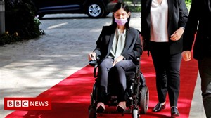 | Is sustainable living possible for visually-impaired people?  Israeli minister Karine Elharrar waited for two hours outside the Glasgow venue but couldn't get inside.  www.bbc.co.uk

