THE END OF NATURAL GAS?
How the Netherlands is turning its back on natural gas - https://www.bbc.com/future/article/20211025-netherlands-the-end-of-europes-largest-gas-field
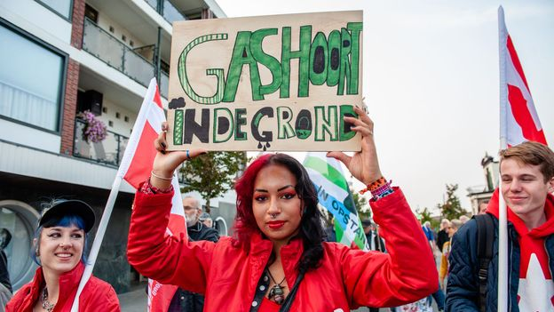 | How the Netherlands is turning its back on natural gas - BBC Future  Natural gas has provided the Netherlands with cheap heat for generations. As its largest gas field slowly closes down, a wealth of clean alternatives are opening up to keep homes warm.  www.bbc.com
* Disclaimer *
The BBC is not responsible for the content of this email, and anything written in this email does not necessarily reflect the BBC's views or opinions. Please note that neither the email address nor name of the sender have been verified.

