THE WORLD IN 2031
BBC ARTICLE

Tech Tent: The world in 2031 - https://www.bbc.co.uk/news/technology-59008812
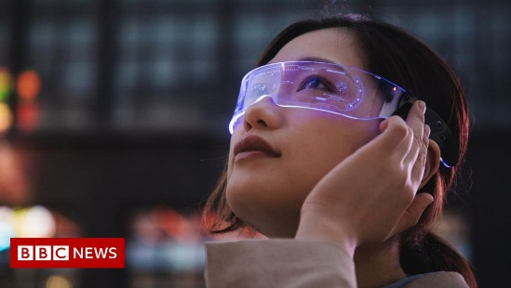 | Tech Tent: The world in 2031  How the metaverse, energy tech and AI might influence how we live in years to come.  www.bbc.co.uk
* Disclaimer *
The BBC is not responsible for the content of this email, and anything written in this email does not necessarily reflect the BBC's views or opinions. Please note that neither the email address nor name of the sender have been verified.

