WOMEN’S WORKLOAD IN THE MODERN AGE

BBC News - The hidden load: How 'thinking of everything' holds mums back
https://www.bbc.com/worklife/article/20210518-the-hidden-load-how-thinking-of-everything-holds-mums-back
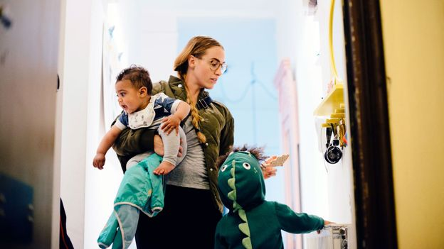 | The hidden load: How 'thinking of everything' holds mums back - BBC Worklife  Organising a playdate, or booking the kids’ medical check-ups. Working out how to hide vegetables in their evening meals, or ensuring there’s enough on the shopping list.  www.bbc.com

