EL SALVADOR MODEL OF SERVICE PROVISION FOR WOMEN

Link: https://apolitical.co/solution-articles/en/el-salvador-brings-services-women-one-roof
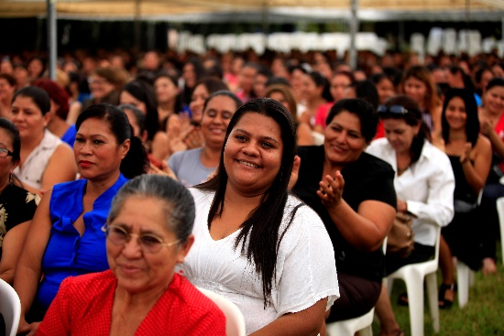 | El Salvador brings all its services for women under one roof  More than 1.5 million women have benefitted from the innovative model  apolitical.co
I also attach

