HOW TO GET MORE WOMEN TO BECOME COMPUTER CODERS?

BBC News - What can we do to get more women into coding?
https://www.bbc.co.uk/news/business-59045771
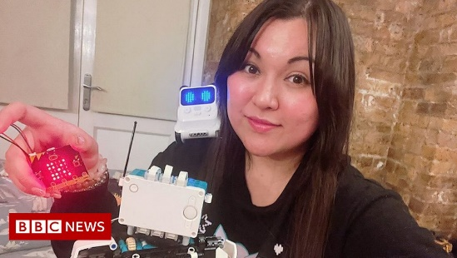 | What can we do to get more women into coding? - BBC News  The UK is facing an acute shortage of workers with digital skills - computer coders, cybersecurity experts and data analysts, are all in high demand.  www.bbc.co.uk

