INDIA FATHERS EMBRACE PATERNITY LEAVE

BBC News - Why Indian fathers are embracing paternity leave
https://www.bbc.co.uk/news/world-asia-india-60491095
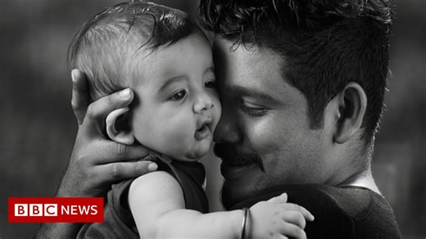 | India coronavirus: Pro tips on parenting in pandemic  The pandemic and changing family structures have highlighted how young parents are struggling with childcare.  www.bbc.co.uk

