JOB SEEKING IN INDIA (2022)

BBC News - India's jobs crisis is more serious than it seems
https://www.bbc.co.uk/news/world-asia-india-59870297
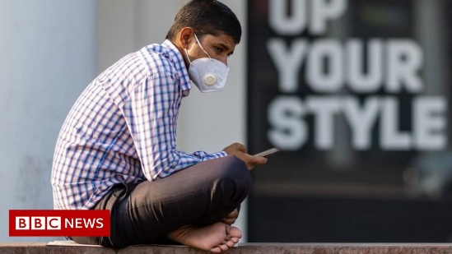 | India's jobs crisis is more serious than it seems - BBC News  Mr Maurya's plight shines a light on the acute jobs crisis facing India. The pandemic battered Asia's third-largest economy, which was already in the throes of a prolonged slowdown.  www.bbc.co.uk

