SOME REASONS FOR HIGH RATE OF FEMALE SUICIDE

BBC News - What's behind suicides by thousands of Indian housewives?
https://www.bbc.co.uk/news/world-asia-india-59634393
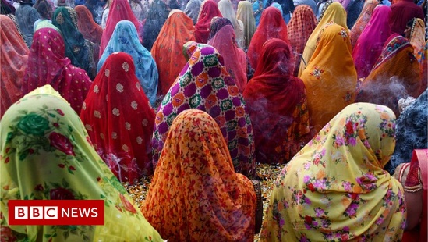 | What's behind suicides by thousands of Indian housewives? - BBC News  According to the recently released data by the government's National Crime Records Bureau (NCRB), 22,372 housewives took their own lives last year - that's an average of 61 suicides every day or ...  www.bbc.co.uk

