BREAKTHROUGH IN NUCLEAR FUSION
BBC News - Major breakthrough on nuclear fusion energy
https://www.bbc.co.uk/news/science-environment-60312633
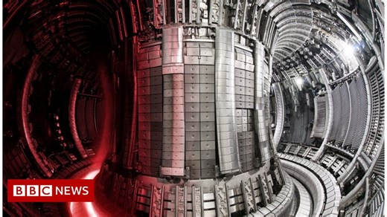 | Watch the five-second pulse light up the JET reactor  A lab in Oxfordshire takes a big step towards harnessing the energy source of the stars.  www.bbc.co.uk

