EGYPT’S GREEN ECONOMY

BBC News - Egypt's Red Sea resort that's making waves
https://www.bbc.com/travel/article/20220714-egypts-red-sea-resort-thats-making-waves
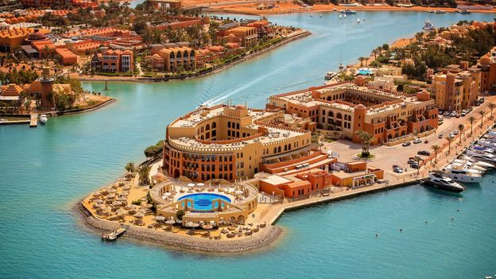 | Egypt's Red Sea resort that's making waves - BBC Travel  On the shore of the Red Sea, the forward-thinking town of El Gouna was founded with a mission: to do its part to protect the environment.  www.bbc.com

