GENERATION Z: SHARING PAY INFORMATION VIA TIKTOK

BBC News - Pay gap: Will Gen Z salary-sharing on TikTok make a difference?
https://www.bbc.co.uk/news/world-us-canada-62935715
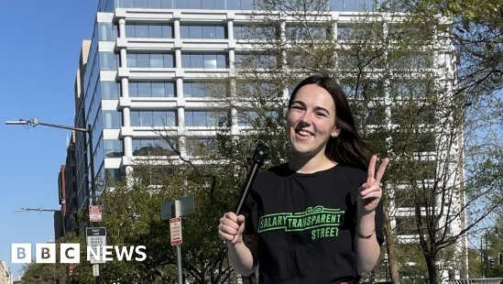 | Pay gap: Will Gen Z salary-sharing on TikTok make a difference?  Gen Z is known for sharing everything about their lives - from their outfits to their latest meals - online. Now, they're sharing their salaries, defying a long-held taboo and ruffling employers ...  www.bbc.co.uk

