KENYA’S TECHNOLOGY HUB FOR KIDS

BBC News - Kenya's tech hub: Meeting the DIY coders and gurus of the future
https://www.bbc.co.uk/news/world-africa-62053996
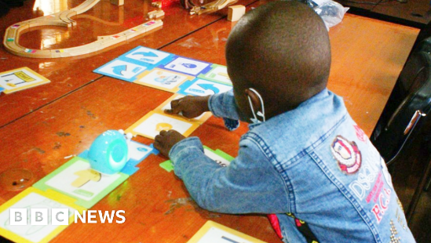 | Kenya's tech hub: Meeting the DIY coders and gurus of the future - BBC News - bbc.co.uk  On a balmy morning in Nairobi a group of children are building robots using motors and wires, while in an adjacent room a child is learning how to use software to spell their name on a computer.  www.bbc.co.uk

