TAPPING INTO CHILDREN’S CURIOSITY

https://www.theguardian.com/pioneering-innovation-for-a-purposeful-future/2022/sep/02/young-children-are-naturally-curious-how-a-company-is-inspiring-kids-to-be-the-scientists-of-the-future?CMP=Share_AndroidApp_Other
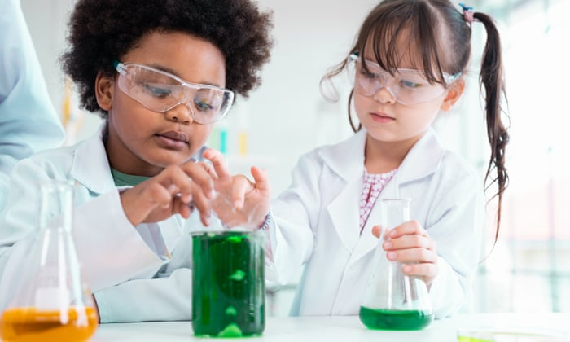 | ‘Young children are naturally curious’: how a company is inspiring kids to be the scientists of the future | Pioneering innovation for a purposeful future | The Guardian  Henkel spokespeople Ute Krupp (left) and Sandra Breuer (right) The programme started in 2011, originally as week-long holiday programmes for the children of Henkel employees.  www.theguardian.com

