A RUTHLESS INSIGHT INTO THE POTENTIAL IMPACT OF ROBOTISATION

BBC News - Fired Twitter cleaning staff 'treated like garbage'
https://www.bbc.co.uk/news/technology-63912116
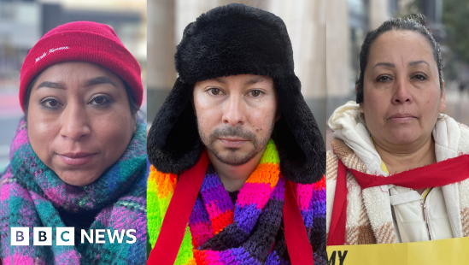 | Fired Twitter cleaning staff 'treated like garbage' - BBC News  The cleaners, who were sacked on Monday, have been protesting outside the headquarters in San Francisco.  www.bbc.co.uk

