WHERE DOES FLEXIBLE/AGILE WORKING GO NEXT?

https://www.theguardian.com/choose-your-own-route/2022/nov/17/from-co-working-spaces-to-hybrid-working-where-next-for-business-flex?CMP=Share_AndroidApp_Other
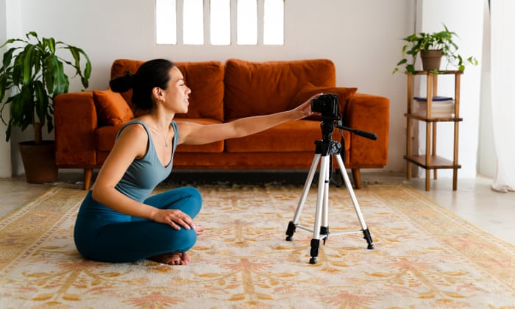 | From co-working spaces to hybrid working: where next for business flex? | Choose your own route | The Guardian  In March 2020, Abigail McLachlan had just invested £180,000 in East of Eden, the yoga and pilates business she runs in Walthamstow, east London.She was expanding with two shiny new studios ...  www.theguardian.com

