FUTURE HEALTH

BBC News - Half of world on track to be overweight by 2035
https://www.bbc.co.uk/news/world-64831848
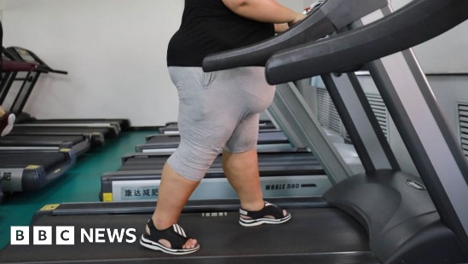 | Half of world on track to be overweight by 2035  Africa and Asia are expected to see the biggest rises in obesity, the World Obesity Federation says.  www.bbc.co.uk

