COAL MINES: A FUTURE SOURCE OF HEAT

https://www.bbc.com/reel/video/p0fbsw4s/heating-homes-using-abandoned-coal-mines
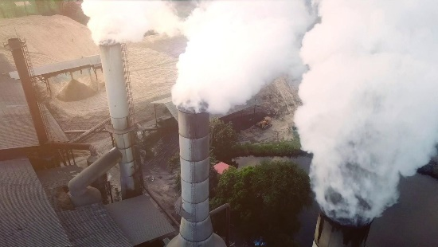 | Heating homes using abandoned coal mines - BBC Reel  /  www.bbc.com

