GERMANY CLOSES ITS NUCLEAR POWER STATIONS

BBC News - Germans split as last three nuclear power stations go off grid
https://www.bbc.co.uk/news/world-europe-65260673
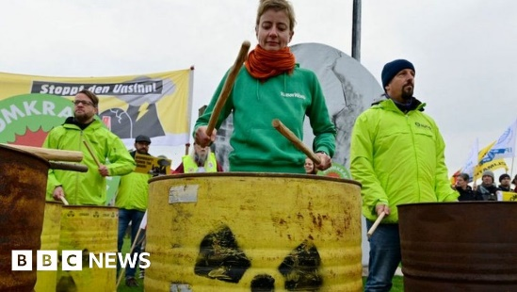 | Germans split as last three nuclear power stations go off grid  More than 60 years of nuclear power comes to an end on Saturday, but many Germans are unhappy.  www.bbc.co.uk

