PROPONENTS OF AI STRIKE BACK

BBC News - Martha Lane Fox warns against hysteria over AI
https://www.bbc.co.uk/news/technology-65162257
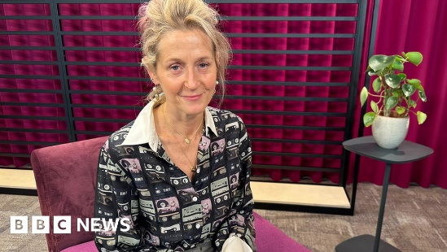 | Martha Lane Fox warns against hysteria over AI  The tech pioneer told the BBC we should see artificial intelligence as an opportunity.  www.bbc.co.uk

