UK GENDER PAY GAP

https://www.bbc.com/news/business-65179430
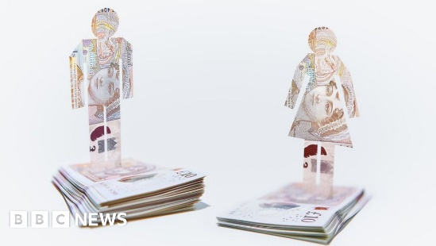 | Men still out-earn women in most jobs - BBC News  Men still earn more than women, according to data gathered by the BBC. Despite a continued push for equality, the difference in wage has remained at 9.4%, the same level as in 2017/18, when ...  www.bbc.com

