Technical Assistance for Promoting Decent Future of Work Approach with a Focus of Gender Equality

TREESP1.4. FoW/P-01
EuropeAid/140341/IH/SER/TR

Intervention 13: Workshops for New Employment Strategies

Report on the Gaziantep-Based Workshop Held on 13 July 2023

July 2023
Ankara

TABLE of Contents

Table of Contents 2
Abbreviations 3
1. INTRODUCTION & CONTEXT 4
2. DESCRIPTION OF THE EVENT 5
2.1. Venue & Timing 5
2.2. Agenda 5
2.3. Participation 6
2.4. Visibility 7
3. WORKSHOP CONTENT & OUTCOMES 7
4. CONCLUSION 12
Annexes 12

Abbreviations

AO Administrative Order
Bağ-Kur Insuranced Self-Employed Institution
EU European Union
MoLSS Ministry of Labour and Social Security
NGO Non-Governmental Organisation
OB Operation Beneficiary
PwD People with Disabilities
TAT Technical Assistance Team
ToR Terms of Reference
TP Technical Proposal

IntroductIon & CONTEXT

Technical Assistance for Promoting Decent Future of Work Approach with a Focus of Gender Equality Project started on 1 February 2021, co-funded by the EU Delegation to Turkey and the Republic of Turkey and is scheduled to end on 31 July 2023. The Operational Beneficiary is the Department of Employment Policies of the General Directorate of Labour for the Ministry of Labour and Social Security (MoLSS), and the Contracting Authority is the Directorate of European Union and Financial Assistance in the MoLSS. The Project is designed with 4 Categories and 15 Interventions:

- Category 1: Capacity-Building Programme:
  - Int 1: Training for Staff.
  - Int 2: IT-Based Monitoring System.
  - Int 3: Study Visits.
  - Int 4: Advocacy and Awareness-Raising Strategy.
- Category 2: Awareness Raising:
  - Int 5: Opening/Closing Conference.
  - Int 6: Communication Plan.
  - Int 7: Public Spot Film.
- Category 3: Scientific and Technical Studies:
  - Int 8: Sectoral Studies.
  - Int 9: Report on Employment of People with Disabilities for Decent Future of Work.
  - Int 10: Report on Mobbing Complaints with a particular focus on gender.
  - Int 11: Impact assessment on women’s employment conditions.
- Category 4: Coordination and Cooperation Mechanisms:
  - Int 12: Pre/post-study workshop on studies (sectoral + PwD + mobbing + impact assessment).
  - Int 13: Workshop on new employment strategies.
  - Int 14: Establishment of Future of Work Commission.
  - Int 15: International Conference on Future of Decent Work.
Under Intervention 13, the Project is required to deliver 5 workshops in 5 provinces (Ankara and an indicative list including Bursa, Izmir, Adana and Istanbul) aimed at generating ideas for new employment strategies to be pursued by MoLSS.

The ToR (as amended by AO7) stipulation for Intervention 13 is:

5 workshops will be organised in 5 different provinces to have feedbacks and inputs for drafting new employment strategies such as NES, women employment policies and to discuss regional needs and problems with the participation of relevant public institutions, academicians, NGOs, social partners, professional organisations, representatives of private sector. Indicative list of pilot provinces other than Ankara: Adana, Bursa, Gaziantep and İzmir. 50 local participants will attend to each workshop and will last one day. After completion of the workshops, a detailed report will be prepared by the Contractor. 5 staff of the Operation Beneficiary will participate to each workshop.

To date, 3 workshops have been delivered: Ankara - 6 July 2021; Bursa - 21 October 2021; and Adana - 12 January 2022. With the exception of the Ankara Workshop – which took the form of a public dialogue platform to gain stakeholder input to the draft Youth Employment Strategy – the other provincial workshops have sought to gain an understanding of matters of importance to each province and to arrive at some policy ideas which could address perceived local issues.

Consequently, OB requested that the Gaziantep-based Workshop should focus on identifying regional problems/needs as well as determination of policy / precautionary recommendations of labour market issues and problems currently being experienced in Gaziantep province.

In advance of the workshop, TAT produced a Desk Research Report, providing an overview of economic and employment trends, and giving some prominence to the Gaziantep Strategic Plan for 2022-2026. This Report is attached at Annex 1.

DeSCRIPTION OF THE EVENT

2.1. Venue & Timing

The Workshop was held in Gaziantep on 13 July 2023. The OB selected the Gaziantep Green Park Hotel as it offered the space and facilities which were required for the event.

2.2. Agenda

TAT and OB worked together on the agenda for the Workshop, the final version was as follows:

Time | Agenda | Speakers / Moderators
09.30 - 10.00 | Registration
10:00 - 10.20 | Opening Speeches | Mr. Aykut Geçer - Head of Employment Policies Department - Ministry of Labour and Social Security  Mr. Murat Akyüz – Deputy Governor of Gaziantep
10.20 - 10.50 | Overview of Gaziantep's economy, labour market and the development dynamics | Ms. Esra Sermin Ata  Ministry of Labour and Social Security
10.50 - 11.00 | Information about working groups | Mr. Evren Helvacı  Ministry of Labour and Social Security
11.00 - 11.15 | Break
11.15 - 12.30 | Thematic Working Group Discussions: Identifying problems and needs.  1) Increasing competitiveness in the regional economy by considering the changing conditions in production and trade, raising a workforce suitable for green and digital transformation  2) Developing inclusive employment to contribute to regional development  3) Increasing employment in the region by strengthening the entrepreneurial ecosystem and creating new jobs  4) Strengthening rural economies and developing qualified employment in rural areas  5) Recovery of employment in the region after the earthquake | 5 thematic working groups will be moderated by the MoLSS representatives.  - Moderator: Ms. Esra Sermin Ata  - Moderator: Ms. Zeynep Bulut  - Moderator: Mr. Serdar Uğurlu  - Moderator: Mr. İbrahim Konuk  - Moderator: Mr. Evren Helvacı
12.30 - 13.30 | Lunch Break
13.30 - 14.45 | Thematic Working Group Discussions: Determination of policy/precautionary recommendations  1) Increasing competitiveness in the regional economy by considering the changing conditions in production and trade, raising a workforce suitable for green and digital transformation  2) Developing inclusive employment to contribute to regional development  3) Increasing employment in the region by strengthening the entrepreneurial ecosystem and creating new jobs  4) Strengthening rural economies and developing qualified employment in rural areas  5) Recovery of employment in the region after the earthquake  It is expected that the policy/precautionary recommendations will be determined and prioritized for the problems and needs identified in the first session by the working groups. | 5 thematic working groups will be moderated by the MoLSS representatives.  - Moderator: Ms. Esra Sermin Ata  - Moderator: Ms. Zeynep Bulut  - Moderator: Mr. Serdar Uğurlu  - Moderator: Mr. İbrahim Konuk  - Moderator: Mr. Evren Helvacı
14.45 - 15.00 | Break
15.00 - 15.45 | Sharing the results of the group works on problems and needs | The results of the group work will be presented to the participants by one participant to be determined by each group.
15.45 - 16.30 | Sharing the results of the group works on policy/precautionary recommendations
16.30 - 17.00 | Evaluation & Closing | Mr. Aykut Geçer - Head of Employment Policies Department - Ministry of Labour and Social Security

2.3. Participation

OB prepared and distributed an invitation letter prior to the event. 49 participants joined the workshop, representing different organisations and institutions, of which 29 were public sector, 3 were private sector and 17 were other institutions/organisations. 6 MoLSS staff were present and 4 persons from TAT. A participant list is attached at Annex 2.

Picture 1: Workshop Participants (Green Park Hotel, Gaziantep)

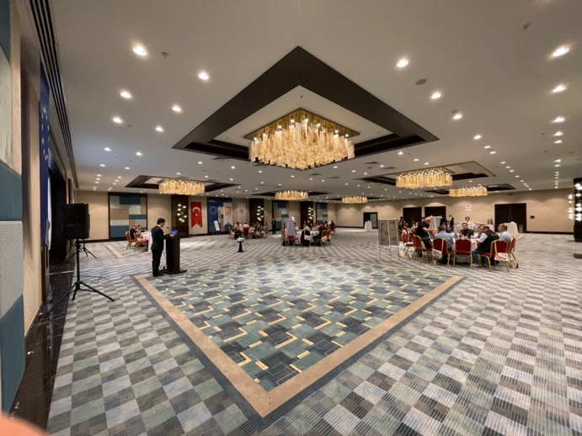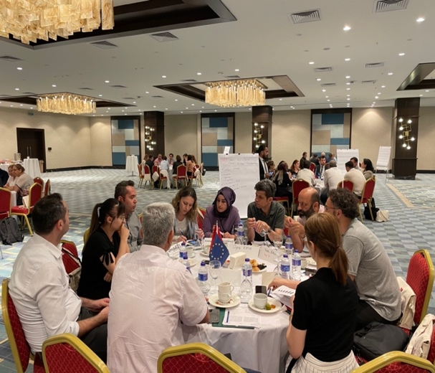
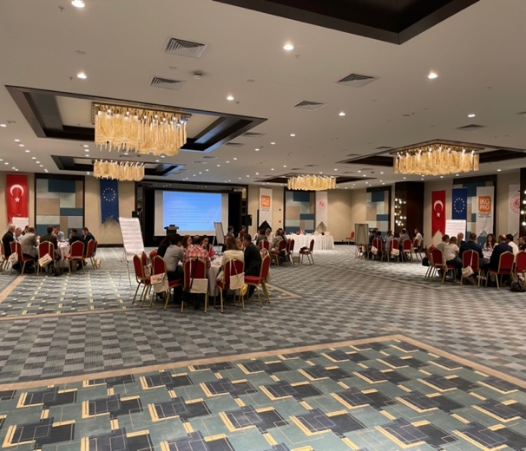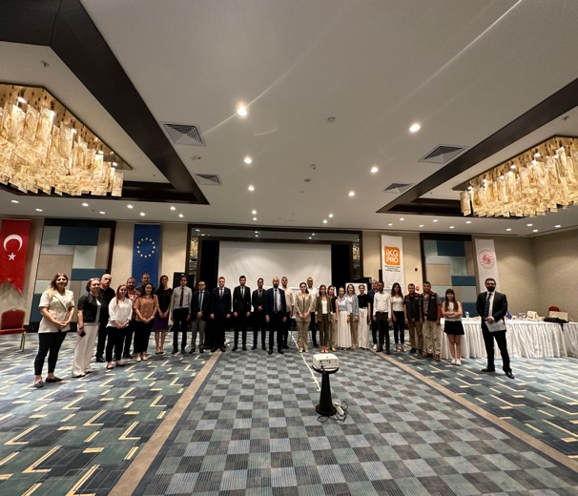

2.4. Visibility

The Project’s visibility materials were displayed:

- 2 roll-up banners were used as a backdrop for the registration table.
- 2 sets of banners (Turkish flag; HRDOS logo; MoLSS logo) were hung in the meeting area.
- Visibility kits were issued to all participants comprising: bag; notepad; pen; factsheet; folder; USB stick; mug.

Workshop STRUCTURE, content & Outcomes

Following introductory remarks, aimed at setting the agenda for discussions, the main part of the workshop involved participants working in 5 thematic working groups each moderated by MoLSS representatives, to discuss the 5 thematic topics over 2 sessions. In session 1, the groups focused on identifying problems and needs, and in session 2, they came up with policy/precautionary recommendations aimed at overcoming perceived problems and barriers.

The Outcomes of the 5 thematic working groups are as follows (shown in tabular form for ease of reference):

GROUP 1 - Increasing competitiveness in the regional economy by considering the changing conditions in production and trade, raising a workforce suitable for green and digital transformation

PROBLEMS AND NEEDS | POLICY/PRECAUTIONARY RECOMMENDATIONS
Lack of communication among stakeholders | - Establishment of a wide-range platform to serve as board for development and cooperation under the lead of city governors.
Lack of awareness for green and digital transformation and value-added products | - Regular physical/online meetings/seminars within the above-mentioned platform and establishment of a web portal for platform members.
Lack of entrepreneurial vision, success stories & role models in the province | - Projection of success stories and role models to public within the above-mentioned web-portal and provision of entrepreneurial support for individuals.
Lack of interest for vocational training programmes. | - Increasing cooperation & communication among private companies, vocational high schools and vocational trainers within the province.  - Awareness & prestige raising activities for vocational training programmes.
Insufficient planning in the province in terms of unskilled labour force | - Stakeholder participation, regular monitoring & update and assessment of the plans.

GROUP 2 - Developing inclusive employment to contribute to regional development

PROBLEMS AND NEEDS | POLICY/PRECAUTIONARY RECOMMENDATIONS
Unregistered employment of immigrants and gender inequality | - Review of the of immigration and settlement policy.  - Empowerment of MoLSS’ provincial offices.  - Individual application opportunities for unregistered migrant workers.  - Removal of “Kızılay Kart (special debit card for refugees)” practice.  - Strict supervision of companies founded by immigrants.
Problems of women with care obligations in employment | - Development of more care services.  - Review of maternity leave and working hours.  - Awareness raising activities for women.  - Provision of a quota practice for women depending on the sectors.
Increase in migration from rural to urban areas in terms of skilled labour force | - Orientation of immigrants to agriculture and positioning to agriculturally developed regions.
Increase in child labour due to migration | - Increasing audits and random checks.  - Provision of social support to families.  - Better opportunities for vocational training programmes.
Lack of education and employment opportunities in terms of youth employment | - Provision of social benefits and incentives for youth employment.  - Constant provision of vocational training programmes and entrepreneurship opportunities.
Increase in the number and percentage of disabled people after the earthquake (60 %) | - Awareness raising activities for employers.  - Provision of incentives for disabled people in employment as well as employers.  - Provision of social support and care services to families of disabled people in registered employment.

GROUP 3 - Increasing employment in the region by strengthening the entrepreneurial ecosystem and creating new jobs

PROBLEMS AND NEEDS | POLICY/PRECAUTIONARY RECOMMENDATIONS
Structural problems of the national education system and lack of regional awareness of entrepreneurship | - Structural transformation of the apprenticeship system, vocational education and technical high schools and increasing the interest in vocational education for a better entrepreneurial environment.  - Inclusion of entrepreneurship & regional market needs courses into the education curriculum of vocational education and technical high schools.  - Assigning entrepreneurship mentors in vocational education and technical high schools.
Economic fluctuations and unpredictability of costs | - Increasing awareness and enthusiasm for entrepreneurship concept by media (mass, social) and public service ads.  - Provision of incentives and benefits for entrepreneurs to minimise the risks.  - Establishment of an entrepreneurship insurance system.
Insufficient planning within the province in terms of entrepreneurship | - Identification of regional and sectoral entrepreneurship needs, establishment of entrepreneurial information offices and assigning mentors to entrepreneurs.  - Establishment of entrepreneurship platforms to increase cooperation and networking in between investors and entrepreneurs.  - Introduction of future of work concept to entrepreneurs.
Easy accession to social assistance and benefits | - Increasing audits and random checks for social assistance beneficiaries.  - Setting a maximum time/amount limit for social assistance and benefits.

GROUP 4 - Strengthening rural economies and developing qualified employment in rural areas

PROBLEMS AND NEEDS | POLICY/PRECAUTIONARY RECOMMENDATIONS
Increase in youth migration from rural to urban areas | - Decrease in Bağ-Kur premiums and extend due dates.  - Enhance education, health and social opportunities in rural areas.  - Lower taxation for agricultural income and promoting the cooperative system in rural areas.
Traditional agricultural production methods and not being open to innovations in agriculture | - Increase youth interest in agriculture and promoting youth accession to agricultural production.  - Regular seminars, trainings and demonstrations regarding the innovations and digitalisation in agriculture by public, private institutions and NGOs.
Insufficient integration of migrant labour force to local culture and work discipline in agriculture | - Regular seminars, meetings and trainings to increase integration of immigrants into local culture.
The ineffectiveness of professional and non-governmental organisations working in agricultural sector | - Increase government support to professional and non-governmental organisations.  - Enhance capacity, network and cooperation among such organisations by regular meetings, trainings and seminars.
Lack of good and appropriate agricultural practices in agricultural production | - Widespread use of automatic irrigation systems.  - Less use of pesticides and registration of amounts used.  - Provision of incentives for organic farming practices.  - Provision of easy access to markets for individual producers.  - Production planning in cooperation with national and local authorities.

GROUP 5 - Recovery of employment in the region after the earthquake

PROBLEMS AND NEEDS | POLICY/PRECAUTIONARY RECOMMENDATIONS
Lack of education, health and housing opportunities in the region after the earthquake | - Public-privates sector cooperation for housing opportunities for employees.  - Tax and social security premium reductions for regional employers and employees (especially for re-entrants).  - Provision of incentives for students and teachers within the region.
Lack of incentives for employers, self-employed, artisans and craftsman | - Determining regional and sectoral strong micro areas specific to the region and applying incentives, tax & social security premium deductions to those operating in these areas.  - Provision of salaried apprenticeship system and vocational education to students who are studying in these micro areas.  - Provision of incentives to technical schools which are operating in these micro areas.
Insufficient understanding of the cooperative system in the region | - Provision of information, cooperation and networking offices within the region to promote the cooperative system.  - Promotion of cooperative system by capacity building activities for public institutions, private companies and NGOs.

CONCLUSIONS

As with previous workshops in this series, the Gaziantep Workshop was a highly interactive event, reflecting a) stakeholders’ strong commitment to identifying and resolving local issues, and b) MoLSS’s consistent approach to creating a meaningful platform of ‘social dialogue in action’ in their policy deliberations. The working group structure - the first time this had been used in these workshops – greatly assisted debate, and many useful ideas were able to emerge.

The ideas generated in the Gaziantep Workshop will be combined with those from previous workshops under Intervention 13 to produce a ‘synopsis of outcomes and recommendations’ before the end of the project.

ANNEXES

Annex 1: Desk Research Report
Annex 2: List of Participants

