Technical Assistance for Promoting Decent Future of Work Approach with a Focus of Gender Equality

TREESP1.4. FoW/P-01
EuropeAid/140341/IH/SER/TR

Intervention 13: Workshops for New Employment Strategies

Report on the İstanbul-Based Workshop Held on 28 September 2023

October 2023
Ankara

TABLE of Contents

Table of Contents 2
Abbreviations 3
1. INTRODUCTION & CONTEXT 4
2. DESCRIPTION OF THE EVENT 5
2.1. Venue & Timing 5
2.2. Agenda 5
2.3. Participation 6
2.4. Visibility 7
3. WORKSHOP CONTENT & OUTCOMES 7
4. CONCLUSION 12
Annexes 12

Abbreviations

AO Administrative Order
EU European Union
MoLSS Ministry of Labour and Social Security
NGO Non-Governmental Organisation
OB Operation Beneficiary
PwD People with Disabilities
TAT Technical Assistance Team
ToR Terms of Reference
TP Technical Proposal

IntroductIon & CONTEXT

Technical Assistance for Promoting Decent Future of Work Approach with a Focus of Gender Equality Project started on 1 February 2021, co-funded by the EU Delegation to Turkey and the Republic of Turkey and was scheduled to end on 31 July 2023 but was time-extended to 30 November 2023. The Operational Beneficiary is the Department of Employment Policies of the General Directorate of Labour for the Ministry of Labour and Social Security (MoLSS), and the Contracting Authority is the Directorate of European Union and Financial Assistance in the MoLSS. The Project is designed with 4 Categories and 15 Interventions:

- Category 1: Capacity-Building Programme:
  - Int 1: Training for Staff.
  - Int 2: IT-Based Monitoring System.
  - Int 3: Study Visits.
  - Int 4: Advocacy and Awareness-Raising Strategy.
- Category 2: Awareness Raising:
  - Int 6: Communication Plan.
  - Int 7: Public Spot Film.
- Category 3: Scientific and Technical Studies:
  - Int 8: Sectoral Studies.
  - Int 9: Report on Employment of People with Disabilities for Decent Future of Work.
  - Int 10: Report on Mobbing Complaints with a particular focus on gender.
  - Int 11: Impact assessment on women’s employment conditions.
- Category 4: Coordination and Cooperation Mechanisms:
  - Int 12: Pre/post-study workshop on studies (sectoral + PwD + mobbing + impact assessment).
  - Int 13: Workshop on new employment strategies.
  - Int 14: Establishment of Future of Work Commission.
  - Int 15: International Conference on Future of Decent Work.
Under Intervention 13, the Project is required to deliver 5 workshops in 5 provinces (Ankara and an indicative list including Bursa, Izmir, Adana and Istanbul) aimed at generating ideas for new employment strategies to be pursued by MoLSS.

The ToR (as amended by AO7) stipulation for Intervention 13 is:

5 workshops will be organised in 5 different provinces to have feedback and inputs for drafting new employment strategies such as NES, women employment policies and to discuss regional needs and problems with the participation of relevant public institutions, academicians, NGOs, social partners, professional organisations, representatives of private sector. Indicative list of pilot provinces other than Ankara: Adana, Bursa, Gaziantep and İzmir. 50 local participants will attend to each workshop and will last one day. After completion of the workshops, a detailed report will be prepared by the Contractor. 5 staff of the Operation Beneficiary will participate to each workshop.

(Subsequent correspondence confirmed that Istanbul would be an eligible province for the final workshop).

To date, 4 workshops have been delivered: Ankara - 6 July 2021; Bursa - 21 October 2021; Adana - 12 January 2022 and Gaziantep – 13 July 2023. With the exception of the Ankara Workshop – which took the form of a public dialogue platform to gain stakeholder input to the draft Youth Employment Strategy – the other provincial workshops have sought to gain an understanding of matters of importance to each province and to arrive at some policy ideas which could address perceived local issues.

Consequently, OB requested that the İstanbul-based Workshop should focus on engaging the business and NGO communities in social dialogue as part of the Ministry of Labour and Social Security’s policy and strategy development processes.

In advance of the workshop, TAT produced a Desk Research Report, providing an overview of economic and employment trends, and giving some prominence to the İstanbul Strategic Plan for 2024-2028. This Report is attached at Annex 1.

DeSCRIPTION OF THE EVENT

2.1. Venue & Timing

The Workshop was held in Istanbul on 28 September 2023. The OB selected the İstanbul Nippon Hotel as it offered the space and facilities which were required for the event.

2.2. Agenda

TAT and OB worked together on the agenda for the Workshop, the final version was as follows:

Time | Agenda | Speakers / Moderators
09.30 - 10.00 | Registration
10:00 - 10.20 | Opening Speeches | Mr. İbrahim Akın – Deputy General Director of Employment Policies Department - Ministry of Labour and Social Security
10.20 - 10.50 | Overview of İstanbul's economy, labour market and the development dynamics | Ms. Esra Sermin Ata  Ministry of Labour and Social Security
10.50 - 11.00 | Information about working groups | Mr. Evren Helvacı  Ministry of Labour and Social Security
11.00 - 11.15 | Break
11.15 - 12.30 | Thematic Working Group Discussions: Identifying problems and needs.  - Raising a workforce suitable for green and digital transformation by considering the changing conditions in production & trade, and just transition measures.  - Developing inclusive employment at the workplace and economy scales.  - Increasing employment in the region by strengthening the entrepreneurial ecosystem and creating new jobs.  - Development of registered employment by considering new developing forms of work (platform economy, remote work, home services).  - Strengthening the education-employment relationship at all levels to support transformation in sectors (automotive, energy, textile, buildings). | 5 thematic working groups will be moderated by the MoLSS representatives.  - Moderator: Ms. Esra Sermin Ata  - Moderator: Mr. Nihat Çakmak  - Moderator: Mr. Evren Helvacı  - Moderator: Ms. Başak Bozdemir  - Moderator: Ms. Fatma Temiz
12.30 - 13.30 | Lunch Break
13.30 - 14.45 | Thematic Working Group Discussions: Determination of policy/precautionary recommendations  - Raising a workforce suitable for green and digital transformation by considering the changing conditions in production & trade, and just transition measures.  - Developing inclusive employment at the workplace and economy scales.  - Increasing employment in the region by strengthening the entrepreneurial ecosystem and creating new jobs.  - Development of registered employment by considering new developing forms of work (platform economy, remote work, home services).  - Strengthening the education-employment relationship at all levels to support transformation in sectors (automotive, energy, textile, buildings).  It is expected that the policy/precautionary recommendations will be determined and prioritized for the problems and needs identified in the first session by the working groups. | 5 thematic working groups will be moderated by the MoLSS representatives.  - Moderator: Ms. Esra Sermin Ata  - Moderator: Mr. Nihat Çakmak  - Moderator: Mr. Evren Helvacı  - Moderator: Ms. Başak Bozdemir  - Moderator: Ms. Fatma Temiz
14.45 - 15.00 | Break
15.00 - 15.45 | Sharing the results of the group works on problems and needs | The results of the group work will be presented to the participants by one participant to be determined by each group.
15.45 - 16.30 | Sharing the results of the group works on policy/precautionary recommendations
16.30 - 17.00 | Evaluation & Closing | Mr. İbrahim Akın – Deputy General Director of Employment Policies Department - Ministry of Labour and Social Security

2.3. Participation

OB prepared and distributed an invitation letter prior to the event. 44 participants joined the workshop, representing different organisations and institutions, of which 15 were public sector, 5 were private sector and 24 were other institutions/organisations. 6 MoLSS staff were present and 3 persons from TAT. A participant list is attached at Annex 2.

Picture 1: Workshop Participants (Nippon Hotel, İstanbul)

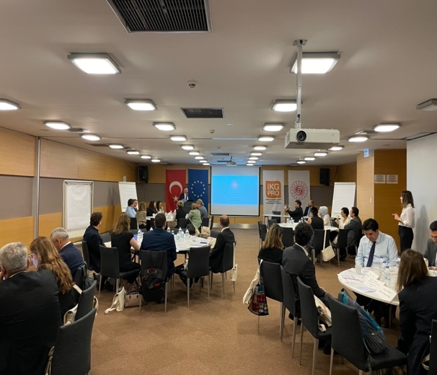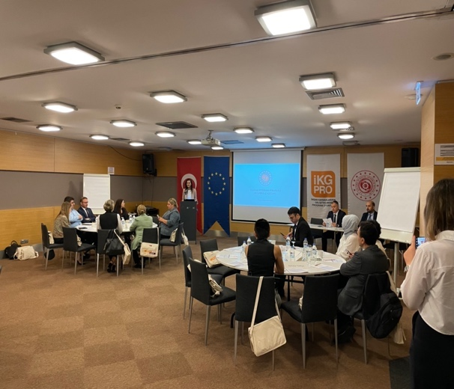
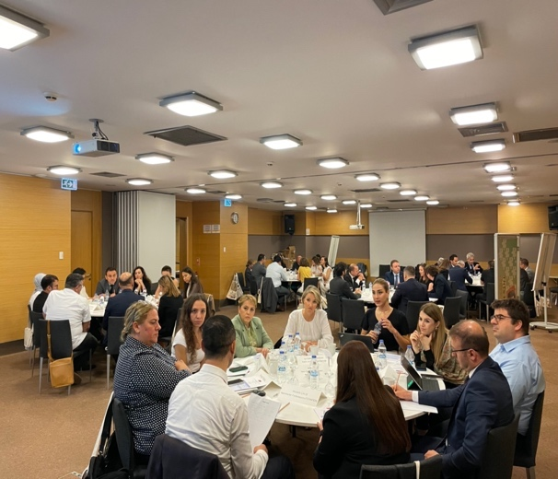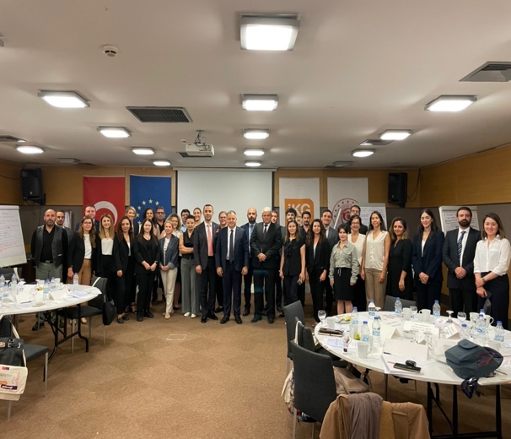

2.4. Visibility

The Project’s visibility materials were displayed:

- 2 roll-up banners were used as a backdrop for the registration table.
- 2 sets of banners (Turkish flag; HRDOS logo; MoLSS logo) were hung in the meeting area.
- Visibility kits were issued to all participants comprising: bag; notepad; pen; factsheet; folder; USB stick; mug.

Workshop STRUCTURE, content & Outcomes

Following introductory remarks, aimed at setting the agenda for discussions, the main part of the workshop involved participants working in 5 thematic working groups each moderated by MoLSS representatives, to discuss the 5 thematic topics over 2 sessions. In session 1, the groups focused on identifying problems and needs, and in session 2, they came up with policy/precautionary recommendations aimed at overcoming perceived problems and barriers.

The Outcomes of the 5 thematic working groups are as follows (shown in tabular form for ease of reference):

GROUP 1 - Raising a workforce suitable for green and digital transformation by considering the changing conditions in production & trade, and just transition measures.

PROBLEMS AND NEEDS | POLICY/PRECAUTIONARY RECOMMENDATIONS
Lack of awareness green and digital transformation (Especially SME s) | - Provision of awareness and training programmes for all levels of labour force (labour force, NGOs, chambers, employers, students, etc.)
Lack of funding for labour force adaptation during the transformation process | - Provision of financial support and grant mechanisms for vocational education  - Re-structuring of KOSGEB supports within the scope of green labour force  - Increasing funding from İŞKUR for employees for target trainings in the area of concerns  - Provision of employee social security premiums by government during the trainings  - Increasing the support of development agencies regarding green transformation and provision of a sustainable structure
Lack of legal obligation and infrastructure on the basis of labour force transformation | - Completion and utilisation of national emission trading system as soon as possible as a legal liability and provision of a user-friendly manual  - Provision of premium and taxation support for employers during the transformation process
Perception of low-level student quality and prestige of vocational education | - Modernising vocational high school infrastructures and systems and encouraging vocational education by providing incentives for students studying in vocational high schools  - Awareness & prestige raising activities for vocational training programmes, schools and students
Lack of data and know-how for policy development | - Provision and development of TUBİTAK supports  - Inter-institutional data sharing  - Provision of access to TUİK s sustainable development indicators

GROUP 2 - Developing inclusive employment at the workplace and economy scales.

PROBLEMS AND NEEDS | POLICY/PRECAUTIONARY RECOMMENDATIONS
Youth employment and NEET s | - Preparation of a comprehensive research for labour market needs and skills gaps  - Provision of vocational training programs for skill mismatches and mentoring support  - Provision of government supported internship programmes  - Provision of incentives for employers in youth employment  - Provision of a common standard in remuneration and benefits policies for İstanbul
Discrimination against disadvantaged groups (women, elderly, disabled, migrants, etc.) | - Redaction of bureaucratic obstacles by updating the relevant legislation  - Awareness raising activities for employers and employees  - Removal of information that may cause discrimination from the job application process  - Provision of a scorecard system for non-discriminative employers and provision of taxation and premium benefits
Unregistered employment of disadvantaged groups (women, elderly, disabled, migrants, etc.) | - Creation of a new model in unpaid family labour (especially in agriculture and household services) and enrichment according to needs over time.  - Provision of premium and taxation support for employers who are supporting registered employment and tax reduction for SMEs which are employing a certain number of registered employees  - Inter-institutional collection of inclusive data and sharing  - Provision of a legislative framework to include different forms of work within the scope of registered employment
Lack of inter-institutional coordination and cooperation | - Integration of related platforms (employment, internship, training, etc.) used by government institutions (MoLSS, SSI, İŞKUR, Presidency HR Office, etc.) and data sharing  - Inclusion of NGOs, local governments, chambers, etc. into coordination and cooperation mechanisms  - Routine and anonymous data sharing for public interest
Women with care obligations and the inadequacy of care services | - Increasing the number of the nursery schools (especially for 0-3 ages) and provision of accessible pricing options by government, local governments, etc.  - Provision of better services for elderly and disabled care services  - Provision of gender equality awareness raising activities (especially in care services)  - Harmonization of common practices in public and private sector  - Review of maternity & paternity leave and working hours.  - Awareness raising activities for women.  - Provision of a quota practice for women depending on the sectors.  - Harmonisation of working hours and school hours for families with children

GROUP 3 - Increasing employment in the region by strengthening the entrepreneurial ecosystem and creating new jobs.

PROBLEMS AND NEEDS | POLICY/PRECAUTIONARY RECOMMENDATIONS
Insufficient awareness of technopreneurship concept | - Provision of financial support (grants, credits, etc.) for technopreneurs  - Provision of training programmes (on the job, internship, etc.) for technopreneur candidates  - Public-private sector cooperation to create more suitable atmosphere for technopreneurs (İŞKUR, KOSGEB, etc.)  - Taxation incentives for Turkish “digital nomads” who are currently working abroad or working for abroad companies from Turkey  - Establishment of a special mediation mechanism for technopreneurs for dispute settlement  - Establishment of a common platform for technopreneurs
Insufficient number and lifespan of cooperatives and social enterprises | - Provision of a legislative framework to ease the establishment and functioning of cooperatives & social enterprises  - Provision of taxation benefits and establishment incentives  - Provision of a mapping & needs study for cooperatives and social enterprises in cooperation with public & private institutions to increase the efficiency of social and public purchases  - Provision of technology and business development mentorship for cooperatives and social enterprises
Economic fluctuations, unpredictability of costs and low level of sustainability | - Provision of incentives and benefits for entrepreneurs to minimise the risks.  - Ongoing training programmes and mentorship support for entrepreneurs  - Preparation of skill-focused labour market analyses and sharing the results with entrepreneurs in regular basis (public, private and NGO sectors)  - Re-structuring and transformation of the vocational education and apprenticeship system in line with entrepreneurship needs

GROUP 4 - Development of registered employment by considering new developing forms of work (platform economy, remote work, home services).

PROBLEMS AND NEEDS | POLICY/PRECAUTIONARY RECOMMENDATIONS
Uncertainty in the employment status of platform workers (pay-roll, freelance? etc.) | - Amendment of relevant legislations (labour law, social security law, etc.) in line with the emerging needs of new forms of work
Restrictive regulations on flexible working models in the labour law (on call working 4 hours max., part time working 30 days max., duration, disadvantaged, etc.) | - Provision of new policy developments considering the regional needs in line with the labour market
Lack of regulations encouraging flexible working (especially for SME s) | - Regular seminars, meetings and trainings to increase integration of immigrants into local culture.
Lack of flexible arrangements for special policy groups (women, young people, first-time employees, trainees, interns, etc.) | - Regulation of premium and tax regulations considering fair competition conditions for individuals
Incompatibility of social security and work permit systems with new forms of work | - Provision of incentives to widespread the new forms of work both for employers and employees

GROUP 5 - Strengthening the education-employment relationship at all levels to support transformation in sectors (automotive, energy, textile, buildings).

PROBLEMS AND NEEDS | POLICY/PRECAUTIONARY RECOMMENDATIONS
Weakness of sectors in determining their own needs (green and digital transformation) | - Provision of sector specific assessment and evaluation tools and instruments  - Provision of sector specific needs & competence profiles  - Provision of training programmes to fill in the qualification gaps
Weakness of academia and industry collaboration | - Development of academia, industry and R&D collaborations on the axis of green and digital transformation  - Development of sector specific road maps, conformity analysis and cooperation maps  - Inclusion of green and digital transformation topics into university curriculums
Lack of policies to eliminate the qualifications and skills gaps | - Organisation of continuous training programmes and provision of mentoring support to companies to improve the skills of the existing workforce for provision of new competencies, focusing on green and digital transformation. (İŞKUR, MoNE, LLL, etc.)
Insufficient awareness on the topics | - Promotion of best practises by social and mass media  - Inclusion of best practices to relevant legislations  - Provision of incentives for best practices
Insufficient women participation & employment in target sectors | - Directing women to the STEM field to benefit more from the women workforce & production in target sectors  - Promotion of best women STEAM practises with female students in primary and secondary schools  - Provision of special quota for women executives

CONCLUSIONS

As with previous workshops in this series, the İstanbul Workshop was a highly interactive event, reflecting a) stakeholders’ strong commitment to identifying and resolving local issues, and b) MoLSS’s consistent approach to creating a meaningful platform of ‘social dialogue in action’ in their policy deliberations. The working group structure - the second time this had been used in these workshops – greatly assisted debate, and many useful ideas were able to emerge.

The ideas generated in the İstanbul Workshop will be combined with those from previous workshops under Intervention 13 to produce a ‘synopsis of outcomes and recommendations’ before the end of the project.

ANNEXES

Annex 1: Desk Research Report
Annex 2: List of Participants

