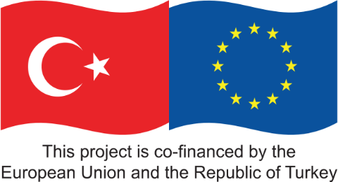



**TECHNICAL ASSISTANCE FOR PROMOTING  
DECENT FUTURE OF WORK APPROACH WITH  
A FOCUS ON GENDER EQUALITY  
  
(TREESP1.3. FoW/P-01)**

**TÜRKIYE**

**CATEGORY 3: SCIENTIFIC AND TECHNICAL STUDIES**

**Intervention 11: RECOMMENDATION REPORT ON IMPACT ASSESMENT**



Table of Contents

List of Abbreviations

Executive Summary

1. Introduction and Background on the study
2. Context
3. Impact of legislations on women’s participation in labour force and women’s employment
   1. International Legal Frameworks to Promote Gender Equality at Work
      1. Normative International instruments - ILO conventions and recommendations on gender equality at work
         1. Convention on the Elimination of all Forms of Discrimination against Women (CEDAW)
         2. ILO Declaration for the Future of Work
         3. ILO Declaration on Fundamental Principles and Rights at Work
         4. ILO Tripartite Declaration of Principles concerning Multinational Enterprises and Social Policy (MNE Declaration)
   2. Oher International initiatives
      1. The 2030 Agenda for Sustainable Development (SDGs)
      2. The Beijing Declaration and Platform for Action for Equality, Development and Peace (BDPfA)
      3. 61st Commission on the Status of Women
      4. UN Secretary-General’s High-Level Panel on Women’s Economic Empowerment
      5. UN Women’s Empowerment Principles (WEPs)
      6. The Equal Pay International Coalition (EPIC)
   3. G7 and EU policy frameworks
      1. G7 recommendations on gender equality at work
      2. European Union frameworks
         1. Main European legislation
         2. Progress in case-law of the European Court of Justice (ECJ)
         3. Latest developments
   4. Main Actions For Gender Equality In The World Of Work
      1. Achieving equal pay for work of equal value
         1. International Labour Standards and other key instruments
         2. Some examples of national legal framework in European countries (France and Spain)
         3. Laws and policies during the COVID related to equal pay for work of equal value
      2. Preventing and ending mobbing, gender-based violence and harassment in the world of work
         1. International Labour Standards and other key instruments
         2. Some examples of national legal framework in European countries (EU and Finland)
         3. Laws and policies during the COVID
      3. Promoting work – life balance and equal sharing of care responsibilities
         1. International Labour Standards and other key instruments
         2. Some examples of national legal framework in European (Germany and Norway)
         3. Laws and policies during the COVID related to promoting work – life balance and equal sharing of care responsibilities
   5. Supporting women´s equal participation in decision-making in the world of work
      1. International labour standards and other key instruments
      2. Some examples of national legal framework in European (France and Italy)
      3. Laws and policies during the COVID related to Supporting women´s equal participation in decision-making in the world of work
   6. Building a future of work that works for women
      1. International Labour Standards and other key instruments
      2. Some examples of national legal framework in European countries (Belgium and Denmark)
   7. Review of National Legislation in Türkiye in terms of Women Employment
   8. The Impact of Labour Law on Women Employment In Türkiye. A Brief Comparison Study.
      1. An Introduction to the Main Impacts of Laws and Policies on Female Labour Participation
      2. A Comparison of Türkiye with Other Countries
         1. A Brief Analysis of G20 Countries
      3. Some Indicators for Türkiye
         1. Analysis of Data Gender Employment in Türkiye during the Period 2015 – 2021
            1. Female Employment Rate (2015 – 2021)
            2. Gender Employment Gap (2015 – 2021)
      4. On Part-Time Work
      5. On Gender Pay (2015 – 2018)
      6. Educational Attainment and The Gender Wage Gap
      7. Perspectives on working life
      8. Self-Employed Women Workers
      9. Some Social indicators
      10. Information from ISKUR and Social Security Institutions
4. Methodology And Data Of The Field Study
   1. Steps for the Preparation of the Recommendation Report on Impact Assessment
   2. Qualitative Assessment by Stakeholders
   3. Results of the Pre-Study Workshop
5. Quantitative Information Derived From a Major Field Study
   1. Design of the Field Study
   2. Results of the Field Study
      1. Results from Employee Participants
         1. Demographic profile of Employee Participants
         2. Implementation of the Law and Level of Satisfaction
      2. Results from Employer Participants
         1. Demographic Profile of the Employers
         2. Implementation of the Law and Level of Satisfaction
6. Policy Recommendations And Suggestions To Enhance Relevant Regulations And To Draft New Policies
   1. Legislation that Promotes More Gender Equality and Avoids Enforcing the Stereotype that Women should have the Main Responsibility for Family Care
   2. Suggested Improvements in the Existing Labour Law
      1. Paid and Unpaid Maternity Leave
      2. Nursery Requirement for Workplaces
      3. Work after Maternity Leave
      4. Equal Pay
      5. Care Work Provisions
      6. Care Incentives for Persons not Covered by the Existing Law
      7. Government Support to the Employment of Victims of Domestic Violence
      8. Other Recommendations
   3. Summation of Recommendations
7. Conclusions

**List of Tables**

Table 1. Policy responses to the COVID-19 pandemic in support of workers with care responsibilities in G7 and selected EU countries

Table 2. Laws and Regulations in Turkiye

Table 3. Law Sources used for The Women Business and the Law Reports in Turkiye

Table 4. Comparative data on employment Türkiye from 2015 to 2021

Table 5. Part – Time work in Türkiye (2016 – 2020)

Table 6. Distribution of Employment by Gender and Age Group in Türkiye (%)

Table 7. Social Indicators in Türkiye (2008 – 2020)

Table 8. Number of Face-To-Face interviews conducted by sector in each of the provinces for the Field study

Table 9. Distribution of Respondents by Province (employees)

Table 10. The Demographic structure of Respondents

Table 11: Distribution of respondents per province (employers)

**List of Figures**

Figure 1. The state of the gender gap in the world

Figure 2. Actual versus expected decline in the gender gap in participation for G20 countries, 2012-2018

Figure 3. The gender gap in part-time work remains large in G20 countries, 2012-2017

Figure 4. Gender pay gaps remain substantial in G20 countries, 2006 and 2018

Figure 5. Türkiye - Scores for Women, Business and the Law 2022

Figure 6. Female Employment Rate Türkiye (2015 – 2021)

Figure 7. Employed Rate by gender Türkiye (%) (2015 - 2021)

Figure 8. Unemployment rate by gender Türkiye (%) (2015 - 2021)

Figure 9. Employment rate by educational level Türkiye (less than high school) (%) (2015 – 2021)

Figure 10. Employment rate by educational level Türkiye (high school) (%) (2015 – 2021)

Figure 11. Employment rate by educational level Türkiye (vocational high school) (%) (2015 – 2021)

Figure 12. Employment rate by educational level Türkiye (less than high school) (%) (2015 – 2021)

Figure 13. Employment by sector of activity - Agriculture Türkiye (% of men and women) (2015 – 2021)

Figure 14. Employment by sector of activity - Industry Türkiye (% of men and women) (2015 – 2021)

Figure 15. Employment by sector of activity - Construction Türkiye (% of men and women) (2015 – 2021)

Figure 16. Employment by sector of activity - Service Türkiye (% of men and women) (2015 – 2021)

Figure 17. Duration of working life in Türkiye, 2013-2019

Figure 18: Provisions of the Law that respondents get benefited (%)

Figure 19. Assessment on how Provisions in the Labour Law Facilitate Women´s Working Life in Practice (Question B3)

Figure 20: Assessment on how the Provisions in the Labour Law Facilitate Women’s Work Life in Practice (Question B4)

Figure 21. Measures taken at the Workplace to implement the Provisions of the Law (Question B5)

Figure 22: Assessment on the Efficiency of the Law by Participants

Figure 23: Suggestions by Participants to Improve the Law from a gender Perspective

Figure 24. Number of Employees at the Interviewed Enterprises, 2022 (%)

Figure 25. Distribution of Employees by Gender, 2022 (%)

Figure 26. Respondents’ Level of Knowledge about Preparation and Implementation of the Labour Law

Figure 27. The Provisions of the Law that Employees Benefited (%)

Figure 28. Assessment on How Provisions in the Labour Law Facilitate Women´s Working life in Practice

Figure 29. Assessment on Implementation on the Labour Law in Practice

Figure 30. Measures Taken by the Employers

Figure 31. Is there any Additional Cost Associated with the Measures for Women´s Employment and Figure 32. Cost Burden of the Measures for Women´s Employment (%)

Figure 33. Support in the Implementation of the Provisions of the Labour Law

Figure 34. Do women have Equal Wages, Career Opportunities and Vocational Training with Male Employees?

Figure 35 . Having a Mediation in a Labour Court Case regarding Rights Granted to Women Employees during the past Five Years

Figure 36. Suggestions to Improve Conditions for Female Employers

**List of Annexes**

Annex 1. Desk Research Report.

Annex 2. Questionnaire for Stakeholder Meetings.

Annex 3. Pre-Study Workshop Evaluation Report.

Annex 4. Semi-Structured Questionnaires for Field Study.

Annex 5. Post-Study Workshop Evaluation Report.

# LIST OF ABBREVIATIONS

|  |  |
| --- | --- |
| **Abbreviation** | **Meaning** |
| **BDPfA** | Beijing Declaration and Platform for Action |
| **CEDAW** | Convention on the Elimination of Discrimination against Women |
| **CJEU** | Court of Justice of the European Union |
| **COVID-19** | Corona virus disease 2019 |
| **CSA** | Civil Servants Act of 1965 |
| **DV** | Domestic violence |
| EA | Employment Act |
| EBMOs | Employer and business membership organisations |
| ECCE | Early childhood care and education |
| EC | European Commission |
| EIGE | European Institute for Gender Equality |
| EPIC | Equal Pay International Coalition |
| EU | European Union |
| EctHR | European Court of Human Rights |
| ECHR | European Convention of Human Rights |
| GAP III | EU’s new Action Plan on Gender Equality and Women’s Empowerment in External Action 2021–2025 |
| G7 | Group of seven |
| G20 | Group of twenty |
| GBVH | Gender-based violence and harassment |
| GDP | Gross domestic product |
| GEAC | Gender Equality Advisory Council |
| GRP | Gender-responsive procurement |
| HREIA | Human Rights and Equality Institutions Act. 2016 |
| ICESCR | International Covenant on Economic, Social and Cultural Rights |
| ICT | Information and communication technology |
| ILO | International Labour Organisation |
| ILO MNE | Declaration ILO Tripartite Declaration of Principles concerning Multinational Enterprises and Social Policy |
| IOE | International Organisation of Employers |
| IPU | Inter-Parliamentary Union |
| ISKUR | Turkish Employment Agency |
| ITUC | International Trade Union Confederation |
| IWPR | Institute for Women’s Policy Research |
| KAGIDER | Women Entrepreneurs Association of Türkiye |
| KOSGEB | Small and Medium Enterprises Development Organisation of Türkiye |
| MEA | Maritime Employment Act. 2005 |
| MSMEs | Micro, small and medium-sized enterprises |
| NGO | Non-governmental organisation |
| OA | Obligations Act- 2011 |
| OSH | Occupational safety and health |
| OECD | The Organisation for Economic Co-operation and Development |
| OSCE | Organisation for Security and Co-operation in Europe |
| PEA | Press Employment Act |
| PC | Penal Code - 2004 |
| SDGs | Sustainable Development Goals |
| SH | Sexual harassment |
| SMEs | Small and medium-sized enterprises |
| STEM | Science, technology, engineering, and mathematics |
| TUIK | Turkish Statistical Institute |
| Turkish WIN | Turkish Women's International Network |
| UDHR | Universal Declaration of Human Rights |
| UNGA | United Nations General Assembly |
| UN Guiding Principles | UN Guiding Principles on Business and Human Rights |
| UNHROHC | United Nations Human Rights Office of the High Commissioner |
| USD | United States dollar |
| W7 | Women 7 |
| WED | Women’s Entrepreneurship Development |
| WE EMPOWER-G7 | EU, UN Women and ILO project “Empowering women at work through responsible business conduct |

# **EXECUTIVE SUMMARY**

This Report was commissioned by the Department for Employment Policies under Ministry of Labour and Social Security to examine the effectiveness of current legislation in protecting workers’ (especially women’s) rights and in promoting greater participation of women in the Turkish labour force, with a view to making recommendations for adjustments in legislation where deemed necessary. The Report was produced by the project team working within the EU-funded project ‘Technical Assistance for Promoting Decent Future of Work Approach with a focus on Gender Equality’.

It is generally recognised that the coming decade will see many changes in the workplace in terms of how we work, where we work, and what we will be doing. The COVID-19 pandemic accelerated changes in the idea of where people could work, with a move towards home-based working seen by many as a way of achieving a better work/life balance, through the elimination of lengthy commuting requirements in larger cities. Robotisation, automation, AI and digitalisation have already impacted the world of work and changed the banking and retail sectors dramatically. This process of change will continue and expand and jobs will be affected. Commentators predict that by 2030, in Türkiye some 7.5m jobs will be lost as a result of these changes, but that almost 9m jobs will be created – by the very forces (robotisation, automation, etc.) which will have eliminated the conventional jobs.

Throughout this coming era of change, some things will remain constant. Women will continue to produce children, and women in work will continue to require periods of leave to care for their new families; they will continue to need access to childcare to enable then to return to work should they choose to do so; and they will need to have some degree of flexibility to take time away from work to care for sick children throughout their working lives. The Technical Assistance team (TAT) of the ‘Technical Assistance for Promoting Decent Future of Work Approach with a Focus on Gender Equality’ project was asked to examine the extent to which current Turkish legislation and practice was, in fact, providing the necessary basis for protecting women’s working rights, and, through a better understanding of the situation ‘on the ground’ and through a thorough examination of comparative legislation from other countries, to make recommendations, where necessary, to tighten up Turkish legislative framework.

To achieve this, TAT carried out a 6-stage study during the period April 2021 to August 2022:

* Conducting extensive desk research into international and Turkish legislation and approaches regarding women’s working rights;
* Holding a series of structured meetings with relevant stakeholder institutions in Türkiye;
* Delivering a Pre-Study Workshop during which 51 representatives of the public and third sectors were encouraged to formulate their views on how Turkish legislation and practice were working and whether changes were required;
* Undertaking a field study involving over 500 face-to-face interviews with employers and employees in 5 Turkish provinces (Adana, Ankara, Bursa, Istanbul and Izmir);
* Delivering a Post-Study Workshop during which 110 representatives of the public and third sectors provided feedback to draft Recommendations formulated from feedback in the preceding stages;
* Subjecting all feedback to a data analysis process.

The results of this assignment are summarised in this Report, the main outputs of which are a series of 18 recommendations for legislative and policy change divided into the following 10 thematic/sub-thematic areas, each containing a range of specific policy recommendations:

* Legislation that promotes more gender equality and avoids enforcing the stereotype that women should have the main responsibility for family care;
* Suggested improvements to the existing Labour Law:
  + Paid and Unpaid Maternity Leave;
  + Nursery Requirement for Workplaces;
  + Work after Maternity Leave;
  + Equal Pay;
  + Care Work Provisions;
  + Care Incentives for Persons not Covered by the Existing Law;
  + Government Support to the Employment of Victims of Domestic Violence;
* Other Recommendations.

Some of the recommendations in this Report are cross-referenced with recommendations/ideas which emerged from a parallel study TAT undertook into 5 selected sectors in Türkiye, for which a separate Executive Summary Report is available.

This Report is the result of a collaborative effort to which many stakeholders have contributed with their time, ideas and comments. This has been greatly appreciated by the project team, who have been very impressed by the depth of knowledge and commitment they have encountered during the assignment.

**FoW TAT**

**July 2022**

1. INTRODUCTION AND BACKGROUND OF THE STUDY

This Report has been produced by the EU-funded project ‘Technical Assistance for Promoting Decent Future of Work Approach with a Focus on Gender Equality’ (2021-2023). Its main goal is to identify the contribution of recent legislative arrangements to women's employment to support women's participation in the labour force. This study will help the policymakers to decide on the continuation of the policies implemented as well as identify the areas that need amendments in this field. The major questions to be addressed concerning the legal arrangement to support women’s employment are; maternity leave, paternity leave, part-time work, unpaid leave, registered/ unregistered employment, incentives for improving women’s employment etc.

The information included in this Report has been derived from:

* An extensive desk research into international and Turkish approaches;
* A series of structured meetings with institutions directly involved in implementation of the relevant articles of Labour Law to get an general overview about latest legal arrangements in this context;
* A Pre-Study Stakeholder Workshop at which 51 representatives of the public and third sectors formulated their views on how to improve women employment in Türkiye;
* Face-to-face interviews with women employees and employers in 5 provinces: Ankara, Adana, Bursa, İstanbul, and İzmir.

1. CONTEXT

The project’s Terms of Reference (ToR) set the following task for the Technical Assistance Team:

*“An impact assessment will be conducted concerning the latest legal arrangement for women employment such as maternity leave, paternity leave, part-time work, unpaid leave, registered/ unregistered employment, incentives for improving women employment, care facilities, remote working, etc.*

*The aim of the Impact Assessment is to identify the contribution of recent legislative arrangements to women's employment in order to support women's participation in the labour force and to determine the tendency to continue or change the policies implemented in this field.*

*A detailed desk study of Turkish legislations, laws, directives, etc. will be conducted in Ankara and the subject study will be compared with the EU and ILO legislation, data, strategies, etc.*

*In addition to desk study, interviews with public institutions and organisations in Ankara that implement the relevant articles of Labour Law will be done accordingly. Moreover, Face-to-face interviews will cover also women employees and employers in the sectors where regulations are most effective and least effective in Ankara, Adana, Bursa, İstanbul and İzmir.*

*The face-to-face interviews will be conducted with a total of 500 persons, approximately 100 persons for each province.*

*The Report will be prepared in cooperation with the relevant institutions, NGOs, professional organisations and social partners.*

*A recommendation report which will include analysis of finding of the research will be drafted in English with executive Turkish summary and it will be used to update relevant strategy plans and/or policies. The subject report will be officially disseminated by the Operation Beneficiary to relevant stakeholders such as relevant public institutions, NGOs, social partners-“*

1. IMPACT OF LEGISLATIONS ON WOMEN’S PARTICIPATION IN LABOUR FORCE AND WOMEN’S EMPLOYMENT
   1. International Legal Frameworks to Promote Gender Equality at Work

The resources available to governments seeking to promote gender equality in the world of work include normative instruments and international initiatives. Normative instruments derive their universal authority from the process by which they were developed. International labour standards and other ILO normative instruments are adopted by the International Labour Conference, which consists of delegates from the governments and the most representatives’ employers’ and workers’ organizations of each of the 187 Member States. Where the UN is concerned, the Convention on the Elimination of Discrimination against Women (CEDAW) is the most relevant international treaty that addresses gender equality. International initiatives and other policy frameworks, on the other hand, facilitate the implementation of international normative instruments and targets by creating opportunities for stakeholders to engage on specific topics.[1]

3.1.1. Normative International instruments - ILO conventions and recommendations on gender equality at work

Normative instruments set out the broad objectives of gender equality, identify obstacles which need to be overcome and advocate for a systemic approach to tackling gender discrimination. In the world of work, the principal instruments of this kind are ILO conventions and recommendations. Although addressed principally to governments, these conventions and recommendations are also useful in formulating corporate policies, and they are referenced in other normative instruments and initiatives, serving to standardize and coordinate approaches.

Between the ILO conventions and recommendations on gender equality at work, we can consider:

The Equal Remuneration Convention, 1951 (No. 100) and Recommendation No. 90; the Discrimination (Employment and Occupation) Convention, 1958 (No. 111) and Recommendation No. 111; the Workers with Family Responsibilities Convention, 1981, (No. 156) and Recommendation No. 165; the Maternity Protection Convention, 2000 (No. 183), and Recommendation No. 191; the Domestic Workers Convention, 2011 (No. 189) and Recommendation No. 201; and, more recently, the Violence and Harassment Convention, 2019 (No. 190) and Recommendation No. 206. The gender perspective is mainstreamed through many other ILO instruments on working time, part-time work, home-based work, social security, and occupational safety and health. [2] The content of the conventions is described in the various sections below. Türkiye has ratified most of the conventions (including the Fundamental, Governance and Technical Conventions), except the ones in red. [3]

* + - 1. Convention on the Elimination of all Forms of Discrimination against Women (CEDAW)

Adopted in 1979, the CEDAW is the most important human-rights treaty for women, adopted by 189 States parties. It lays out obligations to eliminate discrimination and achieve substantive equality. Importantly, CEDAW covers not only discriminatory laws, but also practices and customs, and it applies not only to government action, but also government responsibility for addressing discrimination against women by private actors.

The Convention covers both civil and political rights (rights to vote, to participate in public life, and to acquire, change or retain one’s nationality, equality before the law and freedom of movement) and economic, social, and cultural rights (rights to education, work, health, property, and financial credit).

3.1.1.3. ILO Declaration for the Future of Work

In June 2019, the International Labour Conference adopted the ILO Centenary Declaration for the Future of Work. The Declaration calls for the achievement of “gender equality at work through a transformative agenda, with regular evaluation of progress made, which:

* + ensures equal opportunities, equal participation, and equal treatment, including equal remuneration for people for work of equal value.
  + enables a more balanced sharing of family responsibilities.
  + provides scope for achieving better work–life balance by enabling workers and employers to agree on solutions, including on working time, which consider their respective needs and benefits; and
  + promotes investment in the care economy.”

3.1.1.4. ILO Declaration on Fundamental Principles and Rights at Work

Adopted in 1998, the Declaration on Fundamental Principles and Rights at Work commits Member States to respect and promote principles and rights in four categories, whether they have ratified the relevant Conventions. These categories are:

* freedom of association and the effective recognition of the right to collective bargaining.
* the elimination of forced or compulsory labour, and the abolition of child labour.
* equal remuneration of people for work of equal value.
* and the elimination of discrimination in respect of employment and occupation.

3.1.1.5. ILO Tripartite Declaration of Principles concerning Multinational Enterprises and Social Policy (MNE Declaration)

Adopted in 1977 and updated several times, most recently in 2017, it is the only global instrument in this area that has been elaborated and adopted by governments, employers, and workers around the world. The areas covered include employment, training, living, and working conditions, industrial relations, and general policies. All its principles build on international labour standards and, as such, include several recommendations that are directly or indirectly related to gender equality.

3.2. Oher International initiatives

3.2.1. The 2030 Agenda for Sustainable Development (SDGs)

The 2030 Agenda for Sustainable Development sets out goals (SDGs) for lifting generous portions of humanity out of poverty, while protecting human rights and the planet. Gender equality and women’s empowerment are integral to the achievement of all 17 Goals. The SDGs “seek to realize the human rights of all and to achieve gender equality and the empowerment of all women and girls.” Some SDGs are particularly relevant to achieving women’s economic empowerment and gender equality at work:

* SDG 3 on ensuring healthy lives and promoting wellbeing for all at all ages.
* SDG 4 on ensuring inclusive and equitable quality education and promoting lifelong learning opportunities for all.
* SDG 5 on achieving gender equality and empowering all women and girls.
* SDG 8 on promoting sustained, inclusive, and sustainable economic growth, full and productive employment, and decent work for all.
* SDG 10 on reducing inequalities within and among countries.
* SDG 17 on promoting justice and peace in implementing the SDGs.

3.2.2. The Beijing Declaration and Platform for Action for Equality, Development and Peace (BDPfA)

In 1995, the Fourth World Conference on Women adopted the BDPfA, a comprehensive and visionary international agenda for women’s empowerment. It reaffirms the fundamental principle whereby the human rights of women and girls’ children are an inalienable, integral, and indivisible part of universal human rights. As an agenda for action, the BDPfA seeks to promote and protect women’s full enjoyment of all human rights and fundamental freedoms throughout their lives.

3.2.3. 61st Commission on the Status of Women

The Commission on the Status of Women (CSW) was established as a functional commission of the UN Economic and Social Council (ECOSOC) in 1946. Representatives of UN Member States, UN entities, women’s rights organisations, gender experts and other interested organisations meet annually at the UN Headquarters in New York to discuss progress and the gaps in implementation of the BPfA and 2030 Agenda for Sustainable Development, including the SDGs. Session outcomes and recommendations are referred to ECOSOC for follow-up. The 61st CSW session (CSW 61) took place from 13 to 24 March 2017, with the priority theme of ‘Women’s economic empowerment in the changing world of work’. It will therefore be an important opportunity to further develop consensus on the critical actions needed to further progress on WEE. Agreed Conclusions will be developed, and a range of sessions focusing on sub-topics including gender pay gaps, technology and work, informal and nonstandard work, the care economy, and the economic empowerment of indigenous women will form part of the official agenda.

3.2.4. UN Secretary-General’s High-Level Panel on Women’s Economic Empowerment

In January 2016, the UN Secretary-General appointed a High-Level Panel on Women’s Economic Empowerment, aimed at galvanising progress on WEE under the broader 2030 Agenda and SDGs. Membership includes the heads of UN Women, World Bank, IMF, ILO and other private sector, academic, civil society leaders, and government leaders, including the Secretary of State for Education and Minister for Women and Equalities, United Kingdom. Following evidence collection and global consultation, the Panel published its first report in September 2016. The report identifies challenges to achieving WEE and presents an Agenda for Action. The Panel plans to launch a new series of briefings at CSW and be engaged in extensive outreach and advocacy with diverse groups, including governments and governance institutions, private sector, international organisations and until the Panel’s formal mandate ends in mid-2017.

3.2.5. UN Women’s Empowerment Principles (WEPs)

The Women's Empowerment Principles, launched in 2010, are the result of a collaboration between the United Nations Entity for Gender Equality and the Empowerment of Women (UN Women) and the United Nations Global Compact. These are adapted from the Calvert Women's Principles which provide guidance on how to empower women in the workplace, marketplace, and community by emphasising the business case for the promotion of gender equality by corporate actors.

The WEPs are: Treat all women and men fairly at work - respect and support human rights and non-discrimination; Ensure the health, safety and well-being of all women and men workers; Promote education, training, and professional development for women; Implement enterprise development, supply chain and marketing practices that empower women; Promote equality through community initiatives and advocacy and Measure and publicly report on progress to achieve gender equality.

3.2.6. The Equal Pay International Coalition (EPIC)

The Equal Pay International Coalition (EPIC) is an initiative driven by stakeholders committed to reducing the gender pay gap and making equal pay for work of equal value a reality across all countries and sectors. Led by the ILO, UN Women and the Organisation for Economic Cooperation and Development (OECD), the Coalition engages with governments, employers, workers and their organisations, the private sector, civil society, and academia to accelerate the closing of the gender pay gap and the achievement of pay equity.

* 1. G7 and EU policy frameworks

The G7 and the EU have both fostered ongoing dialogue, often tripartite, adopted policy frameworks and issued calls to action to accelerate progress towards gender equality in the world of work.

* + 1. G7 recommendations on gender equality at work

Combining international standards and goals with social and economic dialogue, the Group of 7 (G7) emphasises the connection between gender equality and increased prosperity. At Taormina in 2017, the G7, along with Women 7 (W7), put forward a series of recommendations for different parties – effectively action plans for full recognition of the beneficial effects of women’s activity in the workplace – drawing attention to the negative effects of unpaid care work, violence, stereotyping and the lack of women’s representation in leadership on gender equality at work.

The G7 Social Communiqué of June 2019 called for a tripartite approach (engaging governments and employers’ and workers’ organizations) to identifying market barriers that cause gender-based labour segregation; increasing women’s representation on boards, in management and in entrepreneurship; investing in skills development and education in all fields (especially science, technology, engineering and mathematics – STEM); formulating a gender-balanced care system; and closing gender gaps in employment, pay (especially after leave) and workplace participation.

* + 1. European Union frameworks

Gender equality is one of the core values of EU legal frameworks, embedded in the Treaties, the Charter of Fundamental Rights of the European Union, and the European Pillar of Social Rights. There is extensive EU legislation related to gender equality, particularly in the workplace, touching on issues such as maternity and parental leave; equal opportunities and equal treatment of people in employment and occupation, including equal pay, social security, working conditions and harassment; and equal opportunities for workers in self-employment, including access to maternity leave benefits.

3.3.2.1. Main European legislation

EU legislation, mostly adopted by the ordinary legislative procedure, includes:

— Directive 79/7/EEC of 19 December 1978 obliging Member States to progressively implement the principle of equal treatment for people in matters of social security.

— Directive 92/85/EEC of 19 October 1992 introducing measures to improve the safety and health at work of pregnant workers and workers who have recently given birth or are breastfeeding.

— Directive 2004/113/EC of 13 December 2004 implementing the principle of equal treatment between women and men in the access to and supply of goods and services.

— Council Directive 2010/18/EU of 8 March 2010 implementing the revised Framework Agreement on parental leave concluded by BUSINESSEUROPE, UEAPME, CEEP and ETUC and repealing Directive 96/34/EC.

— Directive 2010/41/EC of 7 July 2010 laying down objectives for the application of the principle of equal treatment between men and women engaged in an activity, including agriculture, in a self-employed capacity, and on the protection of self-employed women during pregnancy and motherhood, and repealing Council Directive 86/613/EEC.

— Directive 2011/36/EU of 5 April 2011 on preventing and combating trafficking in human beings and protecting its victims. This directive replaces Council Framework Decision 2002/629/JHA and provides for the approximation of sanctions for trafficking in human beings across Member States and of support measures for victims, and calls upon the Member States to ‘consider taking measures to establish as a criminal offence the use of services which are the objects of exploitation […] with the knowledge that the person is a victim [of trafficking]’ in order to discourage demand; it also establishes the office of the European anti-trafficking coordinator; the Committee on Women’s Rights and Gender Equality (FEMM) will prepare an implementation report on the directive later in 2015;

— Directive 2011/99/EU of 13 December 2011 establishing the European Protection Order with the aim of protecting a person ‘against a criminal act by another person which may endanger his/her life, physical or psychological integrity, dignity, personal liberty or sexual integrity’ and enabling a competent authority in another Member State to continue the protection of the person in the territory of that other Member State; this directive is reinforced by Regulation (EU) No 606/2013 of 12 June 2013 on mutual recognition of protection measures in civil matters, which ensures that civil protection measures are recognised all over the EU;

— Directive 2012/29/EU of 25 October 2012 establishing minimum standards on the rights, support, and protection of victims of crime, and replacing Council Framework Decision 2001/220/JHA.

3.3.2.2. Progress in case-law of the European Court of Justice (ECJ*)*

The ECJ has played a significant role in promoting equality between men and women. The most notable judgments have been:

— Defrenne II judgment of 8 April 1976 (Case 43/75): the Court recognised the direct effect of the principle of equal pay for people and ruled that the principle not only applied to the action of public authorities but also extended to all agreements which are intended to regulate paid labour collectively

— Bilka judgment of 13 May 1986 (Case 170/84): the Court ruled that a measure excluding part-time employees from an occupational pension scheme constituted ‘indirect discrimination’ and was therefore contrary to former Article 119 if it affected a far greater number of women than men, unless it could be shown that the exclusion was based on objectively justified factors unrelated to any discrimination on grounds of sex

— Barber judgment of 17 May 1990 (Case 262/88): the Court decided that all forms of occupational pension constituted pay for the purposes of Article 119 and the principle of equal treatment therefore applied to them. The Court ruled that men should be able to exercise their pension rights or survivor’s pension rights at the same age as their female colleagues

— Marschall judgment of 11 November 1997 (Case C-409/95): the Court declared that a national rule which, in a case where there were fewer women than men in a sector, required that priority be given to the promotion of female candidates (‘positive discrimination’) was not precluded by Community legislation, provided that the advantage was not automatic and that male applicants were guaranteed consideration and not excluded a priori from applying;

— Test Achats judgment of 1 March 2011 (Case C-236/09): the Court declared the invalidity of Article 5(2) of Directive 2004/113/EC as being contrary to the principle of equal treatment between men and women in the access to and supply of goods and services. Consequently, for people, the same system of actuarial calculation must be applied to determine premiums and benefits for the purposes of insurance.

3.3.2.3. Latest developments

Below is an overview of the most recent action taken by the EU in the field of equality between men and women:

* The multiannual financial framework (MFF 2014-2020) and the Rights, Equality and Citizenship programme. The programme Rights, Equality and Citizenship finances projects aimed at achieving gender equality and ending violence against women (Article 4).
* The European Institute for Gender Equality (EIGE) In December 2006, the European Parliament and the Council established a European Institute for Gender Equality, based in Vilnius, Lithuania, with the overall objective of contributing to and boosting the promotion of gender equality, including gender mainstreaming in all EU and national policies. It also combats discrimination based on sex and raises awareness on gender equality by providing technical assistance to the European institutions through collecting, analysing, and disseminating data and methodological tools.
* The Women’s Charter and the Strategic engagement for gender equality 2016-2019. On 5 March 2010, the Commission adopted the Women’s Charter with a view to improving the promotion of equality between women and men in Europe and throughout the world.
* Based on the Commission and the European External Action Service (EEAS) Joint Staff Working Document on ‘Gender Equality and Women’s Empowerment: Transforming the Lives of Girls and Women through EU External Relations 2016-2020’ [8]. The new Gender Action Plan stresses ‘the need for the full realisation of women’s and girls’ full and equal enjoyment of all human rights and fundamental freedoms and the achievement of gender equality and the empowerment of women and girls.
* In the area of equal treatment on the labour market, Parliament acts on the basis of the ordinary legislative procedure (co-decision), for example in June 2019, the European Parliament adopted a Directive on work–life balance for parents and carers, which sets out the conditions for paternity, parental and carers’ leave, and extends current provisions on flexible working arrangements to workers with young children and other carers.
* The European Commission (EC) has made bold commitments and ambitious plans to promote equality between women and men, as well as mainstreaming the gender perspective throughout all policy spheres. Its Gender Equality Strategy 2020-25 focuses on ending gender-based violence; challenging gender stereotypes; closing gender gaps in the labour market; achieving equal participation across different sectors of the economy; addressing the gender pay and pension gaps; closing the gender care gap; and achieving gender balance in decision-making and politics. As one of the first deliverables of the Strategy, the EC has prioritized mandatory pay transparency measures.
* In November 2020, the European Commission and the High Representative of the Union for Foreign Affairs and Security Policy put forward the EU’s new Action Plan on Gender Equality and Women’s Empowerment in External Action 2021–2025 (GAP III). The plan aims to promote gender equality and women’s empowerment through all external action of the EU. The Gender Action Plan III provides the EU with a policy framework with five pillars of action for accelerating progress towards meeting international commitments and creating a world in which everyone has space to thrive. It makes the promotion of gender equality a priority of all external policies and actions; offers a roadmap for working together with stakeholders at national, regional, and multilateral levels; steps up action in strategic thematic areas; calls for EU institutions to lead by example; and ensures the transparency of the results.

* 1. MAIN ACTIONS FOR GENDER EQUALITY IN THE WORLD OF WORK**[4]**

International instruments and frameworks, together with national laws, are crucial to the realisation of gender equality at work and women’s economic empowerment.

3.4.1. Achieving equal pay for work of equal value

Achieving gender equality and the economic empowerment of women at work will not be possible without ensuring that the work done by people is valued equally.

The overall gender gap performance[5] is a synthesis of performances across the four dimensions composing the index—the Economic Participation, Educational Attainment, Health and Survival and Political Empowerment sub-indexes. As such it masks significant differences in gender gaps across dimensions. Overall, this year’s positive result has been driven by a progress on the *Political Empowerment* sub-index, as well as by marginal improvements on the Health and Survival and Educational Attainment sub-indexes. Conversely, *the progress towards gender parity in terms of Economic Participation and Opportunity registers a retraction*. As shown in Figure 1, global gender gaps vary significantly across these four dimensions. In two sub-indexes—Educational Attainment and Health and Survival—96.1% and 95.7% of the gap (respectively) have already been closed so far. By contrast, *differences between women and men remain significantly larger on Political Empowerment*, where only 24.7% of the gap has been closed to date, and *on Economic Participation and Opportunity,* where 58.8% of the gap has been closed. In order of gender gap size, Political Empowerment is the area where women are severely under-represented. Despite a significant improvement from the last edition (see section below for more details), so far only 25% of the gap has been closed on this sub-index, and no country has fully closed this gap yet.

**Figure 1. The state of the gender gap in the world**

Source: World Economic Forum, 2020

Gender-pay continues been influenced by distinct factors as occupational segregation (including gender imbalances in leadership positions, or vertical segregation), the undervaluation of feminized industries, the “motherhood penalty” versus the “fatherhood premium” (which refers to the differential impact of having children on women and men’s wages), and differences in wage employment participation. Discrimination, as well as conscious and unconscious biases about the role of women in society, can begin to be rectified through education, communication, and appropriate legislation and public policy that permeates into the private sector.

The undervaluation of paid care work also plays a significant role in the perpetuation of gender pay gaps. Women make up two-thirds of the workforce in the global care industry, in which other groups at risk of discrimination are also disproportionately represented.

Closing the gender pay gap has important economic and social benefits, including “increased female participation in the labour market, entrepreneurship and women moving into higher- paid and higher-skilled jobs.” [6] Equal pay for work of equal value also has positive inter- generational effects, given the importance of women’s incomes in supporting households’ wellbeing.

3.4.1.1. International Labour Standards and other key instruments

3.4.1.1.1.ILO Equal Remuneration Convention, 1951 (No. 100). The right to equal remuneration applies not only in cases where people do the same or similar jobs, but also when they perform work which, though different, is of equal value based on objective criteria, such as skills, working conditions, responsibilities, and effort. As per the Convention, remuneration is not limited to the basic pay or wage that the worker receives, but also includes any other compensation, such as bonuses, stock options and overtime pay.

3.4.1.1.2. The Discrimination (Employment and Occupation) Convention, 1958 (No. 111) and its accompanying Recommendation No. 111, also set forth principles of equality of opportunity and treatment in the world of work, including in relation to remuneration for work of equal value.

3.4.1.1.3. Equal pay is recognized as a human right in such international instruments as the International Covenant on Economic, Social and Cultural Rights (ICESCR), 1966, and the CEDAW, 1979. Equal pay is also a key component of the 2030 Agenda as a key feature of SDG 8, particularly Target 8.5, which aims “by 2030, [to] achieve full and productive employment and decent work for all women and men, including for young people and persons with disabilities, and equal pay for work of equal value”.

3.4.1.1.4. The principle of equal pay for the same work or work of equal value is a foundational principle of the EU and was laid down in the original EEC Treaty of 1957. The principle was implemented in the Equal Pay Directive 75/117/EEC, later replaced by Directive 2006/54/EC (recast). Additionally, legal standards in respect of equal pay have been established by case law of the Court of Justice of the European Union (CJEU).

According to ILO, the main guiding principles for governments in this issue are:

* a comprehensive and effective legislative approach, by fostering an inclusive and transparent labour market and creating “a driving force for gender equality standards”
* ensuring equal opportunity and treatment at work for all
* establishing and applying the right to “equal pay for work of equal value”
* promoting social dialogue and collective bargaining
* establishing and implementing wage transparency
* setting adequate and inclusive minimum wages.

3.4.1.2. Some examples of national legal framework in European countries**[7]** (France and Spain)

**Pay transparency and collective bargaining on equal-pay laws (France)**

French law requires companies with fifty employees or more to report annually on their performance in respect of gender equality and equal pay, as applied to recruitment, training, working conditions, and work–family balance, by job category. In 2018, France adopted a new labour law requiring companies to publicize their progress on women’s economic empowerment in five key areas: closing the gender wage gap; opportunities for raises; opportunities for promotion; no penalties when returning from parental leave; and women occupying 40 per cent of the ten highest-paid positions in the company. The French Government set deadlines for the publication of these results by large enterprises (more than 250 employees) and by SMEs (50-250 employees). Financial penalties (up to 1 per cent of the wage bill) can be imposed if a company refuses to report its score or if a company’s score is still below 75 out of 100 by March 2022 (or 2023 for SMEs).

Additionally, in 2006 France passed legislation, amended in 2010, that requires collective bargaining with the aim of defining and planning steps to eliminate the gender pay gap. This compulsory collective bargaining takes place every year during salary negotiations, or less often if an agreement is in place, and the employer must provide a report on gender equality for consideration. While a collective agreement on the issue does not have to be reached, the negotiations must be conducted seriously and in good faith. Failure to do so can result in sanctions imposed by the Higher Council for Professional Equality.

An analysis by the European Commission’s network of legal experts on gender equality and pay transparency legislation in the EU highlighted France’s pay reporting and pay equity collective bargaining obligations as an example of “best practice.”

**Improving pay transparency and working conditions (Spain)[8]**

Spain revised its Workers Statute Law in 2011 to include domestic workers. This law regulates key aspects of decent work, such as establishing a minimum wage and maximum weekly working hours. Domestic workers, under the revised Spanish law, are also now eligible for social security coverage, health care benefits, parental leave, and contractual benefits.

To increase compliance, the Labour and Social Security Inspectorate enforces the law and investigates grievances. Employers receive a government incentive for complying with this labour legislation, while the General Treasury of the Social Security Scheme has been tasked with disseminating information concerning the law. The Law also calls for impact analyses on a tripartite basis.

In addition, in October 2020 the Spanish Government enacted a new pay transparency law. It requires companies to release employee salary information, explaining how they decide on basic salaries and other benefits. Non-compliant companies may face fines of up to €187,000 (USD220,000). Companies with more than fifty employees will also have to file a four- year strategy for balancing the number of male and female employees in their workforce. For the Government, tackling the gender pay gap will be crucial to economic recovery and will help prevent the gap from widening because of the COVID-19 pandemic.

3.4.1.3. Laws and Policies during COVID related to equal pay

The COVID-19 pandemic is worsening the social and economic situation of women, and threatening the recent progress made in reducing the gender pay gap in some countries. In 2021, 435 million women and girls around the world will be living in extreme poverty (on less than USD1.90 a day), including forty-seven million impoverished because of the COVID-19 pandemic.[9]

Governments are taking action to support workers and families during the pandemic, including some of these crisis-response measures to support women’s jobs and income:

• Austria, Belgium, Denmark, France, Germany, Ireland, Italy, Spain, the United Kingdom, and the United States (26 states) are among those that have introduced new allowances or expanded access to pre-existing schemes, to compensate for the reduction in working hours in companies affected by the pandemic.

• In Australia, 6.5 million lower-income workers with benefit entitlements received a one-off lump-sum payment of AUD 750.66 Ireland made provisions for a new social welfare payment programme to support employees and self-employed people facing unemployment due to the COVID-19 emergency.

• In France and Italy, self-employed workers benefited from a tax-free lump-sum payment of

€1,500 and €600, respectively. In the United Kingdom, the allowance for low-income self-employed workers covers 80 per cent of their average monthly earnings (up to £2,500).

• In France, a temporary lump-sum payment of €500 was paid directly by the public employment service to workers who lost their jobs but were not eligible for unemployment insurance. Financial aid was also provided to 800,000 low-income young people under the age of twenty-five experiencing unemployment and financial hardship during the pandemic.

• In France, healthcare staff in the departments most affected by the COVID-19 epidemic received a tax-free bonus payment of €1,500 and an increased overtime payment.

• Most European Union countries and the United States have introduced measures to support companies, including the extension of deadlines for income tax declarations, suspension of social insurance contributions, and the granting of interest- and collateral-free loans. [10]

3.4.2. Preventing and ending mobbing, gender-based violence and harassment in the world of work

Many Reports have been written on the prevalence of mobbing or other types of violence in work. According to ILO, UN Women and other international organisations, ***Gender-based violence and harassment (GBVH), including sexual harassment***, is incompatible with decent work yet remains pervasive around the world, irrespective of sector or level of income. Globally, more than 30 per cent of women over the age of fifteen have experienced physical and/or sexual violence, 50 per cent have experienced sexual harassment, and 10 per cent have experienced harassment online (cyber harassment).[11]

The occurrence of mobbing or any kind of violence, entails excessive financial and psychological costs for victims, companies, and the national economy. Those experiencing mobbing, violence and harassment at work can suffer harm to their psychological, physical, and sexual health, including physical injuries, anxiety, depression, stress, and other lasting impacts of trauma, including harm to their dignity and to their family and social environment.

Mobbing or violence negatively impacts women’s economic empowerment. Women are more likely to leave the workplace or change jobs, resulting in financial stress.

3.4.2.1. International Labour Standards and other key instruments

3.4.2.1.1. The ILO Violence and Harassment Convention, 2019 (No. 190) and its accompanying Recommendation No. 206 recognize the right of everyone to a world of work free from violence and harassment, including gender-based violence and harassment. The Convention calls on governments to promote a general environment of zero tolerance to violence[12] and harassment and provides a clear framework for addressing and preventing violence and harassment in the world of work.

3.4.2.1.2. In interpreting the Convention on the Elimination of All Forms of Discrimination (CEDAW), the CEDAW Committee considers workplace sexual harassment as a form of gender-based violence that can reduce gender equality in the workplace and result in health and safety issues. Based on ILO Convention No. 111, relevant comments developed by the ILO Committee of Experts on the Application of ILO Conventions and Recommendations consider sexual harassment as a severe form of sex discrimination.

3.4.2.1.3. The EU provides some of the most comprehensive and enforceable regional regulations on workplace violence and harassment. The European Social Charter (Revised), 1996, the Convention on preventing and combating violence against women and domestic violence (known as the Istanbul Convention), 2011, and several EU Directives also seek to prevent and prohibit various forms of violence and harassment. As Europe’s leading human rights organisation, the Council of Europe has undertaken a series of initiatives to promote the protection of women against violence since the 1990s. These initiatives have resulted in the adoption, in 2002, of the Council of Europe Recommendation Rec (2002) of the Committee of Ministers to member states on the protection of women against violence, and the running of a Europe-wide campaign, from 2006-2008, to combat violence against women, including domestic violence. The Parliamentary Assembly has also taken a firm political stance against all forms of violence against women. It has adopted a number of resolutions and recommendations calling for legally binding standards on preventing, protecting against, and prosecuting the most severe and widespread forms of gender-based violence.

Assuming its leading role in human rights protection, the Council of Europe decided it was necessary to set comprehensive standards to prevent and combat violence against women and domestic violence. In December 2008, the Committee of Ministers set up an expert group mandated to prepare a draft convention in this field. Over the course of just over two years, this group, called the CAHVIO (Ad Hoc Committee for preventing and combating violence against women and domestic violence), worked out a draft text. It finalised the draft of the Convention in December 2010.

The Convention on preventing and combating violence against women and domestic violence was adopted by the Council of Europe Committee of Ministers on 7 April 2011. It was opened for signature on 11 May 2011 on the 121st Session of the Committee of Ministers in Istanbul. Following its 10th ratification by Andorra on 22 April 2014, it entered into force on 1 August 2014. The four pillars of Istanbul Convention are: prevention, protection, prosecution, and co-ordinated policies. [13]

3.4.2.2. Some examples of national legal framework in European countries (EU and Finland)

National legal frameworks must recognize the right of workers to an environment that is free from violence and harassment. In adopting an inclusive, integrated and gender- responsive approach to this topic, ILO standards encourage governments to prevent and address violence and harassment in the areas of labour and employment, occupational safety and health, equality, and non-discrimination law – and, where appropriate, criminal law – to give victims a range of remedies best suited for their situation.

Legal frameworks should also provide a broad scope of protection from violence and harassment in the world of work. Legal protection should therefore extend beyond the traditional employment relationship and encompass hiring, training, access to employment, conditions of employment and third parties with whom workers may come into contact.

In line with Convention No. 190, coverage should include “all sectors, public or private, in the formal or informal economy, in urban or rural areas” and “workers and other persons in the world of work, including employees as defined by national law and practice, as well as persons who work, whatever their contractual status, persons in training, including trainees and apprentices, laid-off workers, volunteers, job seekers, job applicants and individuals exercising the authority, duties or responsibilities of an employer”.

Finally, it is necessary to address violence and harassment in the full range of places where it may occur “on occasion, in connection with or as a result of work,” in addition to the traditional physical workplace. This includes work-related travel, social events and training activities, commuting to and from work, and work-related communications (including email, texting, and online platforms) in private homes when they are places of work.

**European Union**

In its objective to combat GBVH, the European Commission (EC) has been working on a pilot project launched by Eurostat to measure the prevalence of violence against women in the EU. The initiative is developing an EU-wide survey built on the methodology used for the EU Agency for Fundamental Rights’ 2014 survey, which included information on whether violence occurred in the workplace. The project is being conducted in cooperation with over a dozen countries, which will pilot the instrument. The survey task force includes national statistical institutes, the European Union Agency for Fundamental Rights (FRA), EIGE, Eurostat, and the EC, which will be finalizing the survey and implementing full-scale fieldwork in late 2019.[14]

**Guidance and assistance through OSH policies and awareness-raising (Finland)[15]**

Finland has ratified the Occupational Safety and Health Convention, 1981 (No. 155) and has implemented a national OSH policy, which includes training, the adaptation of work to the physical and mental capacities of workers, and protection from reprisals against complainants. The implementation of these provisions has included protective and compensation measures in respect of third-party violence, night work and work in isolated areas.

In Finland, labour inspections cover violence and harassment in the world of work as part of their remit, in line with Recommendation No. 206 (Paragraph 21). Labour inspectors submit a questionnaire to workers before they visit a company, asking whether their health and safety is endangered by violence or the threat of violence at work. The answers to this questionnaire help the inspectors to focus their visit and enable them to offer the employer guidance on ways to address workplace issues.

The Ministry of Justice has also launched a “Discrimination-free zone” campaign as part of its “Equality is Priority” project. It brings together over six hundred workplace communities in the fight against discrimination, bullying, and harassment. The programme gives participating communities a “discrimination-free zone” sign to display in their workplace, once they have completed an online form providing information on combating discrimination, including harassment. By completing the online form and displaying the sign, employers declare their workplaces to be “discrimination-free zones.”

3.4.2.3 Laws and Policies during COVID related to preventing and ending mobbing, gender-based violence and harassment in the world of work

The COVID-19 pandemic has amplified existing gender-based violence against women, confirming long-standing research findings that the risk of domestic violence tends to increase in times of crisis. Lockdown measures were set to keep people safe at home. However, home turned out not to be safe for everyone and lockdown measures played a demonstrable role in the significant increase in reports of domestic violence and an increase in gender-based violence overall. While the collection of robust EU-level data is ongoing, preliminary findings from an assortment of independently carried-out studies point towards an escalation of psychological and physical violence against women by an intimate partner.[16]

To prevent further escalation or long-term consequences, action is needed to end gender-based violence against women and girls. Ensuring that victims can access adequate support at this time of crisis, including in rural areas, should be one of the priorities. In April 2020, the Commission urged Member States to guarantee that their emergency responses to the outbreak took account of the needs of groups in disadvantaged situations, such as victims of domestic violence, in line with their obligations under EU law. The Commission also stressed the importance to allocate resources to relevant support and protection services, helplines, and shelters.

* + 1. Promoting work – life balance and equal sharing of care responsibilities

Achieving a healthy work–life balance, given women’s disproportionate share of care responsibilities, is associated with promoting and sustaining gender equality and women’s economic empowerment. [17]

Across the world, without exception, women do most of the unpaid care work: on average 76.2 per cent of the total number of hours devoted to such tasks. In no country in the world do people perform equal shares of unpaid care work.

Before the COVID-19 crisis, unpaid care work was a serious barrier to women’s labour force participation and one of the main obstacles to women moving into better-quality jobs. The pandemic is aggravating the penalties that women are facing in the labour force, as well as increasing decent work deficits and discrimination. Furthermore, when gender intersects with other personal characteristics, such as ethnicity, nationality, age, disability, migration or health status, there is a risk that inequalities among distinct groups of women will also increase.

3.4.3.1 International Labour Standards and other key instruments

* Maternity protection is enshrined in fundamental human rights treaties, including the 1948 Universal Declaration of Human Rights (UDHR), the International Covenant on Economic, Social and Cultural Rights (ICESCR), 1966, and the Convention for the Elimination of All Forms of Discrimination against Women (CEDAW), 1979.
* Several international labour standards adopted by the ILO constituents touch on crucial elements that contribute to the achievement of a healthy work–family balance. The ILO’s first maternity protection convention, the Maternity Convention, 1919 (No. 3), was adopted soon after the organization’s founding in 1919, which is indicative of its centrality in advancing social justice. The more recent Maternity Protection Convention, 2000 (No. 183) aims to preserve the health of the mother and the new-born child, to provide economic and job security – including protection from dismissal and discrimination, maintenance of earnings and benefits during maternity, including breastfeeding, and the right to resume work after giving birth – and therefore to promote equal opportunities in employment and occupation for women. The Social Security (Minimum Standards) Convention, 1952 (No. 102) and the Social Protection Floors Recommendation, 2012 (No. 202) also aim to ensure income security related to maternity.10 Furthermore, the ILO Transition from the Informal to the Formal Economy Recommendation, 2015 (No. 204) recommends that maternity protection and affordable quality care services be extended to workers in the informal economy, as a means of “[promoting] gender equality in entrepreneurship and employment opportunities and [enabling] the transition to the formal economy”.
* The ILO Workers with Family Responsibilities Convention, 1981 (No. 156) and related Recommendation No. 165 set out a number of rights and measures, including additional family leave, childcare and family services, and social security and working conditions provisions, to enable workers to reconcile their work and family life. These standards recognize the need to counter the stereotype that women are responsible for caring and to encourage the sharing of caring responsibilities between women and men, to the benefit of the health, equality, and job quality of all.
* Several EU Directives have defined and advanced a common floor of maternity protection and family responsibility provisions. These include, for instance, the Pregnant Workers Directive 1992, the Gender Equality Recast Directive 2006, and the Equal Treatment Directive 2010, which extended maternity protection rights to the self-employed. More recently, the Work–Life Balance Directive 2019 promotes work–life balance for working parents and other carers. It introduces paid paternity (10 days) and parental leave for all workers, with earmarked periods for each of the parents, carers’ leave, the right of workers with care responsibilities to request flexible working arrangements, and freedom from discrimination for carers taking advantage of these provisions.
  + 1. Some examples of national legal framework in European (Germany and Norway)

As care policies are crucial in ensuring that all people can realize their full economic and social potential, they need to be transformative, gender-responsive and human-rights based and be the primary responsibility of the State. The following are some of the measures that governments can adopt according to ILO:

* + Providing universal maternity protection and inclusive leave policies
  + Expanding quality care services
  + Guaranteeing gender-responsive social protection
  + Providing family-friendly working arrangements
  + Facilitating work attachment and reintegration

Between these measures, we consider particularly two: basic principles of care-sensitive and gender-transformative leave schemes and the facilitation of work attachment and reintegration.

Regarding the *basic principles of care-sensitive and gender-transformative leave schemes*, it is important to consider:

• Ensure mothers are granted at least 14 weeks of leave paid at a rate of at least two-thirds of previous earnings according to Convention No. 183, or up to 18 weeks at one hundred per cent according to Recommendation No. 191.

• Ensure that fathers have access to compulsory paid parental leave for a meaningful period.

• Ensure that a sizeable amount of parental leave is reserved for the father and cannot be transferred to the mother.

• Ensure that other forms of leave, such as adoption leave or leave to care for disabled or sick children, adult, or older family members, are granted.

• Ensure that periods of leave are paid and that benefits correspond at least to two-thirds of previous earnings.

• Ensure that cash and medical benefits during leave are financed through collectively financed mechanisms, such as compulsory social insurance or public funds, and avoid direct costs for employers (“employer liability”).

• Ensure employment protection during leave and guarantee the right to return to the same or an equivalent position.

• Ensure that time spent on leave is credited for social insurance contributions and pension entitlements.

• Ensure universal access to leave rights and benefits, including for those workers in the informal economy.

Source: ILO, Care Work and Care Jobs for the Future of Decent Work, 2018, page 312.

Regarding the facilitation of work attachment and reintegration, it is important to consider that women are more likely to take parental leave and quit their jobs due to family responsibilities than men. Their disproportionate share of unpaid care work makes it more difficult for them to recover from long-term family leaves and career breaks, which may result in loss of skills and expertise and deprive companies and society of much-needed talent. Policies that support the permanence or reintegration of workers with family responsibilities are essential to address “motherhood penalties” and strengthen women’s attachment to the labour market.

In line with the ILO Workers with Family responsibilities Recommendation, 1981 (No. 165), governments could set up or sponsor return-to-work or vocational training programmes and facilities that offer readily accessible and affordable services, such as “vocational guidance, counselling, information and placement services which are staffed by suitably trained personnel and are able to respond adequately to the special needs of workers with family responsibilities”.

**Germany: Leave policies, return-to-work programmes, and care services[18]**

Germany has implemented leave policies designed with the stated goals of giving parents more time for family life, establishing a healthy balance between family and work, promoting shared parenting, and ensuring the livelihood of mothers. The Maternity Protection Act, amended in 2017, extends parental leave (14 weeks at full pay) to students. Mothers who give birth to a child with disabilities are granted a longer leave period, while extended protections are afforded to mothers who miscarry. The law also mandates workplace risk assessments to identify potential hazards for expectant mothers and provides for two paid 30-minute nursing breaks, or one consecutive hour, every day.

Parents are entitled to receive parental leave benefits until the child’s third birthday and may resume work under their original employment contract on return from leave. Parental leave can be taken by the mother or the father, or by both parents. In 2015, Germany introduced the Parental Allowance Plus, which offers financial incentives for the parents to share parental leave and employment together. The Parental Allowance is paid for up to 14 months if both parents take parental leave (12 months if only one parent takes it). It amounts to 67 per cent of prior earnings (up to a maximum of €1,800). With the addition of the Partnership Bonus, parents can also receive an extra four months if both parents work 25–30 hours per week. Since 2008, the share of fathers who take parental leave (minimum of two months) has increased from 7 to 36 per cent.

As a follow-up to the G20 Employment Plan, adopted under the Australian G20 presidency, Germany has set itself the goal of increasing female labour force participation. In 2015, it launched the “Programm Perspektive Wiedereinstieg”, a return-to-work programme for individuals who are taking a family-related break from employment. The programme is funded by the European Social Fund and offers career counselling, skills training, networking, and household support services in twenty-two locations and on-line. Since its launch, 6,300 women have joined and 36.5 per cent of them have already entered the labour market. To highlight its success, the programme has a portal publishing testimonies and good practices, along with resources and tips.66 The Federal government has also introduced a “Good early- childhood education and care” programme, allocating €5.5 billion over the period 2019- 2022 to improve the provision and quality of day care for children.

Since 28 per cent of mothers in Germany are migrants, and 48 per cent of them are unemployed, the Government has established another return-to-work programme, also funded by the European Social Fund, which caters specifically to migrant mothers. The programme, entitled “Strong at work – mothers with a migration background are entering the labour market,” is run at 90 locations nationwide and provides language and skills training, as well as counselling. Since its inception in 2015, two-thirds of participants have found some form of employment opportunity.

**Parental leaves in Norway**

Norway offers generous parental leave of either 49 weeks at one hundred per cent of previous earnings or 59 weeks at 80 per cent, up to a fixed ceiling. When employees are covered under a collective agreement, the employer pays the difference between their wages and this cap. Parental leave benefits are funded by social insurance or general taxation in the case of non-employed women, who receive a flat-rate payment of €7,894 per child.76 Self- employed workers are eligible for the same leave benefits as employees, as are same-sex parents.

This system is the result of a 2013 reform designed to increase men’s take-up of leave by introducing an individual, earmarked, and non-transferable right to well-paid leave for fathers. A quota of 15 weeks’ leave paid at one hundred per cent (or 19 weeks at 80 per cent) is reserved separately for mothers and for fathers on a “use it or lose it” basis. The remaining weeks are a family entitlement that can be taken as a single block of time, on a part-time basis, or split into shorter blocks of time within a three-year period.

The introduction of a “father’s’ quota” significantly increased the take-up of leave by fathers, from 4 to 90 per cent in 2019. While the length of the father’s entitlement has varied over the last decade, most fathers (seven out of ten) have taken exactly the number of weeks corresponding to the father’s quota, regardless of its length. The results of this experiment show that policy design is important and can change social norms and behaviours in less than a generation. When fathers, including managers, had the experience of being “irreplaceable” in caring for their child during parental leave, “this contributed to turning leave-taking into a norm of modern fathering.”

* + - 1. Laws and Policies during COVID related to promoting work – life balance and equal sharing of care responsibilities

The COVID-19 pandemic and related economic crisis are exacerbating gender inequalities in the sharing of unpaid care work. The closure of childcare centres and schools (affecting over one billion children across the world in the first half of 2020 and continuing in some countries), social distancing from relatives and home care workers, the heightened care needs of older and ill persons, and housework intensified by economic and service disruptions are disproportionally affecting women.

Single parents, women with limited earnings and savings, those holding insecure jobs in the informal economy and small enterprises, who typically lack social and labour protection coverage, are among those who suffer the highest impacts. The World Bank estimates that, because of school closures, individuals in high-income countries could experience an earnings gap of USD21,158 (nearly USD5 trillion for the whole group), bringing about a drop in GDP of up to 9 per cent.

The findings of one of the most comprehensive surveys of workers and men, conducted during the pandemic in Canada and the US, indicate that one in four women are considering leaving their jobs, cutting back hours, or scaling back work because of the pandemic, at least temporarily. Among women with young children, the struggle is especially acute, with one in three mothers considering scaling back or quitting altogether – compared with 11 per cent of fathers. Black women have faced major challenges due to the health impact of the pandemic.

A Eurofound survey also confirmed a general deterioration in work–life balance among workers in Europe. This trend was particularly marked among mothers of children under 12 years old, even though in most countries men slightly increased their participation in unpaid care work as compared to the pre-lockdown situation. 30 per cent of these women found it hard to concentrate on their work, as compared with 16 per cent of men. Work is also impinging on family life, with 32 per cent of young mothers reporting that during lockdowns their job prevents them from giving sufficient time to their family, as against 25 per cent of men.

Several countries have taken temporary measures to address the needs of workers with family responsibilities in the context of ECCE and school closures during the COVID-19 crisis. In the long-term, governments should prioritize according to ILO:

* strengthening social protection systems to cover all carers and making family responsibilities a priority criterion for accessing social protection benefits.
* ensuring the right to work–life balance for all workers; and
* investing in the care economy to create more better-quality care jobs.

**Table 1. Policy responses to the COVID-19 pandemic in support of workers with care responsibilities in G7 and selected EU countries**

|  |  |  |  |
| --- | --- | --- | --- |
| **COUNTRY** | **ECCE and schools** | **Parental leaves** | **Other measures** |
| **Austria** | -Not for ECCE (trough demand)  -Yes for schools | No | -Extra social assistance for families  -3 weeks’ special leave on full  pay applies in the case of care for a relative or children under the age of fourteen |
| **Canada** | - ECCE closures varied by province and territory  -ECCE for essential workers | No change to existing measures (except in Quebec for healthcare workers) | -11/13 jurisdictions created new unpaid leave  - Leave for those caring for children over 18 years |
| **Denmark** | -Yes (care for essential | No | -Extra pregnancy protection workers’ children available) |
| **Estonia** | -ECCE remained open (though demand fell), schools closed |  | Extra benefit for parents raising a child with special needs or disability who stopped working; free meal delivery for (some) schoolchildren |
| **France** | -Yes  -ECCE for essential workers´ children, with geographical  variation to extent of closures  -Schools partly closed | No | -Support available to parents unable to work due to ECCE/school closures |
| **Germany** | -Yes, ECCE closures varied by state  -Childcare for essential workers’ children available | Yes (Parental leave benefit adapted for the pandemic) | -Special (partial) income  replacement benefit available for some parents  - Extra social assistance, care support allowance for those affected by care shortages |
| **Hungary** | -Yes  -Childcare for essential workers’ children available during lockdown | Yes, end of parental benefit if due to finish | -Additional or special leave duration extended |

Sources: Kozlowski, A., Blum, S., Dobrotić, I., Kaufman, G. and Moss, P. 2020. International Review of Leave Policies and Research 2020, 11-16. ILO, 2020. The COVID-19 response: Getting gender equality right for a better future for women at work. ILO, Social Protection Responses to COVID-19 Crisis around the World

* 1. Supporting women´s equal participation in decision-making in the world of work

Gender equality and women’s economic empowerment cannot be achieved without improving the gender balance at all levels of decision-making in the world of work (in the political sphere, in employer and business membership organizations, etc). Women’s participation in decision-making and leadership at work has also remained at stubbornly low levels. Globally, in 2018 women accounted for only 27.1 per cent of managers in government, large enterprises and other institutions, a proportion that has not changed significantly in three decades. Women with young children (0-5 years old) are least likely to be managers (25.1 per cent), compared with men with young children (74.9 per cent). This is another aspect of the “motherhood penalty” faced by women and the “fatherhood premium” enjoyed by men.[19]

* + 1. International labour standards and other key instruments

3.5.1.1. The ILO Discrimination (Employment and Occupation) Convention, 1958 (No. 111) and Recommendation No. 111 cover discrimination in relation to access to education and vocational training, access to employment and to occupations, as well as terms and conditions of employment. Gender equality policies and measures should be concrete and specific and may require different treatment for certain groups.

3.5.1.2.The EU Gender Equality Strategy 2020-2025 aims to improve the gender balance on corporate boards by introducing a Directive, first tabled in 2012, to require a minimum 40 per cent of non-executive members of the under-represented sex on the boards of listed European companies.

3.5.1.3. The EU cohesion policy supports women’s entrepreneurship, women’s (re)integration into the labour market and gender equality in traditionally male-dominated sectors. In 2020, Horizon Europe’s European Innovation Council (EIC) will also bring forward measures to promote the participation of women in start-ups and innovative small and medium-sized enterprises.

The main guiding principles for governments to prioritize the promotion of women’s representation and leadership in both the public and private sectors are:

* promoting women’s participation and leadership in political decision-making
* adopting gender-responsive macroeconomic policies
* implementing proactive measures to foster gender balance in company leadership and management positions
* supporting and scaling up women-owned enterprises
* expanding gender-responsive procurement.
  + 1. Some examples of national legal framework in European (France and Italy)**[20]**

**Mandating gender-diverse boards (France)**

On 13 January 2011, France’s Cope-Zimmerman Law was passed, coming into full effect in January 2017 and mandating a quota of at least 40 per cent for all genders on company boards. The binding quota applies to publicly traded companies, or those with more than five hundred employees and a turnover of more than €50 million in the previous three years. In 2012 and 2014, two supplementary laws extended the quota to leadership in governmental bodies, social security organisations, and the cultural and sports sectors. The proportion of women on the boards of France’s largest publicly listed companies increased by almost 32 per cent between 2010 and 2018.50 As a result of the law, France stands out from the rest of EU in terms of the proportion of women serving on company boards, with the highest level among EU Member States as of April 2016 – an impressive result achieved even before the law came into full effect.

**Promoting women in economic and political leadership positions (Italy)**

Italy is another country that has established legal quotas to promote women into higher leadership positions within companies. In 2005, the proportion of Italian women in economic leadership roles were extremely low: only 3 per cent of company board members were women. To take one example, the Central Bank board consisted exclusively of men.60 To rectify this situation and achieve gender parity, the Italian Government passed laws requiring greater gender diversity on company boards. The law passed in 2011 established a one-fifth quota for gender representation, sixty-one and in 2012, this quota was extended to companies not operating in regulated markets.62 Finally, in 2016, the Italian government increased the quota to one-third board members in publicly listed companies.

These quotas have strengthened women’s economic leadership in Italy. In 2018, women accounted for 22 per cent of the board of the Central Bank. In 2019, women made up over 36 per cent of the membership of the boards of publicly listed companies, the second highest figure among G7 countries. The Department for Equal Opportunities is the designated monitoring body and has so far initiated 391 administrative proceedings against non- compliant companies.

Since 2014, Italy has also enacted numerous pieces of legislation to promote women’s quotas in local government, the federal government, and its representation in the European Parliament.66 A 2017 law stipulates that no more than 60 per cent of representatives in an uninominal electoral college can be of the same sex. Both chambers of the national Parliament also have gender-balance mandates because of this law. Consequently, there has been a significant improvement in gender parity in political representation. The Italian legislature at the time of this publication (2020) had the highest representation of women parliamentarians in Italy’s history (35.7 per cent). This proportion has doubled over the last ten years. The World Economic Forum’s ranking of Italy in terms of political empowerment rose from 72nd (out of 115 countries) in 2006 to 46th (out of 144 countries) in 2017.

3.5.3. Laws and Policies during COVID related to supporting women´s equal participation in decision-making in the world of work

The ILO estimates that worldwide around 436 million enterprises in the sectors hardest- hit by the COVID-19 crisis are facing serious disruption. Another survey shows that over 90 per cent of women entrepreneurs suffered a decrease in sales during the pandemic and have less than three months of cash flow remaining. These challenges reflect the fact that women-owned businesses are more concentrated in the sectors most affected by lockdowns, increased care demands that have reduced their ability to focus on their businesses and generate income, and difficulty in adapting quickly to digital operations.

ILO and UN Women recommends that public policies should:

* implement employment retention measures to prevent women from losing their jobs, and focus on gender-responsive employment and entrepreneurship
* sustain business operations, especially MSMEs, to preserve and scale up women entrepreneurs’ contributions to growth and sustainable development during recovery
* use GRP to ensure that large contracts and new investments for economic recovery are distributed equally, and that women benefit from the government’s buying power
* invest in the care economy to support more and better-quality care jobs, which are crucial in times of both crisis and prosperity.
  1. Building a future of work that works for women

In levelling the playing field for people, governments face the ongoing challenge of the global transformations arising from modern technology, demographic shifts, and climate change. Rapid technological advances in automation, artificial intelligence, robotics, and the digital economy are transforming the world of work, with mixed implications for the future of gender equality.

Persistent occupational segregation means that people are likely to be impacted differently by automation. ILO research shows that the impacts of automation are likely to vary across sectors, with women predominant in sectors that are both at highest risk (accommodation and restaurants, manufacturing) and lowest (education, health, and social work) where job losses are concerned.

Modern technologies have also increased employment mediated through digital platforms (platform employment or crowd work), which often precludes access to basic labour and social protections. The incidence of such work as a proportion of total employment is estimated to vary from 0.5 per cent in the United States to 5 per cent in Europe. Women are less likely than men to engage in digital employment (in high-income countries, one in three crowd workers is a woman) and, when they do, they tend to accept gigs with lower added value, to combine paid work with care responsibilities.

These gender gaps also reflect the fact that women are significantly under-represented in the science, technology, engineering, and mathematics (STEM) fields, which generate high- paying jobs that are shaping the future of work. Women are less likely to have digital skills, and the digital skills they do have earn lower returns than those of their male counterparts.

In EU countries, women comprise only 17 percent of people on ICT courses and in ICT careers10 and only 36 per cent of STEM graduates, although girls were outpacing boys in digital literacy in 2018.11 In G7 countries, too, women continue to be under-represented among STEM graduates. This gap in tech education has knock-on effects in the labour market. Women are less likely to be employed in the ICT sector and, when they do get a digital job, they face a gender pay gap significantly larger than the gender pay gap for the overall economy.

Innovative technologies have also stirred concerns about privacy and gender bias in artificial intelligence and robotics, and about accountability and transparency, including the amplified exposure of women and girls to the risk of violence and harassment in technology-enabled spaces.

3.6.1. International Labour Standards and other key instruments

3.6.1.1. The ILO Centenary Declaration for the Future of Work, adopted in 2019, focuses its “human- centred approach” on three areas of action: 1) Increasing investment in people’s capabilities; 2) Increasing investment in the institutions of work; 3) Increasing investment in decent and sustainable work. The Declaration recognizes the challenges posed by technological innovation, demographic shifts, climate change and globalization, and commits the ILO to focusing its efforts on “promoting the acquisition of skills, competencies and qualifications for all workers throughout their working lives as a joint responsibility of governments and social partners.” Specific areas for action include addressing existing and anticipated skills gaps; ensuring that education and training systems are responsive to labour market needs, considering the evolution of work; and enhancing workers’ capacity to make use of the opportunities available for decent work. The Declaration also calls for the achievement of gender equality at work through a transformative agenda that includes the promotion of investment in the care economy.

3.6.1.2. The EU Gender Equality Strategy 2020-25 aims to address gender gaps in STEM-related occupations through the “Updated Digital Education Action Plan” and the implementation of the Ministerial Declaration of commitment on “Women in Digital”. The aim of the Declaration is to encourage women to play an active and prominent role in the digital and technology sectors. In addition, the new “European Skills Agenda” places “access to education, training and lifelong learning for everybody, everywhere in the EU” at the heart of building resilience in the aftermath of the COVID-19 crisis. It focuses on skills and upskilling initiatives, increasing the numbers of STEM graduates, and fostering entrepreneurial and transversal skills (Action 7). The EC has put forward a proposal for an “EU Council recommendation on vocational education and training,” which would address horizontal segregation and gender stereotypes.

Government policies can help to achieve a future of work that is more gender-equal and contributes to the economic empowerment of women by:

* + facilitating lifelong learning
  + closing the gender-related digital divide
  + creating and protecting quality jobs in the care economy; and
  + harnessing technology to promote decent care work.

3.6.2. Some examples of national legal framework in European countries (Belgium and Denmark)**[21]**

**Breaking down occupational segregation in the care workforce (Belgium)**

The European Social Fund sponsored a project entitled “Men into Childcare” (2001-2003), to increase the proportion of men working in ECCE, as part of a broader ten-year plan initiated by the European Commission Network on Childcare.48 The objective was to increase gender-neutral professionalism in the childcare sector so as to decrease gender-related bias and social expectations.49 One significant outcome of this project was the shift to a gender- neutral, less emotional term for the members of the profession: “Kinderbegeleiter”, meaning “companions of children”.

In 2002, the Government of the Flanders region of Belgium mandated a more diverse hiring protocol, emphasizing the need for gender and ethnic diversity in hiring. The training was reformed to be more inclusive of men, and the salaries of all employees in day-care centres were increased. To encourage men to work in childcare, the Government of Flanders also sponsored media campaigns and distributed marketing materials. Although the proportion of men working in ECCE in Flanders rose from 0.9 per cent in 2002 to 3.4 per cent in 2010, the EC’s goal of having 20 per cent male representation in this sector was not achieved.

In 2012, the Government adopted a new Childcare Law, which established minimum qualifications for working in ECCE, thus creating new skills development opportunities.

**Supporting lifelong learning (Denmark)**

The Government’s lifelong learning policy provides adult education in a variety of formats, from informal learning programmes, e-learning and vocational training to formal programmes delivered in adult education centres. The programme is overseen by five government ministries, and performed in partnership with municipalities, non-profit organisations, research centres and social partners.

Adult vocational training programmes target both low-skilled and skilled workers, to enable them to maintain their skill levels, up-skill, and acquire new skills as required by the labour market. Some 3,000 adult vocational programmes on two hundred different subjects are on offer, ranging in duration from half a day to six weeks. All adult vocational programmes are publicly financed, developed by social partners, and approved by the Ministry of Education. Participants who are in employment may have to pay modest user fees, which are typically reimbursed by their employers, while the unemployed are exempted. Providers of the training programmes are required to measure and publicly report the satisfaction rates of participants, which serves to maintain ambitious standards.

The lifelong learning opportunities provided by the general adult education programme are taken up by 90,000 adults each year, with numbers having increased in recent years. Non-formal education programmes attract 700,000 participants annually.

* 1. REVIEW OF NATIONAL LEGISLATION IN TÜRKIYE IN TERMS OF WOMEN’S EMPLOYMENT

This Review is included in the Desk Research Report made on Int. 11. The goal of increasing women's employment is considered in all Türkiye Development Plans (particularly in 10th Development Plan 2014 – 2018 and 11th Development Plan 2019 – 2023), National Employment Strategies and National Plans for gender equality. At the same time, in the negotiations in the EU membership process, the female employment rate is constantly emphasised as one of the macro indicators that Türkiye should make progress on. In this context, there have been considerable legislative amendments and also some regulations were introduced in Türkiye in the last two decades which should be analysed in terms of their impact on women’s employment.

Particularly on gender equality at work as it is also suggested in the Technical Proposal, the review on national legislation will include a desk study on the Constitution, The Civil Code No. 4721, Debts Law No. 6098, Labour Law No. 4857, Law No. 5510, Law No 657, Criminal Law No. 5237, Municipality Law No. 5393, Law No. 6284, Law No. 4447; relevant regulations such as Regulation on Minimum Wage, Regulation on Working Conditions of Pregnant and Breastfeeding Women and Breastfeeding Rooms and Childcare Dormitories, Regulation on Working Conditions of Women Employees in Night Shifts, Implementing Regulation on Part-time Work after Maternity Leave or Unpaid Leave, and Regulation on Dangerous and Very Dangerous Jobs.

In the below table, the most fundamental legislative changes considered in this desk research report are listed with a brief note on their scope.

**Table 2. Laws and Regulations in Türkiye**

|  |  |  |
| --- | --- | --- |
| **Related Laws and Regulations** | **Article** | **Scope** |
| The Constitution | Article 10, 48, 50 | harassment and sexual harassment |
| Debts Law No. 6098 | Article 417, 418, 423 |  |
| Labour Law No. 4857 | Article 5, Article 74/1, article 24 | equality and no discrimination, maternal leave, workplace harassment |
| Law No. 5510 | Article 18/1d Md. 29, Art 4a | maternal leave; premium calculation for maternal leave |
| Law No 657 | Article 101, 104a, 104b 108b | working during pregnancy, maternal leave, paternal leave, breastfeeding leave |
| Law No. 6331 on Occupation Health and Safety | Article 10 | Night shifts |
| Criminal Law No. 5237 | Article 105, 122 | mobbing and harassment at workplace |
| Municipality Law No. 5393 | Article 14 | shelters for women and children |
| Law No. 6284 | Article 3 | child care facilities for protected women |
| Law No. 4447 on Unemployment Insurance | Article 7 | employment incentives for women |
| **REGULATIONS** | | |
| Regulation on Minimum Wage | | |
| Regulation on Working Conditions of Pregnant and Breastfeeding Women and Breastfeeding Rooms and Childcare Dormitories | | |
| Regulation on Working Conditions of Women Employees in Night Shifts | | |
| Implementing Regulation on Part-time Work after Maternity Leave or Unpaid Leave | | |
| Regulation on Dangerous and Very Dangerous Jobs | | |

3.7.1. The Constitution of 1982

This is fundamental with its equality principles in front of law. With the Law No. 5170, a new paragraph was added to the 10th article of the constitution in 2004, following this first paragraph: "Women and men have equal rights. The state is obliged to ensure that this equality is realized.” Pursuant to Article 50 of the Constitution, titled “Working conditions and the right to rest”, “No one can be employed in jobs that do not comply with their age, gender and strength (f.1). Minors, women and those with physical and mental disabilities are specially protected in terms of working conditions.

In 2005, the new Penal Code (No. 5237) came into force giving priority to the protection of individuals’ rights and freedoms. With the law, offensive acts towards women are exposed and classified as an “offense against an individual” rather than a public offense. New significant changes were also introduced to the definition of sexual violence and of sexual harassment in the workplace and punishments for these offences were reinforced. Furthermore, Articles 5 and 122 of the Penal Code state “no discrimination shall be made between persons with respect of sex.”

3.7.2. Labour Law No. 4857

In 2003, the new Labour Law (No.4857) came into force against all manner of discrimination concerning human rights, including gender, between employer and employees. The new Labour Law reinforced existing provisions including prohibiting of gender discrimination and introduced new prohibitions of discriminatory practices owing to marital status or family responsibilities including the prohibition of dismissal on grounds of pregnancy. It also brought provisions prohibiting sexual harassment in the workplace.

The Labour Law emphasizes the principle that no discrimination can be made in terms of fundamental human rights for any reason, including gender, from the perspective of the employee-employer relationship.

Article 5 of the law states that:

* No discrimination based on language, race, gender, political opinion, philosophical belief, religion, sect and similar reasons can be made in the business relationship,
* Unless biological or work-related reasons necessitate, the employer cannot directly or indirectly treat a worker differently in the termination, creation, or implementation of the employment contract due to gender or pregnancy
* It is not possible to decide on a lower wage due to gender for a job of the same or equal value,
* The application of special protective provisions due to the gender of the worker does not justify the application of a lower wage.

Notwithstanding, the new Labour Act enacted in 2003 was an important step towards establishing the principle of anti-discrimination in employment and securing more equal rights between women and men. Article 5, the principle of equal treatment, clearly states that “No discrimination based on language, race, sex, political opinion, philosophical belief, religion and sex or similar reasons is permissible in the employment relationship.”

Pursuant to Article 72 of the Labour Law, it is prohibited to employ men and women of any age who have not completed the age of eighteen in underground or underwater works such as mines, cable laying, sewerage and tunnel construction. In the Labour Law (art. 74), breastfeeding leave is given to female workers for a total of one and a half hours a day to breastfeed their children under the age of one. Sexual harassment is included in the “regulations on termination without notice” in the Labour Law. According to Article 24 of the Labour Law, if the employer speaks or acts in a way that harms and honour of the employee or one of the family members, or sexually harasses the employee, the employee has the right to terminate immediately for just cause.

In accordance with the relevant provisions, a woman who terminated her employment due to marriage is entitled to severance pay. The Labour Law extended paid maternity leave from 12 to 16 weeks; eight weeks before and eight weeks after birth (Article 74). Under the maternity benefit scheme women receive an Incapacity for work compensation amounting to two-thirds (2/3) of their full salary from the Social Security Institution. Women also receive a lump sum pregnancy benefit (subject to the certification of pregnancy before the date of birth), childbirth benefit and nursing grant. 2011 law extended maternity leave to twelve months for civil servants and six months for others on an unpaid basis. It also granted a 10-day paternity leave to civil servants whose wives have given birth. However, paternity leave is voluntary and not foreseen for workers or employees in the law.

3.7.3. Regulation on Minimum Wage (No. 25540)

This prohibits discrimination based on sex in the determination of the minimum wage. The Regulation also published in 2004 aimed to regulate the Minimum Wage Fixing Board. **The Trade Unions and Collective Bargaining Law** uphold that institutions (unions and confederations) must treat members equally and take gender equality into account in their dealings.

3.7.4. Law No 5510 on Social Insurance and Universal Health Insurance

The following articles of the law was amended to include equality principle: Article 28, Article 4/a, Article 41, Article 16, and 18. In particular, Article 16 regulates home-based working.

With the temporary article 16 added to the Law No. 5510 with the Law No. 5763, and according to the Income Tax Law No. 193 (art. 9/6), those who offer products such as the towel, bed linen, knitting work, tarhana or similar for sale in places such as bazaars, fairs, etc., without opening a workplace, have the right to be covered by social security by temporarily paying a lower premium than normal.

3.7.5. Regulation on Working Conditions of Women Employees in Night Shifts

Article 5 of the Regulation controls the procedures and principles regarding the employment of female employees over the age of 18 in night shifts. Female employees cannot work more than 7.5 hours in night shift. Women employees cannot be employed in night shifts for a period of one year from the date they are determined by a doctor's report to be pregnant, and women who are breastfeeding, from the date of birth, without prejudice to the provisions of their own legislation.

3.7.6. Regulation on Working Conditions of Pregnant and Breastfeeding Women and Breastfeeding Rooms and Childcare Dormitories

Female employees cannot be forced to work at night from the time they are found to be pregnant with a health report until delivery. If an employee has recently given birth, she cannot be forced to work at night for a year following the delivery. Pursuant to Article 13 of the Regulation, in workplaces with 100-150 female employees, regardless of their age and marital status, it is obligatory to establish a breastfeeding room separate from the workplace and at a distance of 250 meters from the workplace at most. Regardless of their age and marital status, in workplaces with more than 150 female employees, it is obligatory for the employer to establish a dormitory close to the workplace for the care of employees’ children.

3.7.7. Law No. 6331 on Occupational Health and Safety

In Article 10 of the Law No. 6331, titled risk assessment, control, measurement and research, it is stated that the employer is obliged to make or have a risk assessment in terms of occupational health and safety for groups that require special policies, such as pregnant or breastfeeding employees, and female employees.

3.7.8. Debts Law No. 6098

In Article 417 on the protection of the employee's personality, the employer is obliged to take the necessary measures to prevent the workers from being subjected to psychological and sexual harassment and to prevent further harm to those who have been subjected to such harassment. Article 418 stipulates that the employer should provide care and treatment for a certain period of time in case of pregnancy and childbirth of a female worker who works at home and cannot benefit from social insurance benefits. According to Article 423/3, the employer will not be able to deduct the annual paid leave period of the female worker, who cannot fulfil the act of working for a maximum of three months due to pregnancy and giving birth.

3.7.9 Law No 6284 on Protection of Family and Prevention of Violence Against Women

In accordance with Article 3 of the Law, if the person protected against violence has children, nursery facilities will be provided to support their participation in working life. In addition, the law includes protective measures that can be taken for protecting woman from violence by changing her workplace and not disclosing the workplace address to the violence perpetrator.

3.7.10. Employment Incentives

Several laws and related articles pursue increasing women’s employment through providing incentives towards employment of women. In 2010, the Prime Minister Circular 2010/14 on Increasing Women’s employment and achieving equality of opportunity was adopted specifying the measures to be taken to increase women’s employment. In February 2011, the government passed Law No. 6111 that would discriminate positively for women over the age of 18 by granting the employers who hire female workers exemptions for social security payments. The government has also created investment incentives to underdeveloped regions; most significantly, the Regional Investment Incentives Scheme, which is specifically directed towards regional development.

In 2008 and 2011, important reforms were made in terms of the extension of social insurance coverage (Law No. 5754 and Law No. 6111, respectively). The first reform incorporated salaried domestic workers with steady jobs. The 2011 reform extended coverage to occupations such as casual agricultural workers and home-based workers, thereby giving a large proportion of women access to key social rights and protection mechanisms.

With the Law No. 5763, in order to encourage women's employment, an incentive has been introduced to provide employers' shares of insurance premiums from the unemployment insurance fund. In addition, the employers who are obliged to establish a kindergarten have been provided with the opportunity to outsource this service.

As another positive development, the discriminatory practices in job advertisements were abolished in 2006 with changes in “Procedures and Principles Regarding Those Who Will Be Taken to the Permanent Staff of Public Institutions and Organizations as Workers for the First Time”. In 2006 the General Directorate of the Turkish Employment Agency (İŞKUR) issued a communiqué prohibiting discrimination on grounds of gender in employment relationships in the public sector.

As seen, there has been a number of developments in legislations regulating women’s employment and position in the workplace based on equality and anti-discrimination principles. However, the positive developments need to be assessed in terms of de facto discrimination which still hinders women’s participation in the labour market mostly due to the unpaid care work. It is important to conduct the impact assessment as foreseen under the project to determine what is working and what is not in terms of increasing women’s employment. In addition, the national legislation should be also reviewed in terms of compliance to the future of work concept which brings new challenges for women in terms of updating their skills to match the new requirements of the digital future of work.

3.7.11. Some National Policies on Women's Employment and Gender Equality

Between the main national policies on women's employment and gender equality, we can mention:

* The Türkiye Government in their Development Plans, particularly in the 11th one (2019 – 2023) has a main objective regarding to women: to prevent all kinds of discrimination against women, to ensure that women benefit from equally the rights, opportunities and facilities in all areas of the social life and to empower them. [22] The 11th Development Plan also include some policies regarding the encouragement of the active participation of women in economic, social, cultural life and decision-making mechanisms at all levels offering possibilities for entrepreneurs, and internship and on-the-job-training to increase the active participation of women in economic life. The inclusion of the women in the digital economy is another important issue included.
* The National Employment Strategy 2014 – 2023 is a national policy with a multi-sectoral approach. The timeframe of the Strategy is 10 years between 2014 and 2023. The overall goal of the Strategy is to reduce the unemployment rate including unregistered employment rate in the agriculture sector and to increase employment rate by 2023 with holistic approach, equal opportunities, labour protection, strengthened social dialogue and incentive approach. One of the main objectives is to achieve Equal Opportunities: “It is crucial to develop policies addressing specific conditions of certain demographic groups, in order to provide equal opportunities for all. It is definitive to ensure equal opportunities from education to all relevant sectors and anti-discrimination practices for the vulnerable people, such as women, people with disabilities, the poor, youth, and the population living in rural areas”[23].
* Measures on vulnerable groups especially women are included (the Strategy includes in this category: youth, long term unemployed and disabled) and specifically mentioned that the main characteristics of the group are: low labour force participation rates, work in unregistered and underpaying jobs called “indecent work” and face a higher risk of unemployment despite positive discrimination and no legal obstacles. In their diagnosis, the Strategy pointed out that besides the low level of education, social gender roles which burden the men with the responsibility of work and the women with the responsibility of homework and provision of care to children, elderly and disabled persons are among the reasons of the labour force participation and employment rates of women. Improving and extending institutional support mechanisms of care services are important for increasing the labour force participation rate of women. Among with the low level of labour force participation of women in Türkiye, the high level of unemployment rate reveals a negative picture in regards to OECD and EU countries.
* The Strategy also mentions the importance to eliminate the barriers for labour force and employment participation of vulnerable groups such as women, disabled, youth and long term unemployed. The main targets were: 1. Labour force participation rate of women will increase to 41 percent until 2023. 2. From 2012 to 2023, the unregistered employment of women will be reduced from 54,2 percent to 30 percent.
* As mentioned before, in May 2003, a new labour law, Law no.4857, revised the legislation on employment to ensure equal treatment regardless of gender, ethnicity, or race. This law, establishing the principle of anti-discrimination in employment became operational on June 10, 2003. Accordingly, on January 22, 2004, a Prime Minister Decree aimed at protecting the gender equality principle in the hiring of civil officials. The Decree ordered the public institutions to protect the gender equality principle in hiring in line with the Constitution and the international agreements that the Turkish government is party to. In line with the National Action Plan on Gender Equality, in 2008, the government amended the Labour Law to promote women’s employment under an "Employment Package".
* In 2010, the Prime Minister Circular 2010/14 on “Increasing Women’s employment and achieving equality of opportunity” was adopted specifying the measures to be taken to increase women’s employment, Accordingly, the Turkish government adopted a measure that would discriminate positively the female workers over the age of 18 by granting the employers who hire them exceptions in social security payments. Turkish Is Kurume Gene Müdürlüğü and the European Commission cooperated in two different projects “Active Labour program projects I and II” for 2003-2006 and 2008-2010 periods. There was also a “Twinning project for promoting gender equality in working life” with funding from the European Commission for 2010-2012 period. A critical matter in increasing women’s employment is balancing mothering duties and work responsibilities. The social customs also act as effective barriers to women’s access to jobs.[24]
* Other important action was the creation of the General Directorate on the Status of Women in 1990, in line with the requirements of the United Nations Convention on Elimination of All Kinds of Discrimination against Women. Attached to the Turkish Prime Ministry, its activities are supervised by the State Ministry responsible for women and the family. Its major objectives are to protect and to promote women's rights; to improve women's social, economic, cultural, and political status; and to ensure that women enjoy equal rights and opportunities in all walks of life. To these ends, it conducts and finances research projects with a policy orientation; collaborates with other public institutions, local administrations, and women's associations; and raises consciousness through the mass media about women's issues.

The Directorate (depending of the Ministry of Family and Social Services)[25], has many policies and actions in this area, among which are:

* Women's Empowerment Strategy Document and Action Plan (2018-2023), under the coordination of the Ministry of Family and Social Policies, General Directorate on the Status of Women, regulates the current situation, main objectives, targets, strategies and activities regarding five main policy axes: education, health, economy, participation in decision-making mechanisms, media.
* Gender Equality National Action Plan (2008-2013) Policy related to 7 critical areas (education, health, economy, participation in authority and decision-making processes, poverty, media and environment) to be used as inputs within the scope of the preparation of the "National Action Plan Draft", which will form the basis of public policies and ensure gender equality.
* With UN Women Türkiye for instance, launched the three-year project, "Implementing Gender Responsive Planning and Budgeting in Türkiye". The project aims to eradicate gender inequalities and create a society where everyone has access to equal rights, opportunities, and services. The project's main objective is to empower women and further strengthen gender equality in Türkiye through systematic and sustainable integration of gender perspectives at all stages of national and local policy-making and budgeting processes.
* Finally, it is needed to mention the women's employment action plan currently carried out by İŞKUR. There are two projects to increase women’s employment jointly conducted by the International Labour Organization (ILO) and the Turkish Employment Organization (İŞKUR):
* Phase I of the Project “More and Better Jobs for Women: Women’s Empowerment through Decent Work in Türkiye,” was implemented by the International Labour Organization (ILO) and Turkish Employment Agency (ISKUR) with funding from the Swedish International Development Cooperation Agency (SIDA) in 2013-2018. Important outcomes have been achieved in the Phase I of the Project at the policy level as well as in terms of ensuring access for women to decent work opportunities and raising awareness on gender equality and working conditions in order to support strengthening of women's employment in Türkiye.
* Phase II, which is designed as ‘More and Better Jobs for Women Programme funded by SIDA is implemented under the “Gender Equality at Work Portfolio” of the ILO Office for Türkiye.  
  Under the programme, various projects will be carried out in the provinces of Ankara, Bursa, Istanbul, Izmir, Kocaeli and Konya to promote women’s access to employment opportunities and improve women’s working conditions.
  1. THE IMPACT OF LABOUR LAW ON WOMEN EMPLOYMENT IN TÜRKIYE. A BRIEF COMPARISON STUDY.
     1. An Introduction to the Main Impacts of Laws and Policies on Female Labour Participation

The impact of laws and government policies as the key drivers of female labour force participation can be summarised as follows:

* Previous empirical work[26] has identified laws and government policies as the key drivers of female labour force participation. Government expenditure policies, including maternity leave and child benefits as well as tax policies, have also been shown to significantly affect women’s economic participation. The effect of legal gender-based restrictions on women’s labour force participation, however, has been less explored in a systematic way.
* The World Bank’s Women, Business and the Law Database (WBL)[27] presents a number of indicators on legal restrictions and regulations relating to women’s economic participation and entrepreneurship, including limitations related to accessing institutions, owning and managing property, getting a job (such as restrictions on women’s work, including working at night or in certain industries), building credit, and going to court. The database provides detailed information on the manner in which laws and regulations have been used to establish differences on the basis of gender, generally to the disadvantage of women. For selected indicators, the database allows for tracking legal changes back to 1960, providing ample information to assess the economic effects of such restrictions.
* Less legal discrimination against women is strongly associated with higher female labour force participation. The empirical results highlight that legal equality in economic rights significantly contributes to explaining the variation of labour force participation gaps across countries and time. In particular, the following factors are all related to a statistically significant decrease in the gender gap in labour force participation: legally guaranteed equality between men and women; equal property rights; equal inheritance rights for sons and daughters; joint titling for married couples; women’s liberty to pursue a profession, obtain a job, or open a bank account; a woman’s right to initiate legal proceedings without her husband’s permission; right to sign a contract; and a woman’s right to be the head of a household. These effects come in addition to other factors, such as demographics, education, and family policies that have the expected sign and are statistically significant in the regression analysis. [28]
* Changes in the law may follow from changes in social attitudes that themselves can lead to changes in women’s economic behaviour. At the same time, legal changes enable women to enter into economic activity, which may change social attitudes.
* As for expenditure policy, better access to comprehensive, affordable, and high-quality child care frees up women’s time for formal employment[29] . Thus, reducing the price of childcare by 50 percent could be associated with an increase of 6.5 to 10 percent in the labour supply of young mothers. Other studies document the importance of public infrastructure to boost the participation of women in the labour force. Inadequate infrastructure affects women’s participation more than that of men because women are more often responsible for household activities. [30]
* The availability of maternity leave can encourage greater participation, but its effects can be nonlinear. In other words, while properly designed family benefits can help support female labour force participation, long periods outside the labour market also risk reducing skills and earnings [31]. As parental leave is mostly taken by women, it can indirectly encourage employer discrimination and discourage employers from hiring women for positions that require costly qualification and training periods. This implies that policies that encourage greater parity between paternity and maternity leave could support a more rapid return to work among mothers and help shift underlying gender norms [32].
* Institutions Gender-based legal restrictions impede women’s empowerment and thus their economic participation. In addition, weak or restrictive laws related to family, gender-based violence, and economic opportunities are most likely to impede women’s empowerment, with a lack of gender parity in business and institutional laws strongly associated with lower levels of economic participation by women[33].
  + 1. A Comparison of Türkiye with Other Countries
       1. A Brief Analysis of G20 Countries

At the 2014 Summit in Brisbane, G20 leaders committed to reduce the gender gap in labour force participation by 25 per cent by the year 2025 compared to 2012 (the 25x25 goal). G20 Ministers of Labour further agreed on a set of key principles to improve the quality of women’s employment. At the request of the Japanese Presidency of the G20, the ILO and the OECD have prepared a paper in 2019 to assess progress in reducing gender gaps in the labour market and recent policy development as reported by G20 countries using the template agreed upon during the Turkish presidency in 2015.

The comparison between the countries allows to understand some causes of the delay in achieve the reduction of the gender gap. In all G20 economies, there was an increase in the labour force participation rate of women aged 15‐64 between 2012 and 2018.2 Nevertheless, there remain large country differences in the participation of women and, consequently, in the gender gap in participation. As a result of rising female participation rates, and either smaller rises in male rates or even declines, there has been a decline in the gender gap in participation in almost all G20 economies for which data are available with the exception of Russia (Figure 2).3

In around half of G20 members, the decline in the gender gap is in line with, or better than the targeted progress towards meeting the 2025 goal of a 25% reduction in the gender gap in each country from its value in 2012. In other words, the actual decline in the gender gap between 2012 and 2018 has been around the same or greater than what would be expected assuming a linear decline in the gap each year to reach the 2025 goal. Among this group of countries, particularly large reductions occurred in Japan, Argentina, Brazil and Korea. The actual decline was also noticeably greater than the expected decline in Australia, the United Kingdom and Germany. Of the G20 economies where the decline in the gap was less than expected, there was, nevertheless, a sizeable reduction in Türkiye.

**Figure 2. Actual versus expected decline in the gender gap in participation for G20 countries, 2012-2018**

Percentage points

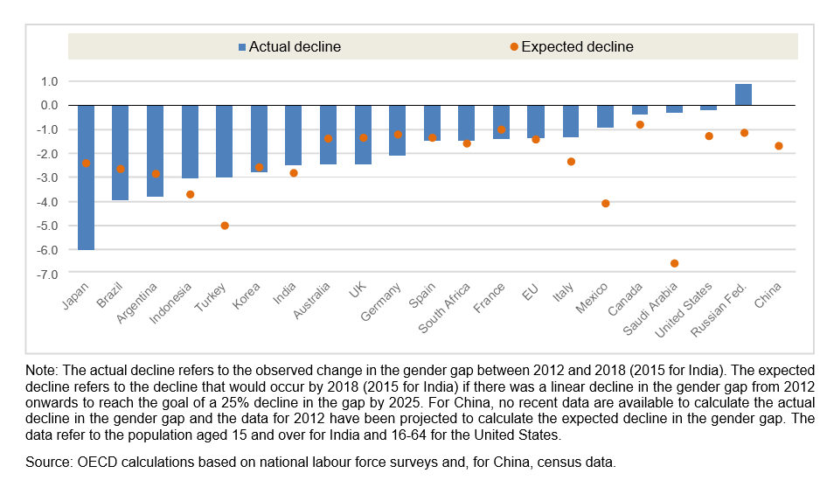

A special remark was made in the Report that women are also more likely than men to work in some non‐standard forms of employment (NSFE), i.e. temporary employment, part‐time and on‐call work, temporary agency work and other multi-party employment relationships, as well as disguised employment and dependent self‐employment. In 2017, in all G20 countries, the share of part‐time employment in total employment was higher for women than men. The gender gap in part‐time share of employment is around 30 percentage points or more in Germany, Italy, the United Kingdom, Argentina, Australia and Japan. Since 2012, there have been mixed trends across G20 countries in the importance of part‐time work as a share of total employment. There have been small rises in some countries but also small falls in others. These changes have been similar for women and men in most countries, and consequently there has been little change in the often-large gender gap in the incidence of part‐time work. Women are also often over‐represented in temporary jobs. Various factors explain the higher presence of women in NSFE: their greater care‐ giving responsibilities, their higher presence in occupations that typically recruit on an on‐call basis, the structure of the economy and women’s lower bargaining power because of their lower unionization rate and lower coverage by collective agreements.

Part‐time and temporary work can be an important means for women to integrate into the labour force. However, especially when involuntary, these forms of work may be associated with lower hourly wages than full‐time work, lower social security benefits and fewer training opportunities, which jeopardises women’s chances to obtain better‐quality jobs.

**Figure 3. The gender gap in part-time work remains large in G20 countries, 2012-2017**

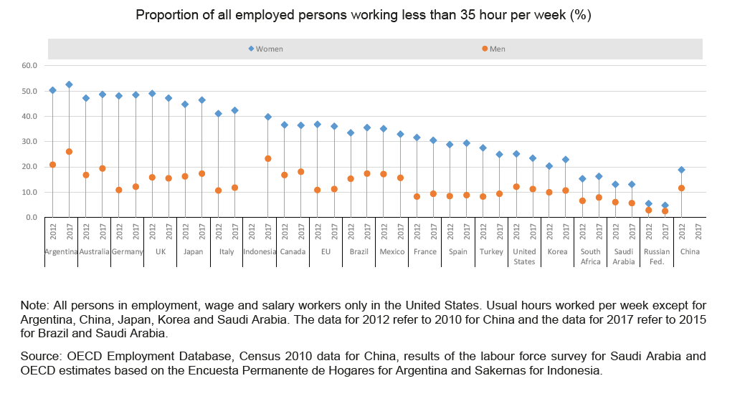

Note: All persons in employment, wage and salary workers only in the United States. Usual hours worked per week except for Argentina, China, Japan, Korea and Saudi Arabia. The data for 2012 refer to 2010 for China and the data for 2017 refer to 2015 for Brazil and Saudi Arabia.

Source: OECD Employment Database, Census 2010 data for China, results of the labour force survey for Saudi Arabia and OECD estimates based on the Encuesta Permanente de Hogares for Argentina and Sakernas for Indonesia.

All G20 countries have introduced national gender equality plans and strategies aimed at advancing the agenda of women at work (e.g., Argentina, Australia, EU, France, India, Spain and Türkiye). These policy frameworks bring together measures under the responsibility of different governmental agencies, including the need to collect more and accurate gender‐disaggregated data. For instance, in 2018 the Australian Government issued the Women’s Economic Security Package, a $119.2 million package of initiatives over four years focusing on three key pillars: workforce participation; earning potential; and economic independence. The Package contains several measures, including a new Time-Use Survey, a Reducing-Barriers-to-Work Forum and a new entrepreneurship grant programmed Boosting Female Founders. In Canada, the Gender Results Framework seeks, among others, to promote equal opportunities for women and men as well as diversified paths in education and skills development; equal and full participation in the economy and gender equality in leadership roles and at all levels of decision‐making. In Australia, the targeted policy measures are supported by the *Towards 2025 Strategy*, a whole‐of‐government strategy led by the Office for Women under the Prime Minister’s department. In the EU, in 2017, the European Commission adopted, in the context of the European Pillar of Social Rights, the initiative on Work‐life balance for working parents and cares.

Some countries have also taken steps towards the elimination of legal barriers to women’s employment (e.g. the Russian Federation) or night work (e.g. India, where women are now permitted to work at night subject to the provision of shelter, rest room, night crèche, women’s toilet, protection from sexual harassment and transportation). In this regard, measures have been introduced to increase the participation of women in male‐dominated sectors, by providing apprenticeship incentive grants or training in sectors such as construction and other male‐dominated trades (e.g., Argentina, Canada). France has adopted sectorial action plans through social dialogue and established the specific target of reaching an employment share of one third of women in male‐dominated sectors by 2025 (currently 12%).

The OECD Report[34] shows that despite the fact that all the G20 countries have new Labour Laws or policies to improve the female participation in the Labour market during the period 2012 – 2018, and that further progress was made, in some countries the gender gap is particularly large, achieving the goal remains challenging and approximately half of G20 members is not on track to meet the goal (assuming a linear reduction in the participation gap year‐on‐year). This is in part linked to the fact that women continue to shoulder a disproportionate share of unpaid work, which increases notably with the presence of young children in the household. In addition, very long hours of work and overtime continue to be more widespread among men. A culture of long working hours not only has detrimental effects on workers’ health and productivity, but may also lead to stigma against workers who choose flexible working time arrangements, such as reduced hours or teleworking, thereby reinforcing the gender gap in unpaid work.[35] The persistent and large gender gap in the sharing of family responsibilities and domestic chores not only hinders progress in the reduction of the gender participation gap, it also has implications for the quality of work for men and women.

Gender gaps in job quality also remain substantial. The gender pay gap remains substantial in most G20 economies, and only very modest progress has been made in closing this gap. This is reflected in persistently large gender gaps in the incidence of low‐paid work, access to managerial jobs and the incidence of non‐standard forms of employment such as part‐time work. Raising the quality of job opportunities available to women that allow for a better work‐life balance would improve their well‐ being, enhance their incentives to participate in the labour market and reduce the underutilisation of their skills.

Women continue to earn substantially less than men in most G20 countries. In terms of median full‐ time earnings, women earn between 30‐35% less than men in Korea and India, down to a gap of 10% or less in France, Türkiye and Italy.

There has been a small reduction in the gender pay gap over the past decade in nearly all G20 countries. However, the pace at which the gap is closing remains weak in most countries and has even stalled in some countries in recent years.

**Figure 4. Gender pay gaps remain substantial in G20 countries, 2006 and 2018**

For full-time median earnings, difference between male and female earnings divided by male earnings (%)

2006

2017 or latest

50

45

|  |  |  |  |  |  |  |  |  |  |  |  |  |  |  |  |  |  |  |
| --- | --- | --- | --- | --- | --- | --- | --- | --- | --- | --- | --- | --- | --- | --- | --- | --- | --- | --- |
|  | |  | | | | | | | | | | | | | | | | |
|  | |  | | | | | | | | | | | | | | | | |
|  |  |  | | | | | | | | | | | | | | | | |
|  |  |  | |  | | | | | | | | | | | | | | |
|  |  |  |  |  | | | | | | | | | | | | | | |
|  |  |  |  |  | |  | | | | | | | | | | | | |
|  |  |  |  |  |  |  |  |  |  |  |  | |  | |  | | | |
|  |  |  |  |  |  |  |  |  |  |  |  |  |  |  |  | | | |
|  |  |  |  |  |  |  |  |  |  |  |  |  |  |  |  |  |  |  |
|  |  |  |  |  |  |  |  |  |  |  |  |  |  |  |  |  |  |  |

40

35

30

25

20



15

10

5

0

 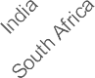  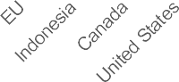 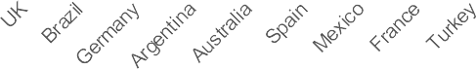 

Note: The data refer to gross (monthly or weekly) earnings of full-time wage and salary workers. The data for 2017 refer to: 2012 for India; 2014 for the EU, France, Spain and Türkiye; 2015 for Brazil and South Africa; and 2016 for Italy and Germany. The data for 2006 refer to 2008 for South Africa.

Source: OECD Earnings Distribution Database, OECD estimates based on national labour force surveys for Argentina, Brazil, India and Indonesia, and the NIDS panel survey for South Africa.

In terms of policy action to foster greater gender equality in the labour market, 2019’s report noted increased attention towards measures aimed at supporting women through work transitions, in particular returning to work after maternity. In 2020, G20 countries are converging in promoting better family leave policies and work‐life balance, taking into consideration that greater choice over time use would be particularly effective within a world of work where everybody needs to be more involved in care. Overall efforts in increasing childcare provisions are re‐confirmed practically in all G20 countries, while more efforts should be undertaken in the context of long‐term care, including care leave provisions. While quality, affordable and inclusive public care services and well‐designed care leave policies for both women and men will help to reduce women’s unpaid work responsibilities, more needs to be done to ensure that men take on a larger responsibility for unpaid work. There is scope for initiatives, such as well‐tailored awareness‐raising campaigns, that challenge deep‐seated gender stereotypes and change mind‐sets concerning what is the ‘appropriate’ role of women and men at home and at work.

Reinvigorated efforts are also noticeable in the context of tackling gender‐based discrimination, including pregnancy and maternity status, and violence and harassment in the world of work. However, this is an area that should be further explored as concerns have been raised regarding the use of non‐standard forms of employment, including in the platform economy, to circumvent the requirement to respect non‐discriminatory provisions and maternity protection legislation for women.

Although entrepreneurship development remains a common intervention area among all G20 countries, more efforts should be devoted to ensure that such opportunities embrace all women, including older women. Recognizing their life experience, self‐confidence and willingness to try new things would help to boost economies, including in rural areas, and tackle poverty in old ages, which is a growing concern in many G20 countries. However, it will also be important to ensure that there are adequate employment and social protections in place for these jobs.

* + - 1. Indicators Analysed by the World Bank (“Women, Business and the Law”)

The Women Business and the Law Reports is a series of annual studies measuring the laws and regulations in 190 economies, in eight areas impacting women’s economic participation – mobility, workplace, pay, marriage, parenthood, entrepreneurship, assets, and pensions. The 2022 Report also includes pilot research on the legal frameworks for available, affordable and quality childcare, as well as on the implementation of laws.

An important methodological note to be consider is that Data refer to the laws and regulations that are applicable to the main business city (Istanbul). Based on this approach, Türkiye scores 82.5 out of 100. The overall score for Türkiye is only slightly lower than the regional average observed across Europe and Central Asia (84.1).

**Figure 5. Türkiye - Scores for Women, Business and the Law 2022**

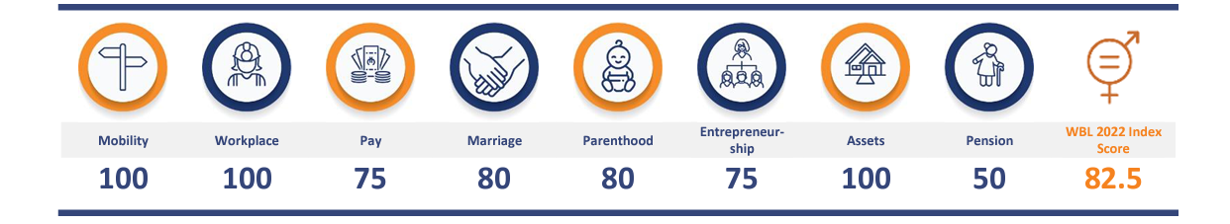

Source: World Bank, “Women, Business and the Law” (2022)

On relative Strengths, when it comes to constraints on freedom of movement, laws affecting women’s decisions to work, and gender differences in property and inheritance, Türkiye gets a perfect score.

The following Table shows some of the questions considered on “Workplace” and “Pay” and the answer applied.

**Table 3. Law Sources used for the Women Business and the Law Reports in Turkiye**

|  |  |  |  |
| --- | --- | --- | --- |
|  | **Question** | **Answer** | **Legal Basis** |
| **Mobility** | Can a woman choose where to live in the same way as a man? | Yes | Civil Code, Art. 186 |
| **Workplace** | Can a woman get a job in the same way as a man? | Yes | Civil Code, Art. 192 |
| Does the law prohibit discrimination in employment based on gender? | Yes | Labour Act, Art. 5  Law on Human Rights and Equality, Arts. 3 and 6 |
| Is there legislation on sexual harassment in employment? | Yes | Penal Code, Art. 105(2); Labour Act, Art. 24(II)(a) |
| Are there criminal penalties or civil remedies for sexual harassment in employment? | Yes | Criminal: Penal Code, Art. 105(2) Civil: Penal Code, Art. 50(1)(b) |
| **Pay** | Does the law mandate equal remuneration for work of equal value? | Yes | Labour Act, Art. 5 |
| Can a woman work at night in the same way as a man? | Yes | No restrictions could be located |
| Can a woman work in a job deemed dangerous in the same way as a man? | Yes | No restrictions could be located |
| Can a woman work in an industrial job in the same way as a man? | No | Labour Act, Art. 72 |

Source: Women Business and the Law

3.8.3 Some Indicators for Türkiye

As we mentioned, the impact of Laws and government policies are key drivers of female labour force participation. We briefly analyse some changes in the labour market from 2015 to 2021 according to some indicators and also some indicators that show social changes of women in Türkiye for the same period. Lastly, we analyse the indicators mentioned for the World Bank’s Women, Business and the Law Database (WBL) for Türkiye on legal restrictions and regulations relating to women’s economic participation and entrepreneurship, including limitations related to accessing institutions, owning and managing property, getting a job (such as restrictions on women’s work, including working at night or in certain industries), building credit, and going to court for the period mentioned.

* + - 1. Analysis of Data Gender Employment in Türkiye during the Period 2015 – 2021

In 2015, according to the Turkish Household Labour Force Survey, the countrywide employment rate stood at 46%. Of those working, only about half were formal wage earners with a permanent job (51%), while one in five were self-employed (4% with employees, 17% without employees). Other workers were split between formal wage earners with a temporary job (4%), informal wage earners (7%) and unpaid family workers (12%), the vast majority of whom worked informally. As a result, the Turkish labour market was also notably characterised by a dual structure with a sharp distinction between formal and informal employment arrangements. Labour market disparities exist throughout the Turkish labour market and are particularly visible when employment rates are disaggregated by gender.

Here the Report shows the trends in female employment, from 2015 to 2021 according the data of TURKSTAT[36] to show the impact of the legislation on women employment of the year 2016.

* + - * 1. Female Employment Rate (2015 – 2021)

According to the results of the Household Labour Force Survey; in 2015, the proportion of those who were 15 years of age and over and in employment was 32**.**2% for females and 71.0% for males, and the gender gap was 38,8%. The percentage of women and men remained at the same average, declining during 2020 as a consequence of the pandemic to 31.0% for females and 64.0% for males, improving in 2021 to an average similar to that of 2015. (There was an improvement of 0.7% in women’s employment during 2021)

**Figure 6. Female Employment Rate Türkiye (2015 – 2021)**

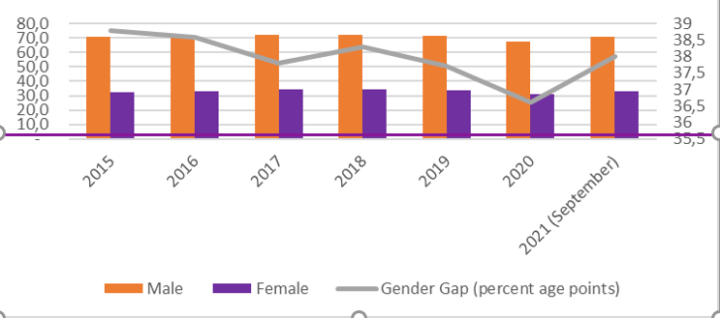

Source: TurkStat

* + - * 1. Gender Employment Gap (2015 – 2021)

The gender employment gap is defined by Eurostat as the difference between the employment rates of men and women aged 20–64. Hidden behind this indicator is the reality of millions of women who are unable to participate in the labour market. These include women who would like to have a job but who cannot take one due to family responsibilities, women who cannot secure a job under the right conditions, one that offers fair treatment, good job quality and equal pay, and women who seek to avoid segregation into the traditional ‘women’s’ sectors.

In Türkiye, the employed rate gap by gender (%) starts with 36.4% in 2015, moves to 34.9% in 2018, 32.6% in 2020 during the pandemic, and returns to 35.7% in 2021.

**Figure 7. Employed Rate by gender Türkiye (%) (2015 - 2021)**

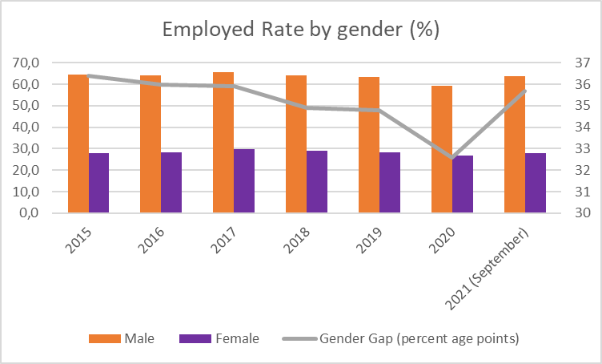

Source: TurkStat

But the employment gap can be better understood with a rise, sometimes sharp, in unemployment. In 2015, 12.7% of women were unemployed (Instead of 9.3% of men) - a gender gap of -3,4%. In 2016, the gap increases to -4.6%, and then decreases to -3.2% in 2018. In 2020, during the pandemic, the gender gap was 1.7%, but returned to -4.6% in 2021.

**Figure 8. Unemployment rate by gender Türkiye (%) (2015 - 2021)**

**(%) (2015 – 2021)**

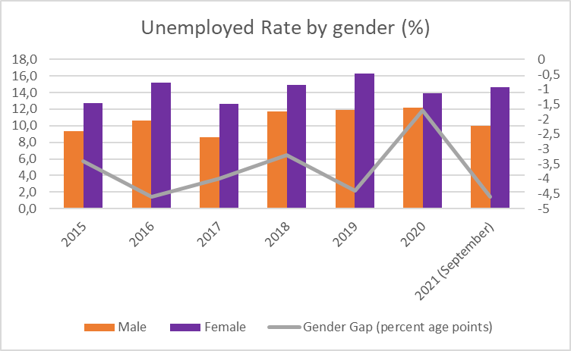

Source: TurkStat

An important consideration is related to educational level. The relatively high shares of women in such different occupational groups (for instance professionals, but also service and sales workers) is a reflection of a gendered and segregated labour market, and of highly uneven educational outcomes. When compared to men, women have either relatively low or relatively high levels of education. Among active workers, in 2019, 46% of women had a primary level of education, compared to 37% of men; at the same time, however, 26% of women were graduates of tertiary education, compared to only 19% of men. Women with higher education levels are more likely to participate in the labour market than men, and the gender wage gap is narrowest among those with a tertiary level of education. The higher rates of labour market participation among women with tertiary education skew the data relating to inequalities in earnings, resulting in a mean wage gap that is narrower than the median wage gap (10% compared to 20%). It is also clear that the gender wage gap is wider among those with lower levels of education, affecting a greater number of women.

To see the employment rate according the level of studies, we can consider that: In 2015, the employment rate by educational level shows that percentage of women with less than high school was 23,9%; started to increase in 2016 to 24.2%, having a maximum for the period considered in 2018 at 25.1% and decreasing again in the following years (to 20.8% in the first quarter of 2021). For women with high school education, the trend starts in 2015 with 26.0%, reaching 27.7% in 2018 before decreasing to 24.5% in the first quarter of 2021. For women in vocational high school, the percentage of the start of the period in 2015 is 33.4% (that shows a gap of 41.5%), maintain the percentage during all the period to show a reduction for the first quarter of 2021: 28.2% (a gap of 41.5%).

**Figure 9. Employment rate by educational level Türkiye (less than high school) (%) (2015 – 2021)**

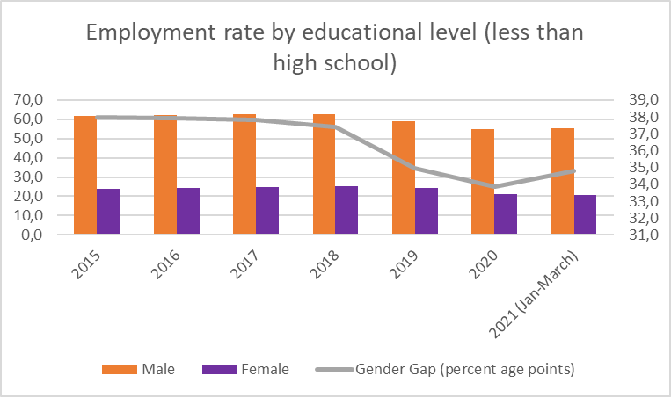

Source: TurkStat

**Figure 10. Employment rate by educational level Türkiye (high school) (%) (2015 – 2021)**

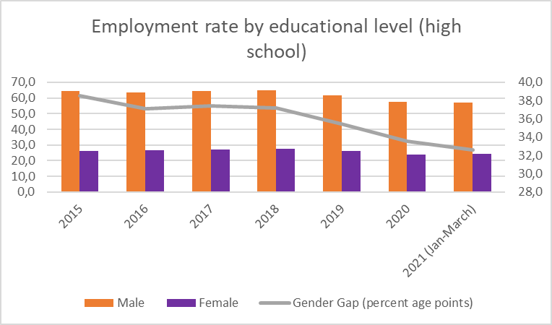

Source: TurkStat

**Figure 11. Employment rate by educational level Türkiye (vocational high school) (%) (2015 – 2021)**

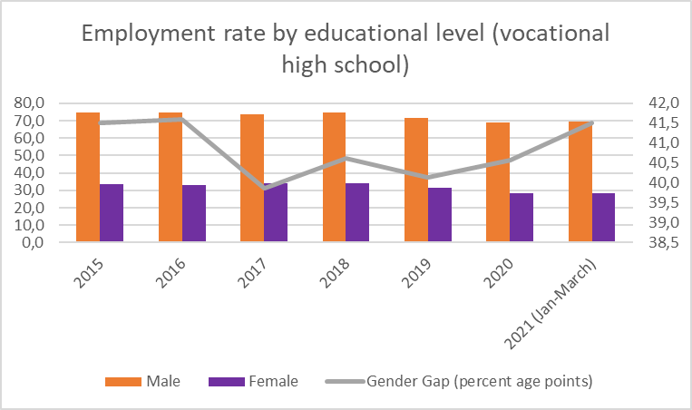

Source: TurkStat

**Figure 12. Employment rate by educational level Türkiye (less than high school) (%) (2015 – 2021)**

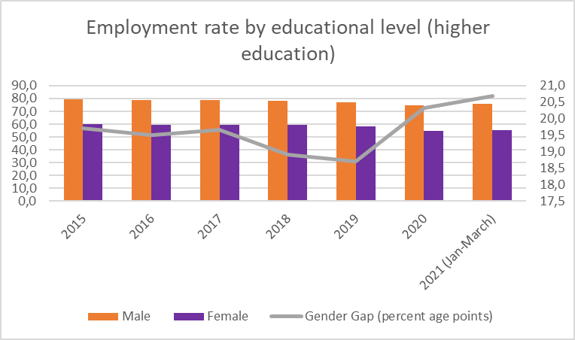

Source: TurkStat

Gender disparities are also observed across different occupations, and men outnumber women in every occupational category. In terms of the total number of women employed, the most common occupational groups for women are service and sales workers, elementary occupations and agricultural workers. These three occupational groups are also the most common among all workers, irrespective of gender, with agricultural workers outnumbering workers in elementary occupations by 1 percentage point. As a proportion of the occupational workforce, there is a relatively high presence of women who work in clerical support (this occupation also has the greatest gender parity), as professionals, and service and sales workers. Other conclusions on women employment in sectors are:

* on employment by sector of activity (% of men and women), from the data collected by TURKSTAT, and considering only 4 sectors (Agriculture, Industry, Construction and Service), women are particularly employed in services. Even though, the gender gap in this sector starts at -3.7% in 2015 and reached -5.0% during the first quarter of 2021.
* The contribution of women in agriculture was 26.8% in 2015 (representing a gender gap of -12.2%) to decrease year after year to 24.9% in 2021 (with a gender gap of 10%).
* Only a 15.3% of women were represented in industry in 2015 (with a gender gap of 6.5%). This increased during 2020 to 17.9% before reducing to 16.7% during the first quarter of 2021 (a gender gap of 6.8%).
* Finally, in construction, the percentage of women was 0.7% (representing a gender gap of 9.4% for the sector). The gender gap started to diminish in 2017 and in 2021 reached 8.2%.

**Figure 13. Employment by sector of activity - Agriculture Türkiye (% of men and women) (2015 – 2021)**

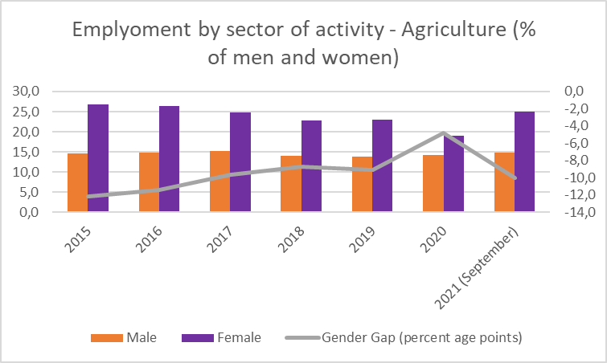

Source: TurkStat

**Figure 14. Employment by sector of activity - Industry Türkiye (% of men and women) (2015 – 2021)**

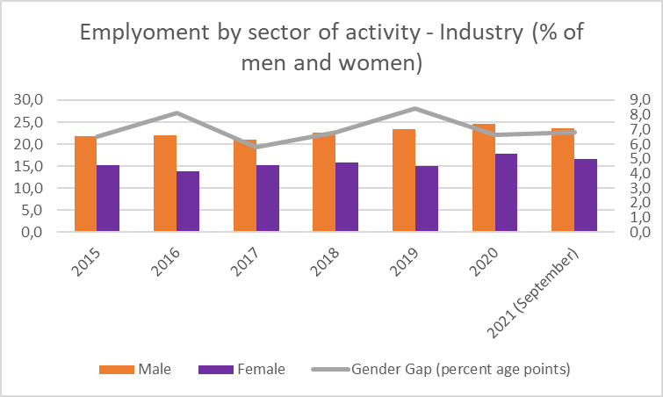

Source: TurkStat

**Figure 15. Employment by sector of activity - Construction Türkiye (% of men and women) (2015 – 2021)**

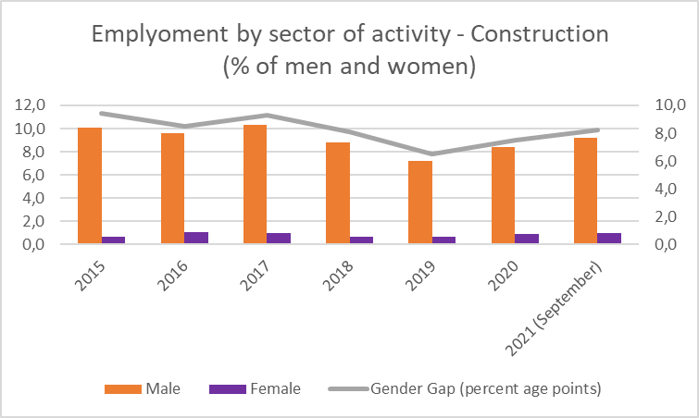

Source: TurkStat

**Figure 16. Employment by sector of activity - Service** **Türkiye (% of men and women) (2015 – 2021)**

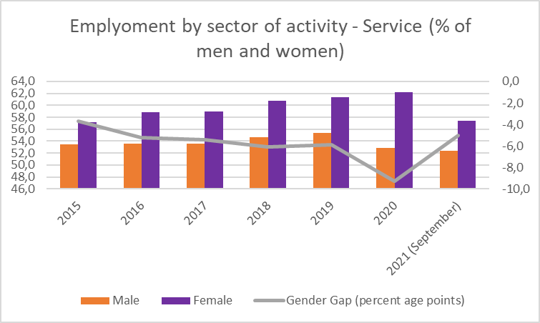

Source: TurkStat

**Table 4. Comparative data on employment Türkiye from 2015 to 2021**



Source: TurkStat

* + 1. On Part-Time Work

In 2016, part-time work in female employment was three times that of male, but in 2020 this had reduced to two times, showing an increase in part-time work for men, with the volume of part-time work for women remaining almost unchanged

**Table 5. Part – Time work in Türkiye (2016 – 2020)**

|  |  |  |  |
| --- | --- | --- | --- |
|  | **2016 (1)** | **2017-2019 (2)** | **2020 (3)** |
| **Total** | 10.3% | - | 12.4% |
| **Male** | 6.5% | - | 9.3% |
| **Female** | 19.1% | - | 19.5% |

Source: TAT Elaboration

Sources of the data:

1. TUKSTAT, Women in Statistics (2017)
2. TURKSTAT, Women in Statistics (2020) There is no information on this
3. TURKSTAT, Women in Statistics (2022)
   * 1. Gender Pay [37] (2015 – 2018)

The Gender Pay Gap in Türkiye,[38] for the period 2015 – 2018 was 15.6%, but gender gap increases with the age: while the gender pay gap is low (3.8%) at the beginning of working life, it rises significantly (25.9%) in 40s, and remains high at later ages[39] (the gap is 29.9% for people aged 60 or over). There was a decline in the gender wage gap from 2015 to 2018 across all age groups. The largest change is observed for the age groups 30-39 and 50-59 age brackets. The proportion of 40 or older women among all women in employment, increased considerably over the period 2015-2018 (Table 1).

**Table 6. Distribution of Employment by Gender and Age Group in Türkiye (%)**

|  |  |  |  |  |
| --- | --- | --- | --- | --- |
|  | 2015 | | 2018 | |
| f | m | f | m |
| Total | 100 | 100 | 100 | 100 |
| >20 | 4.7 | 5.3 | 3.5 | 4.1 |
| 20-29 | 32.1 | 26.4 | 29.7 | 25.2 |
| 30-39 | 34.6 | 33.2 | 32.1 | 32.1 |
| 40-49 | 20.4 | 9.8 | 24.6 | 24.9 |
| 50-59 | 6.6 | 1.8 | 7.9 | 11.4 |
| >60 | 1.7 | 1.8 | 2.1 | 2.4 |

Source: ILO, 2020 - TurkStat, Income and Living Conditions Survey (2015-2018).

In 2018 the gender pay gap in Türkiye was 12.9% (the world average was 21.4%), but motherhood increased the gender pay gap[40] to 29.6%. [41]

According to ILO, the main findings on the Gender Pay Gap in Türkiye, based on factor-weighted methods, are:

* Women in paid employment are better educated than men;
* Public sector employment rate of women is higher than for men;
* When the density of these two groups is decreased, the pay gap is higher.
  + 1. Educational Attainment and The Gender Wage Gap

Looking at the gender wage gap by education, the highest gender wage gap is recorded for the employees with elementary level or less years of education whereas the lowest is observed among their counterparts with a tertiary degree and higher. From 2015 to 2018, the gender wage gap among high school and primary/ middle school graduates decreases whereas it expands by nearly 2.5 percentage points at both ends i.e., the lowest and highest educational attainment.

Sectors and The Gender wage gap on the one hand, calculations by economic activity showcase gender wage gaps far lower than the overall one (14.6%) in male dominated sectors such as the construction sector. On the other hand, in female dominated sectors, such as education (with women’s employment share at 57%), or healthcare and social services (women’s share is 70%), the gender wage gap is higher than the average.

Even when the legislation complies with ILO and EU standards, and in particular some Conventions as 100 and 111, but the gap between the de jure and the de facto situation of women is persistent. The promotion of other international labour standards, such as those concerning maternity protection, workers with family responsibilities, safety and health, part-time workers and homeworkers, and the organisation of rural workers has been used by women, both inside and outside the labour market, are still needed to gain visibility and produce changes.

* + 1. Perspectives on working life

The duration of working life is defined as the number of years that a person is expected to be active in the labour market throughout his/her life. According to the results of the household labour force survey; while the duration of working life of the ones aged 15 and over was 16.7 years for females and 37.7 years for males in 2013, it was 19.1 years for females and 39.0 years for males in 2019.[42]

**Figure 17. Duration of working life in Türkiye, 2013-2019**

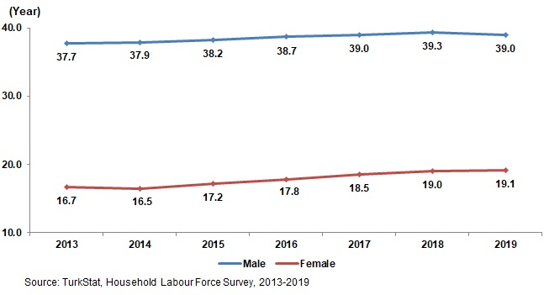

A particular attention is needed on working life, because job quality may have important implications for other outcomes, including health risks incurred in the workplace, mental well-being and work–life balance. To assess the relationship between working conditions and these other outcomes, a regression analysis was performed on the EWCS data in 2019[43], using outcomes as dependent variables, and working conditions as predictors. Even when this subject not considered the changes during the selected period, it shows important conclusions for the impact assessment of the laws in Türkiye.

**Health at work**: The analysis of perceived health and safety risk due to work suggests that, if standard individual characteristics are controlled for (age, marital status, education, sector and occupation), women believe they have fewer health and safety risks at work compared to men. However, when job quality predictors are included in the model, there are no differences in perceived health and safety risk at work among men and women. Instead, and as expected, job quality is closely related to perceptions of health and safety risks in the workplace. With respect to sector, workers in transport are the most likely to perceive high levels of risk, followed by those in public administration and construction. Poor physical environment, night work and exposure to adverse social behaviour are the working conditions that are most likely to increase a worker’s propensity to feel that their health is at risk.

**Mental health status**: In terms of sector, workers in industry report the poorest level of well-being. No gender differences are found with respect to reported well-being. Good management quality and job security are the aspects of working conditions that are most closely associated with positive well-being.

**Work–life balance** Lastly, analysing the relationship between various working conditions and self-reported work–life balance confirms that those who work normal hours (between 35 and 40 hours per week) and those who are easily able to take an hour off from work are more likely to report a good fit between their work and non-work commitments. Further complementary survey questions enable a closer understanding of what may be behind the disparities in work–life balance.

While the reasons workers attribute to their work–family conflicts vary, one of the most commonly stated factors is that they are too tired to complete housework after they return from work. Almost 40% of women but only 33% of men report this reason, a finding that reflects the gendered distribution of housework.

The breakdown of paid and unpaid working hours sheds additional light on the length of the Turkish working week. Notably, it further confirms an unequal distribution of household tasks, putting married women with children at a particular disadvantage. However, there does not seem to be any difference between workers with different family responsibilities in terms of the time they spend commuting. Working time preferences also indicate that 50% of workers would like to work fewer hours than they currently do, 45% would like to keep their current working hours and only 5% would like to increase their hours.

The Turkish data indicate a strong link between workers’ health, well-being, and work–life balance. Safer physical workplaces, positive work environments, standard and predictable working hours and job security all make Turkish workers more likely to report positive overall health and well-being. These findings suggest that improving compliance with existing laws governing occupational safety and health at work, working time and other related issues may prove an effective strategy.

* + 1. Self-Employed Women Workers

According to the TurkStat statistics from 2019, only 8.7 % of employers in Türkiye are female. [44]

Even when a perspective of the changes on women in the last years wasn´t find, a OECD Study of 2016 shows that gender discrimination still experienced by women in the private as well as the public sphere significantly limits their visible participation in economic life outside their homes. A sample survey of nearly 5 000 micro and small enterprises (MSEs) found that 6 % of them led by women, which shows that women's businesses tend to be very small. Nearly half are in trade and one-third are in industry. Many of the one-person women's enterprises are in home-based manufacturing. Women entrepreneurs tend to be younger and have more education than men entrepreneurs, and about half of the women entrepreneurs were employed as wage earners before starting their own businesses. Virtually none of them made use of credit for starting their businesses and very few had access to business support services of any kind. [45]

* + 1. Some Social indicators

Only two social indicators are included, closely related to the Labour Market, that shows the important change that Türkiye has made in the education (particularly higher education) for women, going from 7.6% in 2008 to 19.9% in 2020.

**Table 7- Social Indicators in Türkiye (2008 – 2020)**

|  |  |  |  |
| --- | --- | --- | --- |
|  | **2008** | **2019** | **2020** |
| Proportion of females completing at least one educational level | 72.6% | 85.7% | 87.7% |
| Proportion of females aged 25 and over and who were at least university graduates | 7.6% | 18.5% | 19.9% |

Source: TurkStat, Women in Statistics (2019) (2021)

* + 1. Information from ISKUR and Social Security Institutions

ISKUR have made an important contribution with their Study on the current situation of the use of Maternal Leave Rights, under the Articles 13 and 74 of the Labour Law No. 4857

|  |  |
| --- | --- |
| **LABOUR LAW NO 4877** | **İŞKUR**  **CURRENT STATUS DESCRIPTION**  **(2015-2022 Period)** |
| Article 13 of the Law, one of the parents benefiting from the right to work part-time until the beginning of the month following the start of the compulsory primary education age following the expiry of the permits stipulated in the Article 74 of the Law (number of women and men benefiting) |  |
| Article 74 of the Law , in case the mother dies at birth or after birth, allowing the father to use the periods that the mother cannot use after the birth (number of beneficiaries) |  |
| Article 74 of the Law , one of the spouses or adopters of a child who has not completed the age of three is given maternity leave for eight weeks from the date the child is actually delivered to the family (number of beneficiary women and men) |  |
| Article 74 of the Law , sixty days for the first birth, one hundred and twenty days for the second birth, for the purpose of caring for and raising her child after the end of the postpartum maternity leave and on condition that the child is alive, upon their request .  One hundred and eighty days , half of the weekly working time (number of women benefiting depending on the number of children) | The number of women who benefit from the unpaid leave periods given to the female worker , upon their request , for the care and upbringing of their child after the end of the postpartum maternity leave, and on the condition that the child is alive, is requested.  Scope of Additional Article 5 of the Unemployment Insurance Law No. 4447, ISKUR pays half-time work allowance after birth and adoption to the insurance holders who apply to our Institution and meet the premium payment conditions, during the said leave periods. Therefore, our Institution does not have the information of all persons who are granted unpaid leave within the scope of the second paragraph of Article 74 of the Law No. 4857.  However, from February 2016, when the implementation started, until the end of May 2022, from a total of 36,713 people who were entitled to half-time work allowance from our Institution and were given unpaid leave, equal to half of the weekly working time, within the scope of 74/2;   * 16,375 people first born, * 15,464 people second birth, * 4,874 people have three or more births,   benefited from the grant. All of the eligible persons are female employees. |
| Article 74 of the Law , after the end of the postpartum maternity leave, women or men who adopt a child for the purpose of caring for and raising their child and on condition that the child is alive, are given weekly for sixty days for the first birth, one hundred and twenty days for the second birth, and one hundred and eighty days for the following births, upon their request. unpaid leave for half of the working time (number of men and women benefiting) | The number of women who benefit from the unpaid leave periods given to the female worker, upon their request, for the care and upbringing of their child after the end of the postpartum maternity leave, and on the condition that the child is alive, is requested.  Within the scope of Additional Article 5 of the Unemployment Insurance Law No. 4447, ISKUR pays half-time work allowance after birth and adoption to the insurance holders who apply to ISKUR and meet the premium payment conditions, during the said leave periods. Therefore, since the information of all persons granted unpaid leave within the scope of the second paragraph of Article 74 of the Law No. 4857 is not available in ISKUR, the information of the persons entitled to half-time work allowance within the scope of additional article 5 of the Law No. 4447 is the following:  From February 2016, when the implementation started, until the end of May 2022, all of the people who were granted unpaid leave equal to half of the weekly working time within the scope of 74/2 and who were entitled to receive half-time work allowance from our Institution were female employees. |
| Adding thirty days to the periods specified in case of multiple births within the scope of paragraph 2 of Article 74 of the Law (number of beneficiary women) | The number of women who benefit from the unpaid leave periods given to the female worker, upon their request, for the care and upbringing of their child after the end of the postpartum maternity leave, and on the condition that the child is alive, is requested.  Within the scope of Additional Article 5 of the Unemployment Insurance Law No. 4447, ISKUR pays half-time work allowance after birth and adoption to the insurance holders who apply to our Institution and meet the premium payment conditions, during the said leave periods. Therefore, since the information of all persons granted unpaid leave within the scope of the second paragraph of Article 74 of the Law No. 4857 is not available in our Institution, the information of the persons entitled to half-time work allowance within the scope of additional article 5 of the Law No. 4447 is the following:  From February 2016, when the implementation started, until the end of May 2022, within the scope of 74/2, unpaid leave equal to half of the weekly working time;   * 35,922 single births, * 791 people have multiple births, * 235 adoptions,   A total of 36,948 people was entitled to receive half-time work allowance. All of the eligible persons are female employees. |
| Second paragraph of Article 74 of the Law, the implementation of the specified period as three hundred and sixty days in case the child is born with a disability (number of beneficiary women) | The number of women who benefit from the unpaid leave periods given to the female worker, upon their request , for the care and upbringing of their child after the end of the postpartum maternity leave, and on the condition that the child is alive, is requested.  Within the scope of Additional Article 5 of the Unemployment Insurance Law No. 4447, ISKUR pays half-time work allowance after birth and adoption to the insurance holders who apply to ISKUR and meet the premium payment conditions, during the said leave periods. Therefore, since the information of all persons granted unpaid leave within the scope of the second paragraph of Article 74 of the Law No. 4857 is not available in our Institution, the information of the persons entitled to half-time work allowance within the scope of additional article 5 of the Law No. 4447 is the following:  From February 2016, when the implementation started, until the end of May 2022, the number of people who were entitled to unpaid leave for half of the weekly working time within the scope of 74/2 and who were entitled to receive half-time work allowance from our Institution is 75 due to the fact that the child was born with a disability. All of the eligible persons are female employees. |
| Case of adopting a child who has not completed the age of three, within the scope of paragraph 6 of Article 74 of the Law , one of the spouses or the adopter is given unpaid leave (number of beneficiary women and men) | The number of women who benefit from the unpaid leave periods given to the female worker, upon their request, for the care and upbringing of their child after the end of the postpartum maternity leave, and on the condition that the child is alive, is requested.  On the scope of Additional Article 5 of the Unemployment Insurance Law No. 4447, ISKUR pays half-time work allowance after birth and adoption to the insurance holders who apply to ISKUR and meet the premium payment conditions, during the said leave periods. Therefore, since the information of all persons who are granted unpaid leave within the scope of the second paragraph of Article 74 of the Law No. 4857 is not available in ISKUR, the information of the persons entitled to half-time work allowance within the scope of the additional article 5 of the Law No. 4447 is the following:  From February 2016, when the implementation started, until the end of May 2022, 235 is the number of people who are entitled to half-time work allowance from our Institution and who are entitled to half-time work leave within the scope of 74/2  All of the eligible persons are female employees. |
| The scope of Article 74 of the Law Up to six months unpaid leave, upon request, after the completion of the sixteen-week period or after the eighteen-week period in case of multiple pregnancy (number of women benefiting) |  |
| Number of men and women receiving child benefits |  |

Source: ISKUR Report, June 2022

4.METHODOLOGY AND DATA OF THE FIELD STUDY

4.1. Steps for the Preparation of the Recommendation Report on Impact Assessment

The impact assessment study followed a consultative and participatory approach involving stakeholders throughout the process. This study mainly assesses the appropriateness, and effectiveness of the implementation of the legislation and workers and employers’ level of satisfaction with the provisions mentioned in the law. The mixed research methodology applied includes the following steps:

1. Desk review: Review of available legislations and regulations, research reports, international recommendations/commitments, available statistics and indicators;

2. Interviews and focus group discussions: Interviews and focus discussions were conducted with the major stakeholders responsible from the implementation of the law;

3. A Pre-Study Stakeholder Workshop at which 51 representatives of the public and third sectors formulated their views on how to improve women employment in Türkiye;

3. Field study: Semi-structured Face-to-Face interviews targeting employees and employers conducted to collect data on the difficulties/problems and future expectations of them directly addressed by the Labour Law No 4587. The Face-to-Face Interviews were conducted in 5 provinces: Ankara, Adana, Bursa, İstanbul, and İzmir. A total of 500 Face-to-Face interviews, 100 of which were conducted in each province;

4. Analysis and interpretation of the results, with a comprehensive report to be submitted to the beneficiary institution

The triangulation of the information for the use of multiple methods or data sources and the point of view of different researchers allows to develop a comprehensive understanding of phenomena under study and to test validity through the convergence of information from different sources.

The impact assessment process is comprised of two phases: - the Inception and the Implementation phases. The main activities to be carried out and their timelines are presented in the below table.

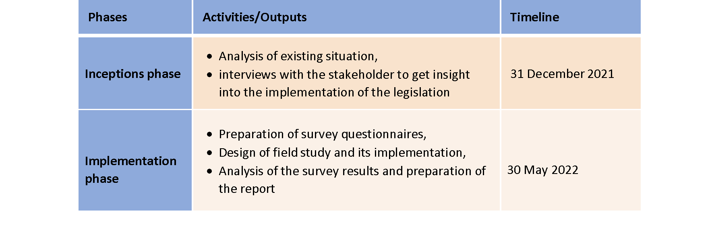

The major output of this impact assessment study is a comprehensive report to be presented to the Ministry that analyses the positive and negative effects of current legal regulations on women's employment by responding below questions:

• To what extent provisions on promoting employment of women in the available legislations meet the requirements and their effectiveness in implementation

• What are the future expectations of the employees and employers?

• Recommendations on what kind of amendments can be done to respond to the national and international requirements of the labour market

4.2.Qualitative Assessment by Stakeholders

After completion of the Desk Review Report, the first round of stakeholder interviews was held between 15-23 December 2021 online with the representatives of the institutions, social partners, and professional organisations agreed with OB, by using a semi-structured questionnaire.

By doing these interviews, it was aimed to introduce the impact analysis study of the project to the main stakeholders and to get their feedback and agreements to identify the bottlenecks in implementation of the legislation (the Labour Law and its related regulations). Accordingly, getting their opinions and views helped the project team in designing the field study including the survey questionnaire, sectors to be included etc.

The list of institutions interviewed is the following:

* SGK - Social Security Institutions-SSI;
* İŞKUR - Turkish Employment Agency;
* TÜRK-İŞ - Confederation of Turkish Trade Unions
* TİSK - Turkish Confederation of Employer Associations and
* TÜRKİYE ODALAR VE BORSALAR BİRLİĞİ - The Union of Chambers and Commodity Exchanges of Türkiye.

In designing the interview questionnaire in-depth review approach was used and questionnaires were structured to assess the appropriateness and effectiveness of the regulation from the perspectives of the organizations involved in the implementation (See Annex 1). The key interview questions were presented below.

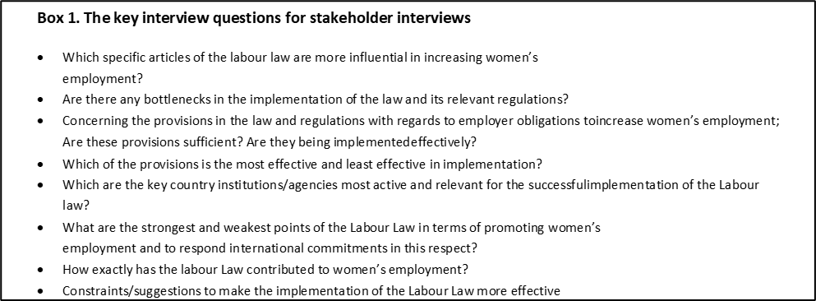

The main findings of the interviews can be summarised as follows:

* The most influential provisions of the Labour Law are Articles 5, 72, 73, 74, and 104 which specifically refers to anti-discrimination, working leaves, maternity leaves, maternal insurance for 4/A workers.
* MoLSS is the sole institution responsible for the implementation of the law
* More support from the government side is expected from the employers to fulfil the responsibilities given to them like the day care centre and breastfeeding room obligation
* Interpretation of the term ‘flexicurity’ from the government and employers’ side are different
* Non-standard work and care facilities are new issues inside the labour market, which are not covered by the existing legislation.

4.3. Results of the Pre-Study Workshop

Following the stakeholder interviews the 1-day online Workshop was organized to be a platform for receiving guidance and suggestions from stakeholders. The aim of the workshop was to present the main findings of the Desk Research, the stakeholder meetings, and to inform them about the field study to be conducted

The 1-day Workshop was, broadly, divided into 2 halves: the morning session comprised a series presentations from MoLSS, TAT and TAT’s experts aimed at establishing a Turkish and international context for subsequent stakeholder discussions on the issue of impact assessment; the afternoon session was focused on stakeholder discussions, held in 4 ‘break-out rooms’, with each room discussing a specific topic in line with the Agenda – feedback from each room was delivered immediately prior to the final wrap-up session.

The Operational Beneficiary issued official invitations to a wide range of relevant stakeholders to participate in the Workshop. This resulted in the following attendance:

|  |  |  |  |  |  |
| --- | --- | --- | --- | --- | --- |
| **Total Attendance** | **Public Sector** | **Private Sector** | **NGOs, etc.** | **From Outside Ankara** | ***TAT*** |
| 51* | 33 | 0 | 8 | 13 | 8 |

*Includes 2 participants who did not identify their names or organisations. They are not, therefore, included in the sector, etc. columns.

One important topic was the roadmap for Impact Assessment study, the participants were briefly informed about the methodology to be employed in the impact assessment study which aims to analyse the effect of existing legislation on women’s employment conditions including women’s participation in the labour force, access to job market, and have decent working conditions.

**On the key issues raised during discussions:** In the afternoon session, the participants were divided into three groups to discuss three focus questions;

* Group 1: Discussion on new legislation for a better future for women and work
* Group 2: Discussion on atypical work
* Group 3: Discussion on care policies

During the group discussions, participants were presented some questions to start the discussion. Each participant from different organisations and institutions were provided the opportunity to comment on the discussion topics from their institutional and individual point of view. Below are the key issues raised during group discussions:

**Group 1: New Legislation for a Better Future for Women and Work (Moderator: Ms. Mehlika Yaycı)**

The following key questions were asked to the audiences to stimulate the group discussion:

1. *Are legal regulations implemented in existing workplaces, in terms of facilitating and sustaining women's employment? Can women workers benefit from those regulations?*
2. *Can we get your thoughts on the positive and negative impacts of said legal regulations on women's employment?*
3. *Regarding the provisions of the national legal regulation we mentioned, what kind of additions/changes do you think should be made therein to facilitate women's employment and ensure its sustainability?*

The main issues discussed in this group are summarised below:

* There is an unfair practice in terms of providing an allowance for unpaid leave equal to half of the weekly working time applied after maternity leave, which is regulated in Article 74 of the Labour Law. Employees whose salary is above the minimum wage are also paid by the SSI/SSK over the minimum wage. Allowances are paid late and incomplete. While the premium is deducted, more deductions are made on the premium base wage, not the minimum wage. For this reason, women who earn a salary above the minimum wage do not want to use this right.
* It is an unequal practice for children to foresee different periods for the 1st, 2nd and 3rd child, about half of the weekly working time after maternity leave, and it should be corrected. Partial work for each child should be increased to 6 months.
* In practice, pregnant women are forced to work 6 days in places where they normally work for 5 days, as pregnant employees cannot work more than 7.5 hours a day legally.
* In workplaces located far from the city, pregnant workers who receive hourly wages wait for an additional 1.5 hours for service because they are not provided with shift service after 7.5 hours. Despite this, she receives her salary over 7.5 hours, not fully.
* Breastfeeding and maternity leave, which are among the rights related to a woman's nature, are rights that depend on the child, not the woman. The language of the legislation needs to be changed.
* 16 weeks’ maternity leave is not enough. Maternity leave should be increased and both women and men should be given the right to postpartum leave.
* Both women and men should be given the right to work remotely for at least 2 years for the first 2 years after giving birth.
* Although daily one and half hour breastfeeding leave is granted for the first year after birth, it cannot be used in practice because it is used with other permission. For this reason, it would be appropriate to increase the breastfeeding leave to at least 2 years and to extend the time to 3 hours.
* Those working in care services are generally female. There is a need for a special regulation in this area.
* Kindergartens work according to normal civil servant working hours. Special working hours should be arranged in kindergartens for shift workers.
* The sanction of a nursery requirement for workplaces employing 150 or more women is very low. In addition, the establishment and operation of nurseries by workplaces is a material and moral burden for these workplaces. Instead, nursery support should be provided to employees by the state and employers. There should be no limit to the number of female employees for kindergarten support. Nursery support should be provided for all female and male employees.
* In order to prevent violence in the workplace, adaptation studies should be carried out in accordance with the ILO C190 convention. A violence prevention and monitoring committee should be established in workplaces. The aim should be to prevent violence before it starts, not only while working, but also at the job application stage.
* All forms of violence in the workplace (physical, sexual, economic, psychological, etc.) need to be addressed in new legislation.
* For women who are under threat of violence, they should be given the right to leave the workplace and receive severance pay, if they can prove it, the right to appointment, paid/unpaid leave, remote work, allowance and income support by İŞKUR, etc. Efforts should be made to ensure that rights are granted.
* For those who work in domestic services at home, SGK provides premium support to employers, but the employers are not sufficiently informed about these supports. To increase registered and secure employment, employers who receive home services at home should be informed about the existing incentives.
* Supportive studies should be carried out to organize daily working hours and support social life.
* Special arrangements should be made on remote working conditions and occupational health and safety. A sample employment contract for remote working should be issued by the state and put into practice, and then it should be put into practice in the private sector as well.
* Maternity leave can be an obstacle to women's employment. During maternity leave, temporary employment relations should be encouraged instead of women on leave and the state should provide premium support for temporary workers.
* Arrangements should be made for employees who are subject to the Provisional Article 20 of the Law No. 506 and who are affiliated with the funds to benefit from the rights in the Social Security Law and the Labour Law.
* Public workers working in affection houses (“sevgi evleri”) established under the General Directorate of Child Services (Ministry of Family and Social Services) are subject to the Code of Obligations, not the Labour Law. A special legal arrangement should be made for those working in such care services, working hours should be regulated.
* Applications should be made to support the family life of spouses working in shifts, and the demands of the spouses should be taken into account regarding the weekday working order and the use of weekends.

**Groups 2: Atypical work (Moderator: Ms. M. Nilgün Egemen)**

In the group discussion, it was aimed to find answers to the following questions.

1. *What are the common atypical employment patterns in Türkiye?*
2. *What are the areas where current policies are insufficient to protect the rights of those who have been working in the atypical employment category?*
3. *How atypical employment can be integrated into existing labour legislation?*
4. *What kind of policies can be developed to protect the rights of employees of this category?*

The main issues highlighted by the participants during the discussions are below:

* Atypical employment is not the main concern of the unions of employers and other social parties unless there is a demand from their members or target groups. It would not be wrong to say, there is no awareness about this issue and some of the participants of the working group mentioned that they just heard about the atypical employment.
* Education, Banking, and finance (because of remote working conditions during this pandemic era), Agriculture, and Service sectors are the main sectors where atypical employment is demanding.
* Provision number 7 about Temporary Employment Relationship in the Labour law encourages women to prefer atypical employment because of their responsibilities at home. The law should promote secure and full-time employment for the labours
* While preparing a new law, cross-cutting areas with the other laws should be considered. As an example, there is a dilemma between Law No: 6331 Workers Health and Safety and Law No: 4857 Labour Law about night shifts of women workers who have a baby below age one.
* There are some training programmes organised by the Ministry of Education and ISKUR about care facilities for the baby, elderly, and patients, home cleaning, and handcraft specific to women but there is no follow on how they are employed with these certificates.
* The number of migrant workers is very high and in some places is more than native ones in house cleaning, and elderly and childcare without any registration
* Domestic violence is the main driver together with their house care responsibilities of women to prefer atypical work. In preparation of legislative framework to promote women's employment comprehensive perspective is necessary. Therefore, just making some amendments in labour law will not be sufficient to increase women's employment unless there are no measures to take the housework burden of women as well as protect them from domestic violence.
* Making care facilities including babies and the elderly as part of public policy is necessary to take this burden from women’s shoulders. In addition, care facilities should be taken as a responsibility of all family members not only for women and all incentives at the business establishment-level should be given by considering the total number of employees not only women workers.
* Atypical employment is more common in small settlements and there is no office of the relevant government organisations (particularly SGK and ISKUR) at the district level to be applied if any problem happens, or information is needed.
* There are some incentives of the SGK for atypical employment, but most of them are not known by both workers and employees. SGK should develop new communication strategies or establish new communication channels to reach all these groups.

**Group 3: Care Policies (Moderator: Dr. Özlem Boztaş)**

In this group, participants were provided three focus questions:

1. *How do you see the existing Labour Law in terms of its provisions related to care responsibilities and obligations? (maternal leave, breastfeeding leave, part-time work after birth, crèche and day-care facilities provided by employers, etc.)*
2. *What is efficient and what needs improvement in practice?*
3. *What additional legislative changes are needed to prevent the care responsibilities from being the main obstacle in front of women's employment.*

The main suggestions given by the participants as a result of the discussions are below:

* The legislation might promote gender equality instead of over-emphasizing the care roles of women in employment. Maternal and breastfeeding leaves may be considered as the rights of the child so parenting leaves could be the solution instead of maternal leaves. Both mother and father might be able to use these rights. The conditions might be determined to ensure that father cannot transfer these leaves to the mother. The parent may use their maternal/paternal leaves in rotation.
* Employer obligations for crèche and day-care facilities are intended for only large enterprises in which 100-150 women are employed. However, women’s employment is proportionally higher in micro-enterprises and informal employment is also high in those enterprises. Thus, care facilities might include all personnel regardless of gender in large enterprises and also additional regulations may be added for micro-enterprises. The state should provide additional incentives and share this care obligation together with the employers.
* Breastfeeding leaves are problematic in practice. The duration and the length might be increased.
* Home-based working might be given as an option for those who would like to use it for sharing the care work at home. Both mothers and fathers can choose to work at home for 1-2 days a week in rotation to share the care work.
* Care work provisions might be extended to cover care for the elderly, patients, and disabled.
* To increase women’s employment is the goal but also retaining women in employment and eliminating the glass ceiling may be targeted. So, additional incentives could be provided for women who are assigned to management positions.
* Home-based working might be regulated well. Lunch breaks, other breaks, and working rights may be preserved in legislation.
* The legislation might target a work-life balance.
* Care incentives might be extended to include platform workers, atypical workers, freelancers, etc. since they lack protection under labour law.

Some policy recommendations emerged from the discussion. Care policies were analysed as one of the key topics to improve and increase women employment from a gender perspective. But also, there were deep reflections on the measures needed concerning the work-life balance. These measures concern both the recipients and providers of care, and include measures to ensure access to the services, time and resources needed for giving and receiving care, as well as regulations and oversight to safeguard its quality.

5. QUANTITATIVE INFORMATION DERIVED FROM A MAJOR FIELD STUDY

5.1. Design of the Field Study

As part of this study, it was suggested to conduct Face-to-Face interviews with women employees and employers to get an overview of how the provisions of the law are perceived and practiced. For this purpose, two different questionnaires were prepared (Annex 2), one for employees and one for employers by considering the feedback received during the interviews. The field research was realized between the mid of March and April in five provinces Adana, Ankara, Bursa, Istanbul, and Izmir. A total of 500 Face-to-Face interviews, 100 of which were conducted in each province.

The questionnaires consisted of three main parts

1. General information about the respondents

2. Attitudes to implementation of the law and their level of satisfaction with the provisions

3. Suggestions and expectations for the future

In designing the questionnaires, it is aimed to measure how effectively the law was implemented, their level of satisfaction, and opinions about the provisions of the existing Labour law as well as their suggestions for the improvement of conditions in favour of female employees. Table 1 presents the number of surveys conducted in each province by sector.

**Table 8. Number of Face-To-Face interviews conducted by sector in each of the provinces for the Field Study**

|  |  |  |  |
| --- | --- | --- | --- |
| **Sector** | **Employer** | **Women**  **Employee** | **Total** |
| **Banking and finance** | 5 | 8 | 13 |
| **Information Technologies** | 5 | 8 | 13 |
| **Education** | 5 | 8 | 13 |
| **Energy** | 5 | 8 | 13 |
| **Health** | 5 | 8 | 13 |
| **Others** | 10 | 25 | 35 |
| **Total** | **35** | **65** | **100** |

Source: TAT Elaboration

The questionnaires aimed to explore the following information to support the assessment of the impact of Labour Law on women’s employment (See Annex 2):

* What is the level of knowledge both employees and employers about the provisions of the law to enhance the women’s employment
* Which of the provisions are most widely used by the employees
* What are the opinions of employees and employers about the effectiveness or suitability of the provisions to promote women’s employment
* What kind of amendments can be done to facilitate participation of more women to labour market

5.2. Results of the Field Study

5.2.1. Results from Employee Participants

5.2.1.1. Demographic profile of Employee Participants

The field study was conducted with 387 female employees. In each of the provinces 65 of the surveys out of 100 were applied to the female employees working in banking and finance, health, education, energy and other sectors including service and retail. The cumulative percentage of the interviews conducted by province in given below:

**Table 9. Distribution of Respondents by Province**

|  |  |  |
| --- | --- | --- |
| **Province** | **No.** | **%** |
| Adana | 72 | 18.6 |
| Ankara | 85 | 22 |
| Bursa | 70 | 18.1 |
| İstanbul | 73 | 18.9 |
| İzmir | 87 | 22.5 |
| Total | 387 | 100 |

Source: TAT Elaboration

86.8% of respondents were employees of private-sector establishments while 13.2% were government officers. 52.2% of the respondents are married and 47.8% are single (divorced/widowed included). 54.5% of the respondents had at least one child while 45.5% have no children. Among the respondents with children, 22.2% have minimum one child under age 6. This question was asked to reflect the care responsibilities of the employees and its link with their perception of the efficiency of law.

Most of the respondents graduated from high school corresponding to 60.5% of the total employees surveyed while 33.6 % of the respondents had a bachelor’s degree and 5.9% had post-graduate degree. The position of the respondents at the work place was also asked: 79.6% of the respondents were employed as workers, 8.8% as technical staff, 10.1% as administrative staff, and only 1.6% as managers.

**Table 10. The Demographic structure of Respondents**

|  |  |  |  |  |  |
| --- | --- | --- | --- | --- | --- |
| **Respondents by sector** | | **Respondents by marital status (%)** | | **Respondents by the status of having children (%)** | |
| **Private** | **Government** | **Married** | **Single** | **With children** | **Without children** |
| 13% | 87% | 52% | 48% | 55% | 45% |

Source: TAT Elaboration

5.2.1.2. Implementation of the Law and Level ofSatisfaction

In this part of the questionnaire, it was asked to get information whether the respondents benefited from the provisions of the law, and their views about how effectively the provisions of the law are being implemented in their workplace. Also, their opinion about the appropriateness of the provisions to facilitate women’s employment was questioned.

According to the responses, the most widely used provision was the maternity leave right. 65.9% of the respondents with children benefited from this right. It is followed by “prohibition of gender discrimination in wages” with 49.3% and transportation facilities for women working the night shift with 37.6%. Only 14.6% of the total respondents stated that they have benefited from crèche and breastfeeding room obligation of the regulation.

**Figure 18: Provisions of the Law that respondents get benefited (%)**

Source: TAT Elaboration

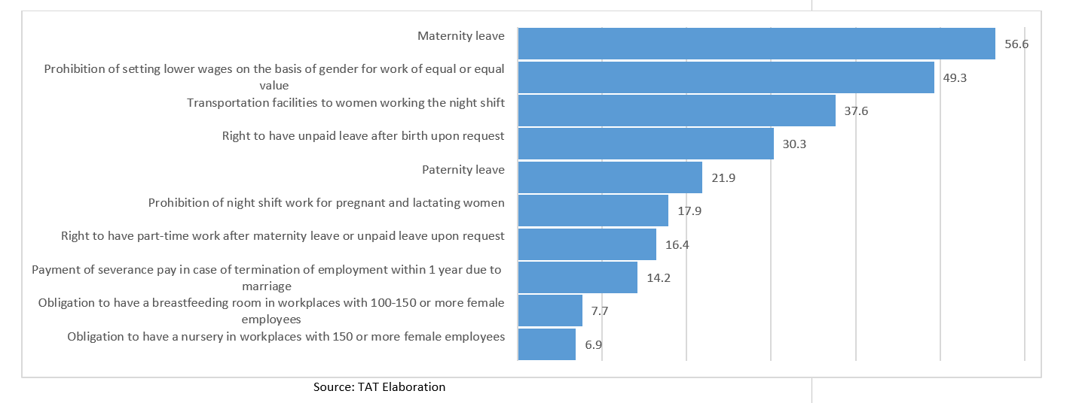

As seen in the figure, paternity leave (21.9%) has the fifth rank in the order of provisions employees benefited mostly, whereas the right to have part-time work after maternity leave was among the least benefited provisions of the law with 16.4%. (The question about paternity leave was addressed to both male and female respondents, since a mother benefits from the support provided by her partner which is, in turn, supported by paternity leave provisions. Hence, it may be regarded as a gender-neutral issue).

The below figure illustrates the employees' assessment of the implementation of the provisions of the law to facilitate women’s employment by considering the situation in their working place.

**Figure 19. Assessment on how Provisions in the Labour Law Facilitate Women´s Working Life in Practice (Question B3)**

Source: TAT Elaboration

From the perspectives of employees’ maternity leave, right to have unpaid maternity leave (71.1%), paternity leave (42.9%) and prohibition of discrimination by gender in terms of payment (41.6%) are the most effective provisions in practice. On the other hand, the right to part-time work after maternity (9%), was stated as the least implemented provision. The breastfeeding room (18.6%) and nursery obligation (19.9%) could be interpreted as these provisions implemented effectively when compared with the size of the enterprises covered in the survey (See Figure 7 p. 31) stated as “not effective”.

**Figure 20: Assessment on how the Provisions in the Labour Law Facilitate Women’s Work Life in Practice (Question B4)**

Source: TAT Elaboration

The respondents were asked (Question B4) about their opinion on how the provisions in the labour law facilitates women’s work life in practice. As seen in Figure 11 above, the majority of the respondents think that maternity leave (85%), transportation facilities (84%), anti-discrimination in terms of wages (78.8%), and prohibition for nigh shifts for pregnant and breastfeeding women (78.8) would facilitate women’s employment. 14.5% of the respondents stated that “paternity leave” would facilitate women’s employment “to some extent”. The reason for this statement can be explained by the gender-biased division of care work in the household.

**F****igure 21. Measures taken at the Workplace to implement the Provisions of the Law (Question B5)**

Source: TAT Elaboration

The respondents were asked about the level of measures taken at their workplace to fulfil the requirements of the law; 61,1% of the respondents said that they can use unpaid maternal leave rights as prescribed by the law. More than half of respondents mentioned that maternity and breastfeeding permits specified in the law can be used without any pressure or restriction (51,7%). It is noteworthy to state that also a large ratio of the respondents did not show this response which suggest that there might be an unspecified pressure on employees in terms of their utilisation of maternity and breastfeeding leaves. In addition, availability of breastfeeding room and crèche facilities are among the least selected option (18.5% and 9.1%, respectively). This low ratio can be also explained with the fact that the majority of the respondents in the study work in companies with lower than 100 female employees (76% of the enterprises included in the study are small and medium scale with 1-100 employees), which are out of the scope of obligation in the Labour law.

The respondents were also asked about their overall assessment on the efficiency of the Labour Law in increasing women’s employment.

**Figure 22: Assessment on the Efficiency of the Law by Participants**

Source: TAT Elaboration

As seen, the majority of the participants stated that the current Labour Law is not sufficient/efficient in increasing women’s employment. Looking at the responses in Section C of the questionnaire which was designed to find out suggestions from the respondents for improving the law for increasing women’s employment, it is seen that the most frequent answer is the duration of maternity leave. Almost 90% of the participants stated that “the **duration of maternity** leave should be longer (equal to government officers). It is also noteworthy that 82.4% indicated that **elderly and patient care** facilities should be also covered by the law. The third most frequent answer is “State support for workplace nurseries” with 82.17%.

In the qualitative part of the study, the respondents answered open-ended questions about their opinions on the law and their suggestions for its improvement from a gender aspect. TAT analysed these responses through content analysis and found out the following:

* Care responsibilities are seen as the main issue to tackle for increasing and retaining women’s employment
* Transportation and working hours should be arranged to provide work-family life balance.
* More and better care facilities should be provided for working mothers and fathers

**Figure 23: Suggestions by Participants to Improve the Law from a gender Perspective**

Source: TAT Elaboration

In conclusion, the findings from the field study indicate that “maternity leave”, “breastfeeding leave”, and “anti-discrimination” provisions of the law are the most effective and widely used at the enterprises. However, the findings also suggest that there is a room for improvement for the law by including elderly and patient care within the scope of the law and by levelling up the duration of maternal in the private sector. In addition, state support for more and better crèches/nurseries are widely suggested by the respondents in the study.

Below, the findings from the field study with the employers are explained in detail.

5.2.2. Results from Employer Participants

5.2.2.1. Demographic Profile of the Employers

Another target group of the face-to-face interviews was the employers that are responsible from the implementation of the regulations. In this regard, in each of the province 35 face-to-face interviews out of 100 were conducted with the managers, owners or high-level officials of the employers (159 persons). 82% of respondents were from private-sector establishments while 18% were from government institutions.

**Table 11: Distribution of respondents per province**

|  |  |  |
| --- | --- | --- |
| **Province** | **n** | **%** |
| **Adana** | 30 | 19% |
| **Ankara** | 34 | 21% |
| **Bursa** | 31 | 19% |
| **İstanbul** | 31 | 19% |
| **İzmir** | 33 | 21% |
| **Total** | 159 | 100% |

Source: TAT Elaboration

The majority of the enterprises included in the study are small and medium scale (%58). Only 28% of the enterprises employ more than 100 people. The below Figure 7 presents the distribution of the number of enterprises by the number of employees in 2022.

**Figure 24. Number of Employees at the Interviewed Enterprises, 2022 (%)**

Source: TAT Elaboration

The number of employees by gender is given in the graph below. As seen 43.6% of the employees are women and when compared to 2015 data from the same enterprises, we see a slight increase in the number of female employees. In 2015, the ratio of female employees at the interviewed enterprises was 39.3%.

The below pie charts present the respondents by gender and their position within the organisation. 62% of the respondents were men and 38 % were women and more than 80% of the respondents were high-level managers including the owner, manager, and senior management positions. The majority of the enterprises included in the study are small and medium scale (%50). Below figure presents the number of employees working at the interviewed enterprises by 2022.

**Figure 25. Distribution of Employees by Gender, 2022 (%)**

Source: TAT Elaboration

While 43.6% of the employees at the interviewed enterprises are women, only 37% of the senior managers are women at the same enterprises. This suggests a clear gap in management positions between men and women.

5.2.2.2. Implementation of the Law and Level of Satisfaction

In the second part of the employer questionnaire, the respondents were asked about their level of knowledge regarding the labour law, their opinion about its efficiency and their suggestions for improvement. As seen from the figure below, only 37% of the respondents know the provisions of Labour Law related to women’s employment. Regarding their opinion about whether the law and provisions about female workers are understandable and clear; it is seen that only 34% of respondents said “yes” and 66% thinks that provisions are not clear.

**Figure 26. Respondents’ Level of Knowledge about Preparation and Implementation of the Labour Law**

Source: TAT Elaboration

Following the general assessment about the law and its provisions, in the next question, the respondents were asked about the level of utilisation of provisions by employees and the frequency of it. As seen below, 95% of the respondent’s state that their employees benefited from the maternity leave rights and 77% of the respondent’s state that their workers used unpaid leave after birth upon request. 64% of the respondents selected paternity leave as the third most frequently used labour right by their employees. (77%) and paternity leave (64%). As seen in Figure 10 below, crèche and breastfeeding room facilities are the least available among other legal provisions (11% and 14%, respectively).

**Figure 27. The Provisions of the Law that Employees Benefited (%)**

Source: TAT Elaboration

**Figure 28. Assessment on How Provisions in the Labour Law Facilitate Women´s Working life in Practice**

Source: TAT Elaboration

As seen above, the majority of the respondents think that maternity leave facilitates women’s working life (90%), which is followed by crèche/nursery obligation (81%). The remaining provisions in the law were considered equally important for increasing women’s employment and facilitating their work life.

**Figure 29. Assessment on Implementation on the Labour Law in Practice**

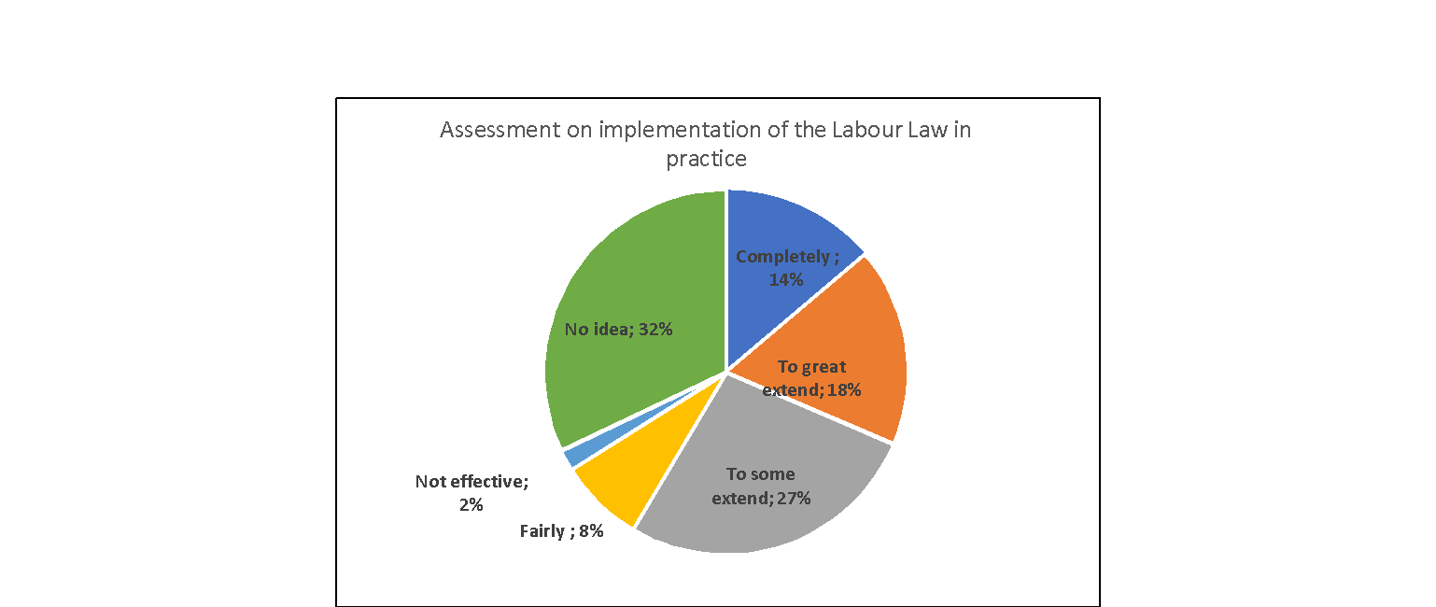

Source: TAT Elaboration

When the respondents were asked about their opinion on the implementation of the related provisions of the law in practice, 31% of the respondents said the provisions of the law are implemented completely or to a great extent.

Regarding measures taken by the employers to fulfil the requirements of the law; 76% of the respondents said that employees can use their postpartum unpaid leave rights as prescribed by law. Following this, 72 % of them mentioned that maternity and breastfeeding permits specified in the law can be used without any pressure or restriction.

More than half of respondents mentioned that Upon request, the right to work part-time after maternity leave or unpaid leave can be used (71%), no lower wages because of gender for work of the same or equal value (64%) and the number of female workers is not less than 30 % of total employees (61%).

The existence of a nursery and breastfeeding room were the least implemented measures taken for female employees.

**Figure 30. Measures Taken by the Employers**

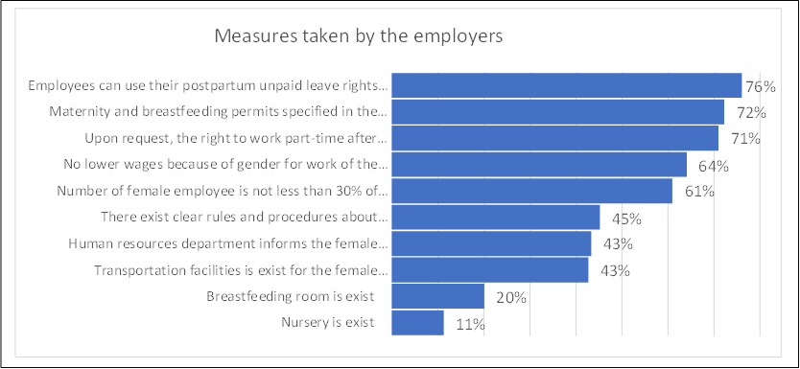

Source: TAT Elaboration

Implementation of existing labour law brings some cost burden to the establishments to fulfil their responsibilities given by the law these responsibilities are establishments of nurseries, breastfeeding rooms and providing transportation facilities for the female employees. The employers were also asked whether they need support for these kinds of responsibilities. 45% of them stated that they need some kind of support for the implementation of the provisions in their workplace. 45% stated financial support, 15% transportation support, 25% training support, and 15% consultancy support. 74% of them mentioned that they have no idea about the additional cost generated due to the activities realized to fulfil their responsibilities.

**Figure 31. Is there any Additional Cost Associated with the Measures for Women´s Employment** and **Figure 32. Cost Burden of the Measures for Women´s Employment (%)**

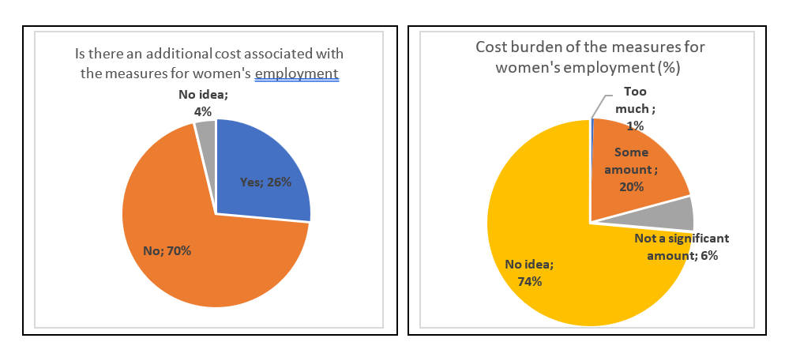

Source: TAT Elaboration

Besides, 45% of the respondents mentioned that they need support in the implementation of the provisions of the Labour Law on increasing women's employment and details of the what kind of support they need is presented in the chart below. 45% of the employers said that they need financial, while 25% of them need to be educated about the law and its provisions.

**Figure 33. Support in the Implementation of the Provisions of the Labour Law**

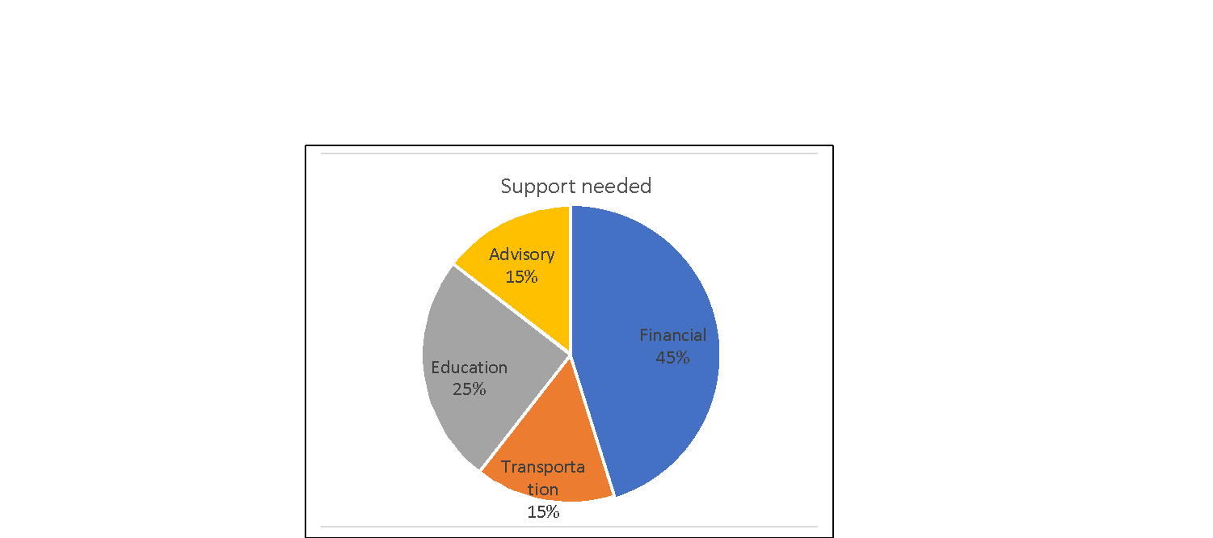

Source: TAT Elaboration

In this part of the questionnaire, they were asked about their policies on wage, carrier opportunities and vocational trainings targeting male and female employees. 75% of them declared that female employees have equal wages, career opportunities and vocational training with male employees

**Figure 34. Do women have Equal Wages, Career Opportunities and Vocational Training with Male Employees?**

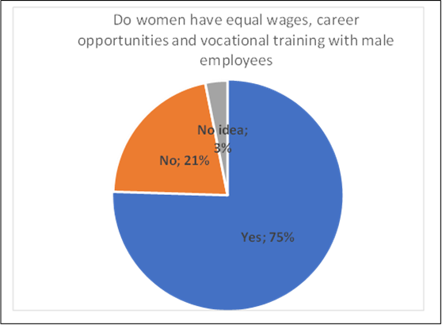

Source: TAT Elaboration

Finally 87% of the respondents stated that they have had no Mediation or Labour Court case regarding the rights granted to women employees by Labour Law during the last five years. Only 6% of them have a Mediation or Labour Court case regarding the rights granted to women employees by Labour Law.

**Figure 35 . Having a Mediation in a Labour Court Case regarding Rights Granted to Women Employees during the past Five Years**

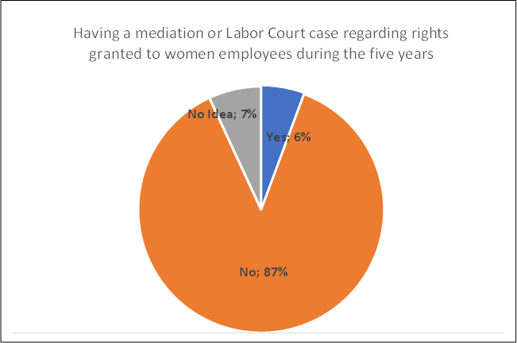

Source: TAT Elaboration

The same question was asked in the employer questionnaire closing section. The results indicate that employers' priorities differed from employees as seen from the below graph. On the employers’ side; more than 80% of the respondents mentioned that more support from the government to establish nurseries and improve the conditions of breastfeeding rooms and nurseries is expected in the future. Extension of postpartum unpaid leave period was among the least preferred policy options.

**Figure 36. Suggestions to Improve Conditions for Female Employers**

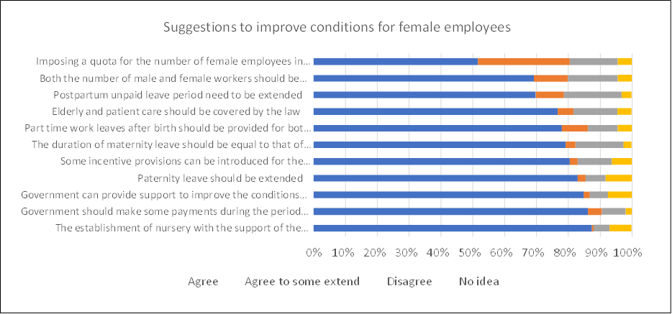

Source: TAT Elaboration

6. POLICY RECOMMENDATIONS AND SUGGESTIONS TO ENHANCE RELEVANT REGULATIONS AND TO DRAFT NEW POLICIES

These recommendations are based on the qualitative and quantitative information derived from the Desk Research, stakeholder meetings, the Pre-Study Workshops, the Field Study’s face-to-face interviews, and, where relevant, the Post-Study Workshop.

Also information from the Sectors Report is considered to enhance these recommendations. The main recommendations of this Report are included in this section, but there are two other important general recommendations:

* *“Take measures to ensure and monitor female employees' participation in in-service training with equal opportunities”.*
* *“Monitor and support the professional development of female employees”.*

For the Sectors in general, there are also three important recommendations:

* “*Focus more on the education of girls and women in the renewable energy sector, science, technology, engineering, mathematics.*
* *Regulate the working hours of female employees in sectors where flexible or remote working opportunities are not available (especially in the health sector).*
* *Increase the involvement of women in the renewable energy sector through improved workplace conditions, mentoring and professional development”*. (Pp 161 – 168, Sectors Report)

6.1 Legislation that Promotes More Gender Equality and Avoids Enforcing the Stereotype that Women should have the Main Responsibility for Family Care

In Türkiye, the new Labour Act enacted in 2003 was an important step towards establishing the principle of anti-discrimination in employment and securing more equal rights between women and men. Article 5, the principle of equal treatment, clearly states that “No discrimination based on language, race, sex, political opinion, philosophical belief, religion and sex or similar reasons is permissible in the employment relationship.” (p.10).

According to the conclusions of the Pre- Study Workshop, the participants suggested that “the legislation might promote gender equality and avoid reinforcing the idea that women have the main responsibility in taking care of the family. The language of the Labour Law should encourage the principle that women and men have equal responsibilities in their families and maternal and paternal leaves are of equal status.” (pp 21 -23)

According to the Field Study, the majority of the employee participants stated that the current Labour Law is not sufficient/efficient in increasing women’s employment. Section C of the questionnaire was designed to encourage respondents to suggest specific improvements in the Law for increasing women’s employment: the most frequent answer was the duration of maternity leave. Almost 90% of the participants stated that the **duration of maternity** leave should be longer (equal to government officers). It is also noteworthy that 82.4% indicated that **elderly and patients care** facilities should be also covered by the Law. The third most frequent answer was “state support for workplace nurseries” with 82.17%. (p.29).

One of the main recommendations of the Sectors Report is : “*to continue supporting women’s full and effective participation in the labour market with equal opportunities*”. This recommendation is related to others that look for “*changing business models and the labour market, to ensure equal opportunity and to promote social cohesion. For this, it is recommended to support skills development for both men and women in the sector* “ and to “Focus more on the education of girls and women in the renewable energy sector, science, technology, engineering, mathematics” in order to increase “the involvement of women in the all the sectors as renewable energy through improved workplace conditions, mentoring and professional development”. (p.161 - 168, Sectors Report).

Also In the analysis of the conclusions for each sector, the interviewees agreed that: In the **education sector**: Sector experts agreed in a 75% that “*developing and increasing the use of new and digital technologies will facilitate women’s employment* “and “*Employees reported a 55.7% probability that a woman could be a manager in the education sector. Also according to sector experts and decision-makers, male-dominated culture in working life (56.0%), lack of role models (30.0%), long working hours (26.0%) and preference for being with family (22.0%) are the main barriers to a smaller number of women managers in the education sector.* (p. 57, Sectors Report)

Also in the **Health Sector**, more than one-third of the sector experts and decision (36.1%) makers believe that “the development and increase of new and digital technologies will facilitate women’s employment in the health sector”. (p. 78). Same conclusion for the **Energy** (a 48.1% of the respondents), **ICT** (no number specified) and **Banking and Finance** (48.6%).

In the general conclusions, for all the sectors, “*according to all employees who responded to the survey, the probability of being a female manager in all sectors is 53.9%. The sectors with the highest likelihood of being a manager for women are the health sector (69.5%), the education sector (55.7%), and the finance and banking sector (52.7%), while the ICT sector (42.9%) is the lowest”. “According to 54.2% of industry experts, the development and increase in the use of new technologies will positively affect the employment of women in the industry*. (pp. 157 – 159, Sectors Report)

The **main recommendations** are:

1. Amend the general framework for equal treatment in employment and occupation needs to ensure the implementation of the principle of equal opportunities and equal treatment of men and women in matters of employment and occupation. (Although equality is included in the Constitution and the law safeguards equal treatment for all, *de facto* discrimination in the access to employment, including promotion, and vocational training; working conditions, including pay; occupational social security schemes need additional regulation for effective implementation).

During the Post-Study Workshop, the stakeholders agreed with the recommendation and stated that:

* The Constitution of the Turkish Republic is defining the principles of equality and anti-discrimination between men and women and the basis for all legislative arrangements in this respect. But the question is how it is implemented in practice. Therefore, additional regulation is needed to describe its practical implementation in workplaces.
* ‘Protective family’ should be added to the legislation as a new parental definition (Recommendations 1-4).

1. Reinforce the principle of equal treatment between persons irrespective of religion or belief, disability, or age inside and outside the labour market (including informal workers, etc.). The framework could contain provisions to ensure that such implementation is made more effective by the establishment of appropriate procedures and some examples of discrimination to clearer up the definition. (e.g. Provisions contrary to the principle of equal treatment might include those based on sex, either directly or indirectly, for: determining the persons who may participate in an occupational social security scheme; fixing the compulsory or optional nature of participation in an occupational social security scheme; laying down different rules as regards the age of entry into the scheme or the minimum period of employment or membership of the scheme required to obtain the benefits thereof).
2. Include into the equality framework a clause on the requirement for social dialogue to foster equal treatment, through the monitoring of workplace practices, collective agreements, codes of conduct and through research or exchange of experiences and good practices. Strengthen the involvement of social partners, without prejudice to their autonomy, in collective bargaining arrangements aimed at establishing anti-discrimination rules.
3. Ensure the application of the principle of equal treatment between men and women engaged in self-employment and home- based working.
4. Eliminate differences between the Labour Law and Public Servants Law No: 657in terms of provisions related to women employees mainly breastfeeding and unpaid work leaves. (pp. )

During the Post-Study Workshop, the stakeholders stated that the elimination of differences between Labour Law No:4857 and Public Servants Law No: 657 may hinder the employment of women in the private sector. Some incentives should be given to enterprises to ensure the full implementation of the provisions of the law.

6.2. Suggested Improvements to the Existing Labour Law

6.2.1. Paid and Unpaid Maternity Leave

The rights related to childbirth and adoptions under Labour Law No. 4857 underwent significant changes in 2016 and new types of rights and leaves were introduced for mothers, parents and child-adopters.

According to participants in the Pre-Study Workshop, the duration of maternal and unpaid work leaves is not sufficient. There is a demand from the employee side to extend the duration of these leaves by giving a right to postpartum leave to both men and women to enable them to look after their children.

In the Field Study, the most widely-used provision was the maternity leave right 65.9% of the respondents with children had benefited from this right, in parallel to this 89,9% of the respondents mentioned that extension of the maternity leave period and should be equal to that of government officers is necessary to improve the conditions for female employees (ranked 1).

From the perspectives of employees’ maternity leave, the right to have unpaid maternity leave (71.1%), paternity leave (42.9%) and the prohibition of discrimination by gender in terms of payment (41.6%) were the most effective provisions in practice. On the other hand, the right to have part-time work after maternity (9%), breastfeeding room (18.6%) and nursery obligation (19.9%) were stated as “not effective”.

According to employer respondents, 95% stated that their employees benefited from the maternity leave rights, 64% of the respondents selected paternity leave as the third most frequently used labour right by their employees (77%) and paternity leave (64%). Crèche and breastfeeding room facilities were the least available among other legal provisions (11% and 14%, respectively).

Employer respondents were asked about their level of knowledge regarding the Labour Law, their opinion about its efficiency and their suggestions for improvement. Only 37% of the respondents knew the provisions of Labour Law related with women's employment; regarding their opinion about whether the law and provisions about female workers are understandable and clear only 34% of respondents said “yes” and 66% thought that provisions were not sufficiently clear.

EU Legislation includes a right to two weeks' paternity leave, introduced in a new directive on work-life balance for parents and carers, which entered into force on 1 August 2019. The right to paternity leave is not subject to a period of work qualification or to a length of service qualification.

The **main recommendations** are:

1. Ensure mothers are granted at least 14 weeks of leave paid at a rate of at least two-thirds of previous earnings according to ILO Convention No. 183, or up to 18 weeks at one hundred per cent according to ILO Recommendation No. 191.

In the employee survey 89,9% of the respondents mentioned that extension of the maternity leave period should be equal to that of government officers as the most preferred policy option for the future.

The Stakeholders during the Post-Study Workshop express pointed out two issues:

* Regulation is also needed for foster families as another parenting situation
* Female civil servants cannot benefit from the right to work part time because the necessary sub-regulations are not available.

1. Ensure that fathers have access to compulsory paid parental leave for a meaningful period and that a sizable amount of parental leave is reserved for the father, and cannot be transferred to the mother.

More than 77% of respondents in the employee survey thought that extending paternity leave period is one of the most important measures to increase women’s employment. They also mentioned that taking care of a child is not the responsibility of the mother. Also, during the postpartum period it is very difficult for women if there is no elderly family member to support the mother. Additionally, 83% of respondents of the employer survey found extension of paternal leave will help to promote female employment.

During the Post- Study Workshop, the stakeholders express that it will be important to have the possibility to choose if the leaves are at the same time or separately.

1. Ensure that other forms of leave, such as adoption leave or leave to care for disabled or sick children, adult, or older family members, are granted.

Related to this recommendation, respondents in the employee survey commented thatchildcare is not only the responsibility of women and the results of the survey show that there is a demand for extension of paternal leave period (77% of respondents). Stakeholders during the Post-Study Workshop stated:

* To have a common language between all the stakeholders on the different types of leaves
* To include such provisions in the collective bargaining or individual employment contracts between employers and employees
* Leave dates should be increased for parents with disabled children
* There is a need to include special provisions for the parents who have disabled children in the legislation in addition to the elderly and patients care facilities; such as early retirement right.

1. Ensure employment protection during leave and the guarantee of the right to return to the same position.

According to the results from the Field Study, 77% of respondents in the employer survey stated that their workers used unpaid leave after birth upon request. However, according to the results of the employee survey, the right to part-time work after maternity (9%) was the least implemented provision. In addition, some respondents in the Field Study (women employees) stated that they hesitated to use their unpaid maternal leaves for fear of losing their jobs. In addition, unpaid leave means that they would lose a substantial amount of their income if they take unpaid leave. (Fig. 6 p. 31 & Fig. 18 p. 39). During the Post-Study Workshop, stakeholders pointed out the following:

* The Civil Servants Law No. 657 has more provisions to facilitate women's employment compared to the Labour Law No. 4857. A new employment strategy can be prepared with concrete recommendations aiming to eliminate these differences and help to raise awareness about the difficulties faced by female employees in their workplaces.
* Additionally, temporary employment can be a solution for the enterprises which have women employees on unpaid maternity leave to ensure the sustainability of the work and avoid any kind of productivity loss
* Informing and awareness practices should be carried out and increased among employees regarding their legal rights especially unpaid leave and return to work at the same position and with equal rights.

6.2.2. Nursery Requirement for Workplaces

According to participants in the Pre-Study Workshop, the sanction for not complying with the nursery provision requirement for workplaces employing 150 and more women was not effective in practice. This sanction might consider the total number of employees, not only women. In addition, the government might provide different modes of support to those establishments having more than 150 employees to fulfil their responsibilities. (pp 21-23) In the Field Study, the establishment of a nursery with the support of the government’ with 87.4% was the most preferred policy option for the future to promote employment of women in the employer survey. On the employers’ side; 87.4% of the respondents mentioned that more support from the government to establish nurseries and improve the conditions of breastfeeding rooms and nurseries is expected in the future as the first priority (p.38) Regarding employees; 82,1% of the respondents stated that the establishment of a nursery with the support of the government is necessary as one of the top priority areas. This was among the top three priority areas which needed to be developed in the future together with making the duration of maternity leave equal to that of government officers and inclusion of elderly and patient care.

In the Sectors Reports, there are interesting conclusions in the Field Study:

In Education sector: “*In order to increase the number of women managers in the education sector, more than half of the sector experts and decision-makers recommended increasing nursery facilities (59.1%), supporting postpartum part-time work opportunities (51.5%) and introducing role models (51.5%) to increase the number of women managers in the education sector. Provision of gender equality training (43.9%) and supporting female employees for socialization and networking (39.4%) were also recommended.*

In Health Sector, also in order to increase the number of women managers, “*close to half of the sector experts and decision makers recommend provision of gender training in the sector (42.9%) and increasing nursery facilities (40.5%)”.* The importance of Nurseries was also highlighted in the Energy sector (35, 5% of the respondents). In order to increase the number of women managers in the finance and banking sector, “more than half of the sector experts and decision makers proposed increasing nursery facilities (55.0%)”.

“*When the most important reasons for the low number of female managers in all the sectors compared to the number of male managers were reported as the male-dominated culture in working life at 50.3%, the few female role models in the sector at 36.7% and long working hours at 27.6%”.* The main conclusion is that “*In order to increase the number of female managers in the sector, it is necessary to increase nursery opportunities (46.4%), introduce role models (44.4%) and support postpartum part-time work opportunities (37.2%)”.*

The **main recommendations** are:

1. Provide clarity on the rights of the mothers and breastfeeding mothers with regard to the qualifying period for nursing breaks and/or the reduction of daily hours of work permissible, including their number, the duration of nursing breaks and the procedures for the reduction of daily hours of work. And to ensure that nursing breaks and the reduction of daily hours of work are counted as working time and remunerated accordingly.

Stakeholders during the Post-Study Workshop stated that there was a problem in the actual implementation of the nursery obligation for those enterprises with more than 150 women employees. It imposed a real burden on the employers and most of the time the number of children who benefited from this service was significantly lower than expected. Instead, childcare payments could be made to parents who have children below age 6, and the government and employers could share this payment. SGK implemented a research project to provide support to the parents for childcare, the results of the project could be considered in formulating the relevant provisions of the law. Another important consideration posited was that employers could make a special agreement with the nurseries to pay for the children of their employees and this payment could be repaid to them by the government as a support to facilitate women's employment.

1. Review the effectiveness of the policy requiring establishments with over 150 employees to provide nurseries, taking into account the full workforce and not only the women within it.

This is a recommendation from stakeholders during the Pre-Study Workshop. According to the Field Study respondents (which targeted small and medium-sized companies), government might provide different modes of support to those establishments having more than 150 employees to fulfil their responsibilities. (pp 21-23). 78.8.% of employees in the survey stated that they had benefited from workplace creche and breastfeeding rooms. This suggests a fairly minimal implementation of this provision in practice since most women are not employed in larger companies with 150 or more women employees but in small and medium-sized companies.

6.2.3. Work after Maternity Leave

According to participants in the Pre-Study Workshop, different weekly working hours for women returning from maternity leave should be considered, taking into account the number of children, with the eligibility period for part-time work increased 6 months per child.

In the Field Study, the right to part-time work after maternity leave was among the least effectively applied provisions of the Law, with only 17.9% considering it to be beneficial (p.34). Also in the Field Study, 86% of respondents (employees) stated that ‘government should make some payments during the period of unpaid maternity leave.

In the open-ended questionssome respondents in the employee survey commented that after maternity leave, they did not use the breastfeeding leaves efficiently due to their heavy working conditions.

According to the results of the employee survey, the right to part-time work after maternity leave or unpaid leave upon request (32.8%) was one of the least implemented provisions (Figure 2) in their working place. Regarding the provisions from which respondents had benefited related to maternity leave: the right to part-time work after maternity leave or unpaid leave upon request was the least used one with 16.4% (Fig 1). Respondents commented that they hesitated to ask for part-time work after maternity and unpaid leave for fear of losing their jobs.

The **main recommendation** is:

1. Provide the possibility to negotiate for flexible working arrangements after maternity leave.

Stakeholders during the Post-Study Workshop stated that flexible/part-time working after maternity leave was included in the Labour Law with the 2016 amendment, but the duration needed to be extended. Additionally, all arrangements in this context should be independent of the number of children and the duration of part-time work should be more for employees having a disabled child.

6.2.4. Equal Pay

On the evaluation of the Gender pay in Türkiye, it seems that continued disparities between the wages of women and men underline the importance of equal pay provisions in legislation. Experience has shown that “equal pay for the same work” provides only limited protection as men and women generally do different types of work and female-dominated work is generally undervalued. Current efforts (and international agreements) thus focus on equal pay for work of equal value.

Between the main recommendations of the Sector Reports, it is mentioned that “*the issue of “gender pay gap” should continue to be addressed”.*

The main benefits of closing the gender pay gap are:

* The benefits of women earning the same as men include an increase in their purchasing power which in turn helps stimulate consumer spending and the economy. This is also the case with more contributions to pension schemes and spending of pension incomes.
* Eliminating the gender pay gap can provide incentives for more women to be economically active, which would advance gender equality and create a virtuous circle.

In the Field Study, employees and employers were asked to make an assessment about whether women had equal wages, career, and vocational training opportunities with male employees. In the employee survey, 40% of respondents in the employer survey and 25% of respondents in the employee survey mentioned that there is a gap between men and women in terms of wage and career opportunities in their workplaces.

The **main recommendation** is:

1. Conduct a transparent gender-based pay gap review among public and private structures to assess whether gender pay gap exists and to what extent, and to repeat the exercise on an annual/bi-annual basis.

The main reference for this recommendation is related to the Article 2 of the ILO Convention No. 100: Equal Remuneration Convention (1951), that established that:

* Each Member shall, by means appropriate to the methods in operation for determining rates of remuneration, promote and, in so far as is consistent with such methods, ensure the application to all workers of the principle of equal remuneration for men and women workers for work of equal value.

6.2.5. Care Work Provisions

With longer life expectancies and the challenges posed by the COVID-19 pandemic, the demand for long-term care services for older persons and PwDs has been rising steeply. In-home, community and residential care services provide a spectrum of long-term care solutions, but legal frameworks and service supply seem to remain insufficient and inadequate (not only in Türkiye but globally). This can have a detrimental effect on women’s employment opportunities, but also on individual’s income security, health and wellbeing. The cost of care provision can be prohibitively high for lower earners, and therefore present a major barrier to employment, especially for women who are traditionally seen as the primary provider of care within families.

According to participants in the Pre-Study Workshop, care work provisions might cover the care for the elderly, patients, and disabled in addition to childcare (p.21). 82.4% of the employee survey respondents indicated that elderly and patient care facilities should be also covered by the law.

One of the main recommendation of the Sector Report is to “*Increase the care services that will facilitate the participation of working women in digital transformation and to facilitate the use of these services by women.”*

The **main recommendation** is:

14. Develop approaches to progressively achieve universal access to transformative and nationally-designed care policy packages that include a combination of time (leave), benefits (income security), services, and the right to care and be cared for. And also to establish a statutory universal and free (or substantially subsidised) long-term care policy and service.

6.2.6. Care Incentives for Persons not Covered by the Existing Law

In the Pre-Study Workshop, one suggestion was that care incentives might be extended to include those groups which are not covered by the existing law including platform workers, atypical workers, freelancers etc.

The development of digital technologies and new business models has contributed to the rise of online platforms and the emergence of platform-mediated work, such as “crowd work”, “gig work”, and other forms of on-demand labour. Most of such work is carried out as some form of non-standard employment or self-employment, and in particular by own-account workers, who also need care incentives.

The main recommendation is:

1. Review labour standards legislation affecting part-time and temporary workers, platform workers, and particularly domestic and care workers (where women predominate) with a view to improving terms and conditions of employment including rights to social benefits, including also Care incentives for them.

Related to this Recommendation, stakeholders in the Post-Study Workshop stated that:

* It is important to make a consideration of Informal workers, particularly in some sectors (Gig workers) / differentiate from free-lance workers
* Platform workers, care workers, domestic workers, and internet marketing are all unregistered and informal workers. There is a need to make special arrangements to make them registered workers
* Since it is the way of working of the future, it is necessary to set up the working conditions of the platform employees from the beginning, in order not to have problems especially in the integration of women.

6.2.7. Government Support to the Employment of Victims of Domestic Violence

Participants in the Pre-Study Workshop suggested that there was a need for women who are under threat of domestic violence to be supported by the government, including the receipt of severance pay, paid/unpaid leave, finding employment, remote work, allowance, and income support, etc. to enable them to better cope with their predicament.

The **main recommendations** are:

1. Adopt an inclusive, integrated and gender-responsive approach to prevent and address violence towards women in the world of work and also to provide support for employment of women who are exposed to violence.

During the Post-Study Workshop, the stakeholders stated:

* Government support is needed for women victims of domestic violence in the form of workplace change or job placement for economic empowerment of victims of violence.

6.2.8. Other Recommendations

Stakeholders in the Post-Study Workshop proposed two further recommendations:

1. Establish an independent inspection/control system/body comprising representatives of government, employees, and employers to ensure self-control of the labour market as well as to monitor the implementation of labour law.
2. In order for the worker and the employer not to come face to face, punishment should be avoided, and the method of self-control and incentives should be applied.

6.2.9. Summation of Recommendations

Here we bring together all the Recommendations mentioned above:

1. amend the general framework for equal treatment in employment and occupation needs to ensure the implementation of the principle of equal opportunities and equal treatment of men and women in matters of employment and occupation. (Although equality is included in the Constitution and the law safeguards equal treatment for all, de facto discrimination in the access to employment, including promotion, and vocational training; working conditions, including pay; occupational social security schemes need additional regulation for effective implementation).
3. Reinforce the principle of equal treatment between persons irrespective of religion or belief, disability, or age inside and outside the labour market (including informal workers, etc.). The framework could contain provisions to ensure that such implementation is made more effective by the establishment of appropriate procedures and some examples of discrimination to clearer up the definition. (e.g., Provisions contrary to the principle of equal treatment might include those based on sex, either directly or indirectly, for: determining the persons who may participate in an occupational social security scheme; fixing the compulsory or optional nature of participation in an occupational social security scheme; laying down different rules as regards the age of entry into the scheme or the minimum period of employment or membership of the scheme required to obtain the benefits thereof).
4. Include into the equality framework a clause on the requirement for social dialogue to foster equal treatment, through the monitoring of workplace practices, collective agreements, codes of conduct and through research or exchange of experiences and good practices. To strengthen the involvement of social partners, without prejudice to their autonomy, in collective bargaining arrangements aimed at establishing anti-discrimination rules.
5. Ensure the application of the principle of equal treatment between men and women engaged in self-employment and home- based working.
6. Eliminate differences between the Labour Law and Public Servants Law No: 657 in terms of provisions related to women employees mainly breastfeeding and unpaid work leaves.
7. Ensure mothers are granted at least 14 weeks of leave paid at a rate of at least two-thirds of previous earnings according to ILO Convention No. 183, or up to 18 weeks at one hundred per cent according to ILO Recommendation No. 191.
8. Ensure that fathers have access to compulsory paid parental leave for a meaningful period and that a sizable amount of parental leave is reserved for the father, and cannot be transferred to the mother.
9. Ensure that other forms of leave, such as adoption leave or leave to care for disabled or sick children, adult, or older family members, are granted.
10. Ensure employment protection during leave and the guarantee of the right to return to the same position.
11. Provide clarity on the rights of the mothers and breastfeeding mothers with regard to the qualifying period for nursing breaks and/or the reduction of daily hours of work permissible, including their number, the duration of nursing breaks and the procedures for the reduction of daily hours of work. And to ensure that nursing breaks and the reduction of daily hours of work are counted as working time and remunerated accordingly.
12. Review the effectiveness of the policy requiring establishments with over 150 employees to provide nurseries, taking into account the full workforce and not only the women within it.
13. Provide the possibility to negotiate for flexible working arrangements after maternity leave.
14. Conduct a transparent gender-based pay gap review among public and private structures to assess whether gender pay gap exists and to what extent, and to repeat the exercise on an annual/bi-annual basis.
15. Develop approaches to progressively achieve universal access to transformative and nationally-designed care policy packages that include a combination of time (leave), benefits (income security), services, and the right to care and be cared for. And also to establish a statutory universal and free (or substantially subsidised) long-term care policy and service.
16. Review labour standards legislation affecting part-time and temporary workers, platform workers, and particularly domestic and care workers (where women predominate) with a view to improving terms and conditions of employment including rights to social benefits, including also Care incentives for them.
17. Adopt an inclusive, integrated and gender-responsive approach to prevent and address violence towards women in the world of work and also to provide support for employment of women who are exposed to violence.
18. Establish an independent inspection/control system/body comprising representatives of government, employees, and employers to ensure self-control of the labour market as well as monitor the implementation of labour law.
19. In order for the worker and the employer not to come face to face, punishment should be avoided, and the method of self-control and incentives should be applied.

7. CONCLUSIONS

* Türkiye has the goal of increasing women's employment included in all Türkiye Development Plans (particularly in 10th Development Plan 2014 – 2018 and 11th Development Plan 2019 – 2023), National Employment Strategies and National Plans for Gender Equality. At the same time, in the negotiations in the EU membership process, the female employment rate is constantly emphasised as one of the macro indicators that Türkiye should make progress on. In this context, there have been considerable legislative amendments and also some regulations were introduced in Türkiye in the last two decades, particularly on gender equality at work.
* During the Interviews done, the interviewees agreed that the most influential provisions of the Labour Law are Articles 5, 72, 73, 74, and 104 which specifically refers to anti-discrimination, working leaves, maternity leaves, maternal insurance for women workers. They also pointed out an existing need to have more support from the State to the employers to fulfil the responsibilities given to them like the day care centre and breastfeeding room obligation. They also pointed out that existing legislation needs to be actualised to cover non-standard work and care facilities.
* The main conclusions of the Pre – Study Workshop to promote women’s employment were categorised in three different groups) a) general structure of the legislation b) suggested areas that need improvement in the existing labour law, and c) suggested new areas of action. On the first, the changes on legislation to increase the promotion of gender equality was the more relevant with an equalisation between the Labour law and Public Servants Law No: 657 in terms of provisions related to women employees mainly breastfeeding and unpaid work leaves. In the second category, it appears duration of maternity and unpaid work leave, the sanction of a nursery requirement for workplaces employing 150 and more women, and different weekly working times after maternity leaves by considering the number of children. On the third category, the stakeholders consider care work, care incentives, violence at work, new conditions for home-based working conditions (remote working)
* The findings from the field study on employee´s answers indicate that “maternity leave”, “breastfeeding leave”, and “anti-discrimination” provisions of the law are the most effective and widely used at the enterprises. However, the findings also suggest that there is room for improvement for the law by including elderly and patient care within the scope of the law and by levelling up the duration of maternity in the private sector. In addition, state support for more and better crèches/nurseries are widely suggested by the respondents in the study.

**FoW TAT**

**July 2022**

1. RESOURCES

* Arenas-Arroyo, E.; Fernandez-Kranz, D.; Nollenberger, N., ‘Can’t Leave You Now! Intimate Partner Violence under Forced Coexistence and Economic Uncertainty,’ IZA Institute of Labour Economics, Discussion Paper Series No.13570, 2020. Available at <https://covid-19.iza.org/publications/dp13570/>
* Deloitte Global Centre for Corporate Governance (2017) Women in the boardroom: A global perspective, 5th Edition, available at: <https://www2.deloitte.com/content/dam/Deloitte/cz/Documents/about-deloitte/cz-women-in-the-boardroom-5th-edition.pdf>
* Edin, P., and M. Gustavsson (2008) “Time out of Work and Skill Depreciation.” Industrial and Labour Relations Review 61 (2): 163–80.
* European Commission (2019) 2019 Report on equality between women and men in the EU, Brussels available at: <https://op.europa.eu/en/publication-detail/-/publication/f3dd1274-7788-11e9-9f05-01aa75ed71a1/>
* European Commission (2021) 2021 report on gender equality in the EU, available at: <https://op.europa.eu/en/publication-detail/-/publication/11d9cab1-fa52-11eb-b520-01aa75ed71a1>
* European Parliament (2012) Gender equality in Türkiye, available in <https://www.europarl.europa.eu/RegData/etudes/note/join/2012/462428/IPOL-FEMM_NT(2012)462428_EN.pdf>
* Ghani, E., W. Kerr, and S. O’Connell (2013) “Promoting Women’s Economic Participation in India.” Economic Premise No. 107
* Gong, X., R. Breunig, and A. King (2010) “How Responsive is Female Labour Supply to Child Care Costs? New Australian Estimates.” IZA Discussion Paper No. 5119, Institute for the Study of Labour, Bonn.
* ILO (2016) Women at work: Trends 2016 (Geneva), available at: <https://www.ilo.org/gender/Informationresources/Publications/WCMS_457317/lang--en/index.htm>
* ILO (2019) A quantum leap for gender equality: For a better future of work for all, Geneva, available at: <https://www.ilo.org/global/publications/books/WCMS_674831/lang--en/index.htm>
* ILO (2019) Understanding the Gender Pay Gap, available at: <https://www.ilo.org/wcmsp5/groups/public/---europe/---ro-geneva/---ilo-ankara/documents/publication/wcms_707580.pdf>
* ILO (2019) Women in Business and Management: The business case for change, Geneva available at: <https://www.ilo.org/wcmsp5/groups/public/---dgreports/---dcomm/---publ/documents/publication/wcms_700953.pdf>
* ILO and Eurofound (2019) Working conditions in a global perspective, available at: https://www.ilo.org/wcmsp5/groups/public/---dgreports/---dcomm/---publ/documents/publication/wcms_696174.pdf
* ILO and UN Women (2021) Rethinking gender-responsive procurement: Enabling an ecosystem for women’s economic empowerment, available at: <https://www.unwomen.org/en/digital-library/publications/2021/07/rethinking-gender-responsive-procurement>
* ILO, Measuring the gender wage gap. Türkiye case, available at: <https://www.ilo.org/ankara/publications/WCMS_756660/lang--en/index.htm>
* ILO, undated. Fact Sheet: Sexual Harassment at Work, Geneva, available at:   
  <https://www.ilo.org/wcmsp5/groups/public/---ed_norm/---declaration/documents/publication/wcms_decl_fs_96_en.pdf>
* IMF (2013) “Women, Work, and the Economy: Macroeconomic Gains from Gender Equity,” IMF Staff Discussion Note, SDN/13/10.
* IMF, Fair Play: More Equal Laws Boost Female Labour Force Participation, available at: <https://www.imf.org/en/Publications/Staff-Discussion-Notes/Issues/2016/12/31/Fair-Play-More-Equal-Laws-Boost-Female-Labor-Force-Participation-42721>
* Klugman, J., and S. Twigg (2012) “The Role of Laws and Institutions in Expanding Women’s Voice, Agency, and Empowerment.” In The World Bank Legal Review: Legal Innovation and Empowerment for Development, edited by Cisse H., S. Muller, C. Thomas, and W. Chenguang. Washington: World Bank
* Lee, S.; McCann, D.M. and Messenger, J.C. (2007) Working time around the world: Trends in working hours, laws and policies in a global comparative perspective, Routledge Studies in the Modern World Economy (Geneva, ILO).
* OECD (2016), ‘Women entrepreneurship Key findings: Türkiye Who wants to be an entrepreneur?’, March 2016, http://www.oecd.org/sdd/business-stats/EaG-Türkiye-Eng.pdf
* OECD and ILO (2019) Women at Work in G20 countries: Progress and policy action, available at: <https://www.ilo.org/wcmsp5/groups/public/---dgreports/---cabinet/documents/publication/wcms_756334.pdf>
* Ozar, S. (2016), ‘Women Entrepreneurs in Türkiye: Obstacles, Potentials, and Prospects’ in Chamlou, N. and Karshenas, M. (eds.) Women, Work and Welfare in the Middle East and North Africa, World Scientific
* Sen, A. (2001) “Many Faces of Gender Inequality.” Frontline 18 (22) available at: http://www.frontline.in/static/html/fl1822/18220040.htm
* Thévenon and Solaz. 2013. “Labour Market Effect of Parental Leave Policies in OECD Countries.” OECD Social, Employment and Migration Working Paper No. 141. OECD Publishing, Paris.
* Thévenon, Olivier. 2013. “Drivers of Female Labour Force Participation in the OECD.” OECD Social, Employment and Migration Working Paper No. 145. OECD Publishing, Paris. http://dx.doi.org/10.1787/5k46cvrgnms6-en .
* UNDP (2020) COVID-19 will widen poverty gap between women and men, new UN Women and UNDP data shows, New York, available at: <https://www.undp.org/press-releases/covid-19-will-widen-poverty-gap-between-women-and-men-new-un-women-and-undp-data>
* United Nations (2020) WHO warns of surge of domestic violence as COVID-19 cases decrease in Europe, UN Regional Informational Centre for Western Europe, available at: <https://unric.org/en/who-warns-of-surge-ofdomestic-violence-as-covid-19-cases-decrease-in-europe/>
* World Bank. World Development Report 2013: Jobs. Washington: World Bank, available at:   
  <https://openknowledge.worldbank.org/handle/10986/11843>
* World Health Organization (2020) the rise and rise of interpersonal violence – an unintended impact of the COVID-19 response on families. Available at: <https://www.euro.who.int/en/health-topics/diseaseprevention/violence-and-injuries/news/news/2020/6/the-rise-and-rise-of-interpersonal-violence-anunintended-impact-of-the-covid-19-response-on-families>.

Links:

* Council of Europe, Istanbul Convention: <https://www.coe.int/en/web/istanbul-convention/text-of-the-convention>
* Gobierno de España, 2020. Real Decreto Legislativo 2/2015, de 23 de octubre, available at: <https://www.boe.es/buscar/act.php?id=BOE-A-2015-11430>
* <https://wbl.worldbank.org/en/wbl>
* <https://www.aile.gov.tr/ksgm>
* National Employment Strategy (2014 – 2023); http://extwprlegs1.fao.org/docs/pdf/tur175309.pdf
* The 11th Development Plan: <https://www.sbb.gov.tr/wp-content/uploads/2021/12/Eleventh_Development_Plan_2019-2023.pdf>
* TurkStat (2020) ‘Women in Statistics 2019’, press release 6 March 2020, available at: https://tuikweb.tuik.gov.tr/PreHaberBultenleri.do?id=33732#:~:text=T%C3%BCrkiye%20%C4%B0statisti k%20Kurumu%2C%20%C4%B0statistiklerle%20Kad%C4%B1n%2C%202019&text=Adrese%20Dayal%C4 %B1%20N%C3%BCfus%20Kay%C4%B1t%20Sistemi,2'sini%20ise%20erkekler%20olu%C5%9Fturdu
* TurkStat (2021) Women in Statistics, available at: <https://data.tuik.gov.tr/Bulten/Index?p=Istatistiklerle-Kadin-2021-45635&dil=2#:~:text=The%20rate%20of%20women%20working,females%20and%209.3%25%20for%20males>
* [www.data.tuik.gov.tr](http://www.data.tuik.gov.tr)



This publication was produced with the financial support of the European Union and the Republic of Türkiye. Its contents are the sole responsibility of the consortium led by WEglobal A.Ş. in consortium with WEglobal Italy, Archidata Srl, and Federation of Trentina Cooperatives (FTC) and do not necessarily reflect the views of the European Union and the Republic of Türkiye.

1. ILO & UN Women (2021) Empowering Women at Work Government Laws and Policies for Gender Equality
2. Conventions are international treaties, open for ratification by Member States, which then have the obligation of translating them into national law and putting themselves under international supervision to ensure that they are applying the provisions of the ratified conventions in law and practice.
3. The ratification of the ILO Conventions is checked in the Government of Türkiye and ILO Ankara websites.
4. The classification in these three issues follows some publications of ILO, UN Women and EU.
5. World Economic Forum (2021) Global Gender Gap Report 2020
6. ILO, 2019. Women in Business and Management: The business case for change, Geneva.
7. These good practices in European countries, both included in ILO and UN Women (2021) and the websites of the governments
8. Gobierno de España, 2020. Real Decreto Legislativo 2/2015, de 23 de octubre, por el que se aprueba el texto refundido de la Ley del Estatuto de los Trabajadores and ILO NATLEX, Real Decreto Legislativo núm. 1/1994, de 20 de junio, por el que se aprueba el texto refundido de la ley general de la seguridad social.
9. UNDP, 2020. COVID-19 will widen poverty gap between women and men, new UN Women and UNDP data shows, New York.
10. This information is included in the Report 2021 – ILO & UN Women
11. European Commission, 2019. 2019 Report on equality between women and men in the EU, Brussels and ILO, undated. Fact Sheet: Sexual Harassment at Work, Geneva.
12. The concept of “violence and harassment” is defined as “unacceptable behaviours and practices, or threats thereof, whether a single occurrence or repeated, that aim at, result in, or are likely to result in physical, psychological, sexual or economic harm, and includes gender-based violence and harassment, including sexual harassment.”
13. Council of Europe, Istanbul Convention, available at: https://www.coe.int/en/web/istanbul-convention/text-of-the-convention
14. European Commission (2021) 2021 report on gender equality in the EU
15. These good practices in European countries, both included in ILO and UN Women (2021)
16. World Health Organization, the rise and rise of interpersonal violence – an unintended impact of the COVID-19 response on families, 2020. Available at: https://www.euro.who.int/en/health-topics/diseaseprevention/violence-and-injuries/news/news/2020/6/the-rise-and-rise-of-interpersonal-violence-anunintended-impact-of-the-covid-19-response-on-families.

    United Nations, WHO warns of surge of domestic violence as COVID-19 cases decrease in Europe, UN Regional Informational Centre for Western Europe, 2020, available at: https://unric.org/en/who-warns-of-surge-ofdomestic-violence-as-covid-19-cases-decrease-in-europe/.

    Arenas-Arroyo, E.; Fernandez-Kranz, D.; Nollenberger, N., ‘Can’t Leave You Now! Intimate Partner Violence under Forced Coexistence and Economic Uncertainty,’ IZA Institute of Labour Economics, Discussion Paper Series No.13570, 2020. Available at https://covid-19.iza.org/publications/dp13570/.
17. ILO and UN Women (2021)
18. These good practices in European countries, both included in ILO and UN Women (2021) and the websites of the governments
19. ILO, 2019.A quantum leap for gender equality: For a better future of work for all, Geneva. Deloitte Global Centre for Corporate Governance, 2017. Women in the boardroom: A global perspective, 5th Edition.
20. These good practices in European countries, both included in ILO and UN Women (2021) and the websites of the governments
21. These good practices in European countries, both included in ILO and UN Women (2021) and the websites of the governments
22. The 11th Development Plan is available on this link: https://www.sbb.gov.tr/wp-content/uploads/2021/12/Eleventh_Development_Plan_2019-2023.pdf
23. National Employment Strategy (2014 – 2023) available at http://extwprlegs1.fao.org/docs/pdf/tur175309.pdf
24. Gender equality in Türkiye (2012), European Parliament, available in https://www.europarl.europa.eu/RegData/etudes/note/join/2012/462428/IPOL-FEMM_NT(2012)462428_EN.pdf
25. More information is available on the link of the Directorate: https://www.aile.gov.tr/ksgm
26. Klugman, J., and S. Twigg. 2012. “The Role of Laws and Institutions in Expanding Women’s Voice, Agency, and Empowerment.” In The World Bank Legal Review: Legal Innovation and Empowerment for Development, edited by Cisse H., S. Muller, C. Thomas, and W. Chenguang. Washington: World Bank; Sen, A. 2001. “Many Faces of Gender Inequality.” Frontline 18 (22). http://www.frontline.in/static/html/fl1822/18220040.htm ; Thévenon, Olivier. 2013. “Drivers of Female Labour Force Participation in the OECD.” OECD Social, Employment and Migration Working Paper No. 145. OECD Publishing, Paris. http://dx.doi.org/10.1787/5k46cvrgnms6-en . Thévenon and Solaz. 2013. “Labour Market Effect of Parental Leave Policies in OECD Countries.” OECD Social, Employment and Migration Working Paper No. 141. OECD Publishing, Paris.
27. <https://wbl.worldbank.org/en/wbl>
28. IMF, Fair Play: More Equal Laws Boost Female Labour Force Participation
29. Gong, X., R. Breunig, and A. King. 2010. “How Responsive is Female Labour Supply to Child Care Costs? New Australian Estimates.” IZA Discussion Paper No. 5119, Institute for the Study of Labour, Bonn.
30. Ghani, E., W. Kerr, and S. O’Connell. 2013. “Promoting Women’s Economic Participation in India.” Economic Premise No. 107, World Bank, Washington in IFM, Fair Play: More Equal Laws Boost Female Labour Force Participation
31. Edin, P., and M. Gustavsson. 2008. “Time out of Work and Skill Depreciation.” Industrial and Labour Relations Review 61 (2): 163–80.
32. World Bank. World Development Report 2013: Jobs. Washington: World Bank.
33. IMF, 2013, “Women, Work, and the Economy: Macroeconomic Gains from Gender Equity,” IMF Staff Discussion Note, SDN/13/10.
34. OECD and ILO (2019) Women at Work in G20 countries: Progress and policy action
35. ILO. 2016. Women at work: Trends 2016 (Geneva) and Lee, S.; McCann, D.M. and Messenger, J.C. 2007. Working time around the world: Trends in working hours, laws and policies in a global comparative perspective, Routledge Studies in the Modern World Economy (Geneva, ILO).
36. www.data.tuik.gov.tr
37. According to ILO, the difference in average wages between women and men who are engaged in paid employment.
38. The calculations in this section were made using data from the Income and Living Conditions Survey as of 2015-2018
39. ILO, Measuring the gender wage gap. Türkiye case.
40. The motherhood pay gap measures the pay gap between mothers and non-mothers, aged 25-50, the latter defined as women without dependent children.
41. ILO, 2019, <https://www.ilo.org/wcmsp5/groups/public/---europe/---ro-geneva/---ilo-ankara/documents/publication/wcms_707580.pdf>
42. TUKSTAT (2020) Women in Statistics
43. ILO and Eurofound (2019) Working conditions in a global perspective, available at: https://www.ilo.org/wcmsp5/groups/public/---dgreports/---dcomm/---publ/documents/publication/wcms_696174.pdf
44. TurkStat (2020) ‘Women in Statistics 2019’, press release 6 March 2020, available at: https://tuikweb.tuik.gov.tr/PreHaberBultenleri.do?id=33732#:~:text=T%C3%BCrkiye%20%C4%B0statisti k%20Kurumu%2C%20%C4%B0statistiklerle%20Kad%C4%B1n%2C%202019&text=Adrese%20Dayal%C4 %B1%20N%C3%BCfus%20Kay%C4%B1t%20Sistemi,2'sini%20ise%20erkekler%20olu%C5%9Fturdu.
45. Ozar, S. (2016), ‘Women Entrepreneurs in Türkiye: Obstacles, Potentials, and Prospects’ in Chamlou, N. and Karshenas, M. (eds.) Women, Work and Welfare in the Middle East and North Africa, World Scientific; OECD (2016), ‘Women entrepreneurship Key findings: Türkiye Who wants to be an entrepreneur?’, March 2016, http://www.oecd.org/sdd/business-stats/EaG-Türkiye-Eng.pdf